

**LAB MANUAL**

NAME: SYED AHSAN ZAFAR

ID: IU04-0122-0111  
COURSE: WEB PROGRAMMING LANGUAGE  
FACULTY: SIR FARAZ ABDUL BASIT

**lab#1**

**TASK CV**

<!DOCTYPE html>

<html lang="en"> <head> <meta charset="UTF-8"> <meta http-equiv="X-UA-Compatible" content="IE=edge">

<meta name="viewport" content="width=device-width, initial-scale=1.0">

<title>Ahsan Resume website html css</title> <link rel="stylesheet" href="style1.css">

</head>

<body>

<div class="container">

<div class="header">

<div class="headerText">

<h1>Syed Ahsan Zafar</h1>

<h1>Cyber Security Analyst</h1>

<h4>Ahsan.15911_n@iqra.edu.pk</h4>

<h4>0330-3098292</h4>

<h4>karachi,Sindh</h4>

<hr>

<h2 id="pf">PROFILE</h2>

<p id="para">I am an aspiring Cyber Security Analyst with a strong passion for protecting digital systems and networks from

evolving cyber threats. I enjoy exploring areas like ethical hacking, network security, and risk assessment to strengthen my

technical and analytical skills. My goal is to develop practical expertise in identifying vulnerabilities.</p>

<hr>

</div><br>

<div class="main">

<div class="left">

<h2 ID="SK">EXPERIENCE</h2>

<h3> OWASP ABC </h3>

<p><b>Position:</b> Web Application Security Tester</p>

<p><b>Duration:</b> 2022-2023</p>

<ul>

<li>Assessed intentionally vulnerable web apps (DVWA, OWASP Juice Shop) against the OWASP Top 10 using

<b>Burp Suite (Community)</b> and manual testing; identified XSS and SQL injection issues and produced proof-of-concept demos.</li>

<li>Authored remediation recommendations and a concise remediation checklist that maps each finding to

secure coding fixes and validation strategies.</li>

</ul>

<br>

<h3>EURONET</h3>

<p><b>Position:</b>Vulnerability Assessment & Reporting</p>

<p><b>Duration:</b>

2023-2024</p>

<ul>

<li>Executed vulnerability scans on isolated virtual machines using <b>OpenVAS</b>

and <b>Nessus (trial)</b>; prioritized findings by CVSS and produced a prioritized remediation spreadsheet for hypothetical IT teams.</li>

<li>Documented scan results, remediation steps, and screenshots in a GitHub repository

to demonstrate reproducible workflows and reporting ability.</li>

</ul>

<h2 class="xyz1" ID="SK">CERTIFICATIONS </h2>

<ul class="xyz">

<li>Penetration testing National cyber security training pakistan</li>

<li>Network Defense National cyber security training pakistan</li>

<li>Junior security analyst <b>CISCO</b> netcad Academy</li>

<li>Data Science Essentials <b>CISCO</b> netcad Academy</li>

</ul>

</div>

<div class="right">

<h2 ID="SK2">SKILLS</h2>

<ul >

<li>HTML</li>

<li>CSS</li>

<li>JavaScript</li>

<li>Nmap</li>

<li>Burp Suite</li>

<li>MetaSploit</li>

<li>Microsoft Azure</li>

</ul>

<h2 ID="SK1">EDUCATION</h2>

<h3>B.Sc in Computer Science</h3>

<p>Iqra University (2022 - Present)</p>

<h3>Diploma in Computer Information Technology</h3>

<p>Domain institute of Information and technology(2019 - 2021)</p>

<h3>Intermediate in Pre-Engineering</h3>

<p>Government Degree Science College For Men(2016 - 2018)</p>

<h3>Matriculation</h3> <p>karachi academy (2015)</p>

<h2 class="xyz" ID="SK">PROJECTS </h2>

<ul class="xyz">

<li>Penetration testing on google website using burpsuit </li>

<li>Packet tracing on Ptcl using wireshark and checks ports using nmap </li>

<li>Capstone project</li>

</ul>

</div>

</body>

</html>

* {

margin: 0;

padding: 0;

box-sizing: border-box;

}

body {

font-family: Arial, sans-serif;

background-color: #68b19e6c;

color: #222;

line-height: 1.6;

padding-top: 20px;

}

.container {

width: 65%;

margin-left: 250px;

background: #fff;

padding: 30px;

border-radius: 10px;

box-shadow: 0 0 10px #2b301ffb;

margin-top: 30px;

}

.headerText {

text-align: left;

margin-bottom: 30px;

margin-left: 10px;

}

.headerText h1 {

font-size: 30px;

color: #222;

}

.headerText h4 { color: #222;

font-weight: lighter;

}

.headerText hr {

margin: 15px 0;

border-color: 2px #b2adad;

}

#pf {

font-size: 20px;

color: #222; border-bottom: 2px #b2adad;

margin-bottom: 10px;

padding-bottom: 5px;

border-bottom: 2px solid #ccc;

padding-left: 5px ;

inline-size: 150px;

text-align: left;

background-color: #257a75;

color: #ffffff;

border-top-right-radius: 30px;

border-bottom-left-radius: 20px;

padding-top: 5px;

}

#para {

margin-top: 10px;

color: #222;

text-align: justify;

padding-left: 5px;

padding-right: 10px;

}

.main {

display: flex;

flex-wrap: wrap;

gap: 70px;

margin-left: 10px;

}

.left {

flex: 1 1 45%;

padding: 20px;

}

.right{

flex: 1 1 45%;

padding: 20px;

}

#SK {

font-size: 20px;

color: #333;

border-bottom: 2px solid #ccc;

padding-bottom: 5px;

margin-bottom: 20px;

inline-size: 300px;

text-align: left;

background-color: #dddce8;

border-top-right-radius: 30px;

border-bottom-left-radius: 20px;

padding-left: 2px;

background-color: #257a75;

color: #ffffff;

padding-top: 5px;

}

#SK2 {

font-size: 20px;

color: #333;

border-bottom: 2px solid #ccc;

padding-bottom: 5px;

margin-bottom: 20px;

inline-size: 300px;

text-align: left;

background-color: #dddce8;

border-top-right-radius: 30px;

border-bottom-left-radius: 20px;

padding-left: 2px;

background-color:#257a75;

color: #ffffff;

padding-top: 5px;

}

#SK1 {

margin-top: 30px;

font-size: 20px;

color: #333;

border-bottom: 2px solid #ccc;

padding-top: 5px;

padding-bottom: 5px;

margin-bottom: 10px;

inline-size: 300px;

text-align: left;

background-color: #dddce8;

border-top-right-radius: 30px;

border-bottom-left-radius: 20px;

padding-left: 2px;

background-color: #257a75;

color: #ffffff;

padding-top: 5px;

}

.left ul {

margin-left: 20px;

}

.right ul {

margin-left: 20px;

line-height: 30px;

}

.left ul li{

margin-bottom: 10px;

}

.right ul li{

margin-bottom: 10px;

}

h3 {

margin-top: 15px;

}

p {

color: #222;

margin-top: 5px;

padding-right: 10px;

}

.xyz{

margin-top: 20px;

}

.xyz1{

margin-top: 55px;

}

  
  
  
  
**PORTFOLIO THEORY#1**

<!DOCTYPE html>

<html lang="en">

<head>

<meta charset="UTF-8">

<meta name="viewport" content="width=device-width, initial-scale=1.0">

<title>SYED AHSAN ZAFAR - Portfolio</title>

<link rel="stylesheet" href="portcss.css">

</head>

<body>

<header>

<nav>

<a id="Portfolio" href="#main">Syed Ahsan Zafar</a>

<div class="nav-links">

<a href="#main">Home</a>

<a href="#Skills">Skills</a>

<a href="#Services">Services</a>

<a href="#projects">Projects</a>

<a href="#about">About</a>

<a href="#contacts">Contact</a>

</div>

</nav>

</header>

<main id="main">

<div class="intro">

<h3 id="rpg"></h3>

<h2>Syed Ahsan Zafar</h2>

<h3>And I'm a <span>Frontend Developer</span></h3>

<p id="introp">

Aspiring web developer currently learning the fundamentals of building responsive and

interactive websites. With a growing interest in technology and design, I'm exploring

web development through HTML, CSS, and JavaScript, and starting to work with modern

tools like React. I am passionate about turning creative ideas into functional web

experiences and committed to growing my skills through practice, projects, and

continuous learning.

</p>

<div id="images">

<a href="https://linkedin.com" target="">

<img src="linkedin-logo-linkedin-icon-transparent-free-png.webp" alt="LinkedIn">

</a>

<a href="https://github.com" target="">

<img src="github_PNG80.png" alt="GitHub">

</a>

</div>

<button>Download CV</button>

</div>

<div class="profile-image">

<img src="1000452071.jpg" alt="Syed Ahsan Zafar">

</div>

</main>

<hr>

<div class="Skills">

<h1>Skills</h1>

<p class="paralign">

As a web developer, I specialize in building responsive, user-friendly

websites and web applications using modern technologies. My core skills include HTML,

CSS, and frameworks . I am experienced with backend development using Node.js and Express,

and I work with databases such as MySQL. I follow best practices in coding, version control (Git),

and performance optimization to deliver high-quality, maintainable solutions. I'm also comfortable with deployment and DevOps tools,

ensuring smooth delivery from development to production.</p>

<ul class="paralignlist">

<li>Html</li>

<li>Css</li>

<li>JavaScript</li>

<li>Microsoft azure</li>

<li>php</li>

<li>C#</li>

</ul> </div>

<hr>

<div class="Projects">

<h1>Projects</h1>

<p class="paralignlist">

I have worked on several full-stack projects in collaboration with back-end developers, where I was primarily responsible for the front-end architecture, UI development, and seamless API integration. One of the key projects I developed was a Task Management Web App, where I built an intuitive and responsive interface using React and Tailwind CSS. The app allowed users to create, update, and organize tasks with real-time status updates, utilizing a RESTful API built in Node.js and MongoDB. I also contributed to an E-commerce platform, where I implemented features like dynamic product listings, cart functionality, and checkout flow, while integrating payment gateways like Stripe.

</p> </div>

<hr>

<div class="services">

<h1>Services</h1>

<p class="paralignlist">

I specialize in crafting modern, responsive, and user-friendly web interfaces using technologies like React, HTML5, CSS3, JavaScript

and Tailwind CSS. I provide end-to-end front-end development services, including UI/UX implementation, pixel-perfect design integration

from tools like Figma or Adobe XD, responsive layout development, component-based architecture,

and performance optimization. I also

focus on integrating RESTful and GraphQL APIs provided by back-end teams, ensuring smooth data flow and dynamic content rendering. My services include building dashboards, SPAs (Single Page Applications), real-time web apps, and e-commerce front-ends, as well as handling form validation, error handling, and cross-browser compatibility.

</p></div>

<hr>

<div class="About">

<h1>About</h1>

<p class="paralignlist">

I began my journey into web development with a curiosity about how websites work and quickly discovered a passion for coding and problem-solving. As a self-motivated learner, I enjoy building small projects that challenge me and help me apply what I am learned. My

goal is to become a well-rounded developer capable of working on both the front and back end of web applications. I am currently focused

on building a strong foundation in frontend development, and I am open to internships, collaborations, and opportunities that allow me

to gain real-world experience and grow in the tech industry

</p>

</main>

<hr>

<footer>

</div>

<div class="Contacts">

<h1>Contact</h1>

<div class="abc"> <a href=ahsan.15911_n@iqra.edu.pk><img src="google_mail_gmail_logo_icon_159346.png" alt="mail logo"></a>

<a href="090078601"><img src="kisspng-portable-network-graphics-computer-icons-scalable-icone-telefone-vetor-clipart-images-gallery-for-fr-1713883380497.webp" alt="call logo"></a>

<a href="www.instagram.com" >

<img src="instagram-vector-logo-icon-social-media-logotype_901408-392.jpg" alt="instagram">

</a>

<a href="www.facebook.com">

<img src="images.png" alt="facebook">

</a>

</div>

</div></footer>

</body>

</html>

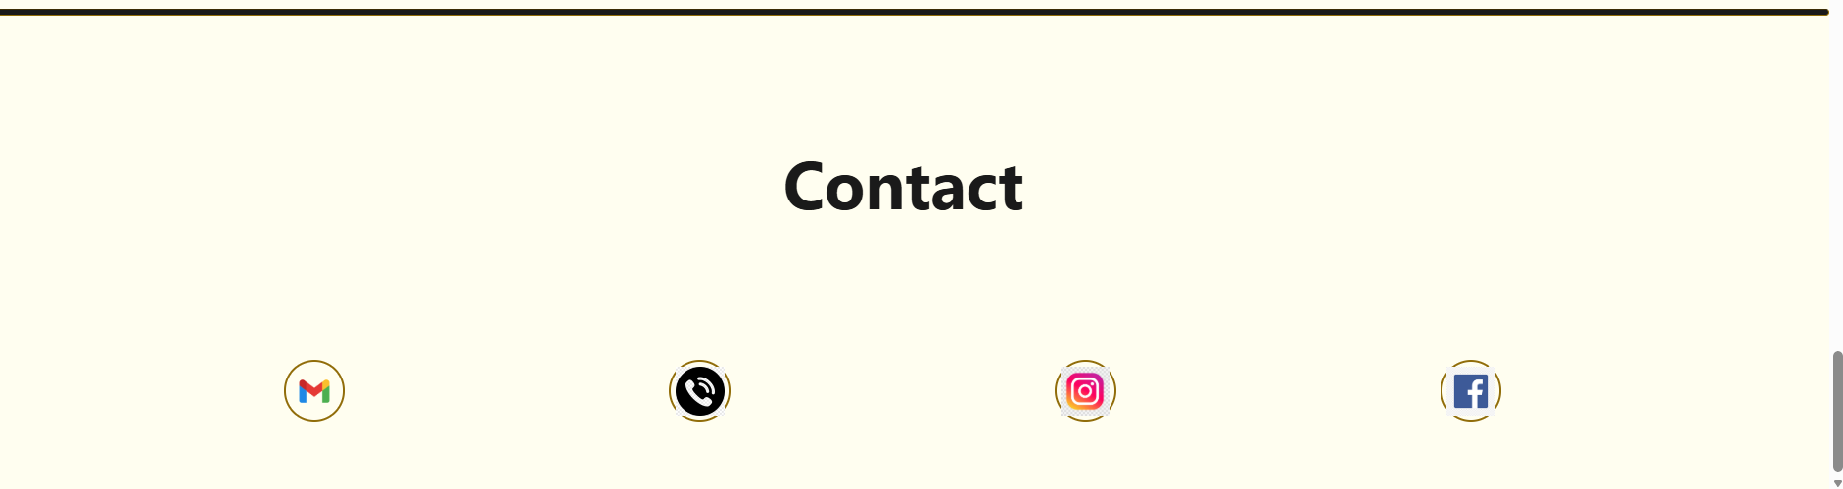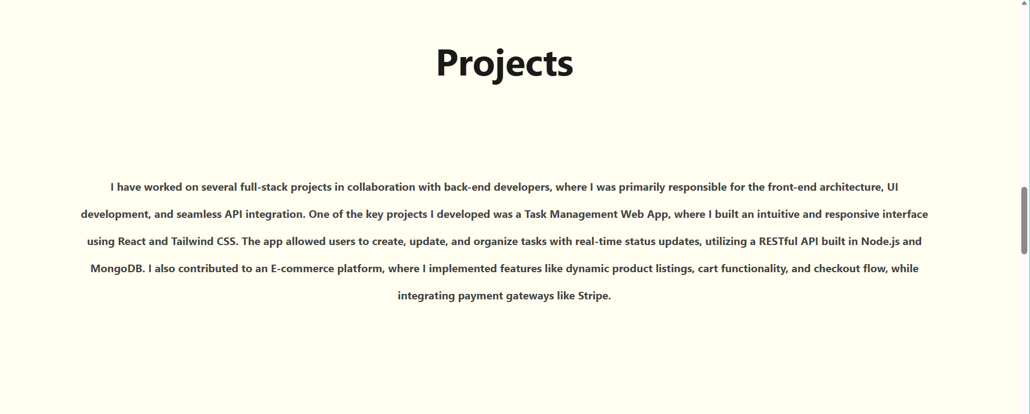

**THEORY**

**TASK # 2  
DIV CONTAINER**   
  
  
  
<!DOCTYPE html>

<html lang="en">

<head>

<meta charset="UTF-8">

<meta name="viewport" content="width=device-width, initial-scale=1.0">

<link rel="stylesheet" href="divdiv.css">

<title>div/span</title>

</head>

<body>

<div class="container">

<div class="box" id="box1">1</div>

<div class="box" id="box2">2</div>

<div class="box" id="box3">3</div>

<div class="box" id="box4">4</div>

<div class="box" id="box1">1</div>

<div class="box" id="box2">2</div>

<div class="box" id="box3">3</div>

<div class="box" id="box4">4</div>

</div>

</body>

</html>

.container{

display: flex;

border-color: black;

border-style: solid;

background-color: rgb(255, 255, 255);

justify-content: space-evenly;

height: 500px;

width: 100%;

align-items: center;

flex-wrap: wrap;

row-gap: 10px;

column-gap: 20px;

}

.box{

width: 150px;

height: 150px;

border-radius: 20px;

text-align: center;

font-size: 120px;

}

#box1{

background-color: purple ;

align-self: start;

}

#box2{

background-color: blue;

}

#box3{

background-color: red;

align-self: start;

}

#box4{

background-color: rgb(140, 122, 122);

align-self: start;

}

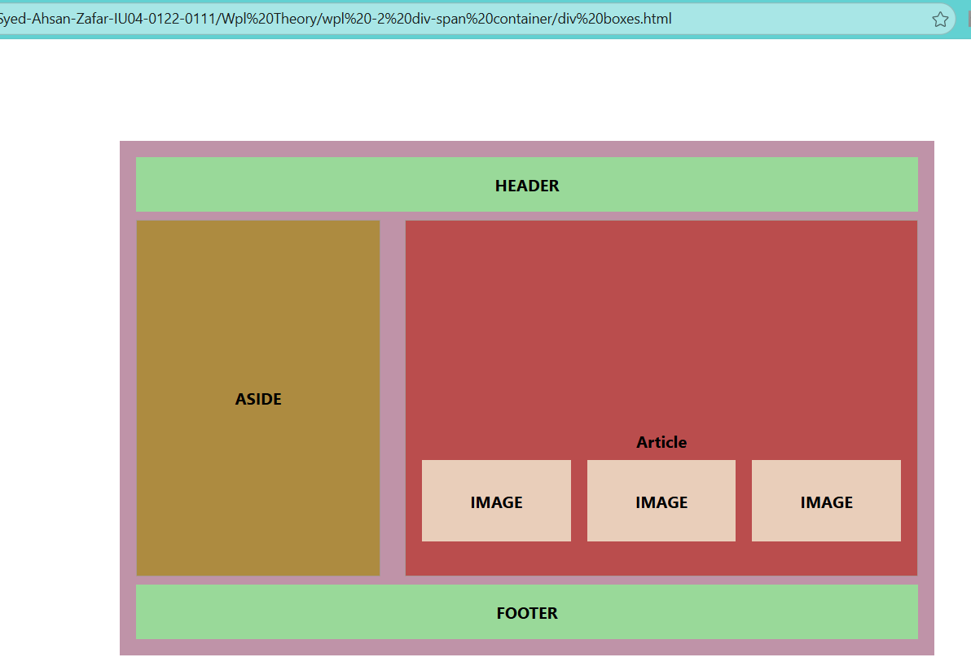

**TASK# 2 MATRIC MARKSHEET**  
  
<!DOCTYPE html>

<html lang="en">

<head>

<meta charset="UTF-8">

<meta name="viewport" content="width=device-width, initial-scale=1.0">

<link rel="stylesheet" href="mtms.css">

<title>matric marksheet</title>

</head>

<body>

<div class="container">

<span><p id="serial"> SERIAL no.<b>12345</b> </p></span>

<span class=" title"><h1>BOARD OF SECONDARY EDUCATION </h1></span>

<img src="../marksheet/bsek logo.jpg" alt="bsek logo">

<h2>STATEMENT OF MARKS</h2>

<h3 ><u> S.S.C EXAMINATION </u></h3>

<h3 id="underline"> SCIENCE GROUP</h3>

<div class="colour">

<table class="info">

<tr><td id="MR"><b>EXAMINATION:</b> &nbsp;&nbsp;&nbsp;&nbsp;&nbsp;&nbsp;&nbsp;&nbsp;&nbsp;&nbsp;&nbsp;&nbsp;

&nbsp;&nbsp;&nbsp;&nbsp;&nbsp;&nbsp;&nbsp;&nbsp;&nbsp;

ANNUAL 2018</td><td id="MR"><b>ROLL NUMBER: &nbsp;&nbsp;&nbsp;&nbsp;</b> 90882</td></tr>

<tr><td id="MR"><b>NAME:</b>&nbsp;&nbsp;&nbsp;&nbsp;&nbsp;&nbsp;&nbsp;&nbsp;&nbsp;&nbsp;&nbsp;&nbsp;&nbsp;&nbsp;&nbsp;

&nbsp;&nbsp;&nbsp;&nbsp;&nbsp;&nbsp;&nbsp;&nbsp; SYED AHSAN ZAFAR</td> </tr>

<tr><td id="MR"><b>FATHERS'S NAME:</b>&nbsp;&nbsp;&nbsp;SYED ZAFAR ALAM</td></tr>

<tr><td id="MR"><b>DATE OF BIRTH:</b>&nbsp;&nbsp;&nbsp;&nbsp;&nbsp;&nbsp; 06-12-1997 &nbsp;&nbsp;

&nbsp;&nbsp;&nbsp;(SIX DECEMBER NINETEEN NINETY SEVEN )</td></tr>

<tr><td id="MR"><b>NAME OF SCHOOL:</b> KARACHI ACADEMY<br>

&nbsp;&nbsp;&nbsp;&nbsp;&nbsp;

&nbsp;&nbsp;&nbsp;&nbsp;&nbsp;&nbsp;&nbsp;&nbsp;&nbsp;&nbsp;

&nbsp;&nbsp;&nbsp;&nbsp;&nbsp;

&nbsp;&nbsp;&nbsp;&nbsp;&nbsp;&nbsp;&nbsp;&nbsp;&nbsp;&nbsp;&nbsp;&nbsp;&nbsp;&nbsp;&nbsp;

SR-123, SECTOR 11-B , NORTH KARACHI </td></tr>

</table>

<table " border="1">

<thead>

<tr>

<th rowspan="2">S.No.</th>

<th CLASS="ALG" rowspan="2">SUBJECTS</th>

<th class="colsize" colspan="2">MAXIMUM <br>MARKS</th>

<th class="colsize" colspan="2">MINIMUM <br>MARKS</th>

<th colspan="3">OBTAINED MARKS</th>

<th rowspan="2">REMARKS</th>

</tr>

<tr >

<th >TH</th><th>PR</th>

<th >TH</th><th>PR</th>

<th >TH</th><th>PR</th><th class="OBSIZE">TOTAL</th>

</tr>

</thead>

<tbody>

<tr> <td>1</td>

<td CLASS="ALG">SINDHI SALEES</td>

<td>75</td>

<td></td>

<td>25</td>

<td></td>

<td>58</td>

<td></td>

<td>58</td>

<td>

</td>

</tr><tr>

<td>2</td>

<td CLASS="ALG">URDU NORMAL</td><td><u>75</u></td><td></td><td><u>25</u></td><td></td><td>58</td><td></td><td><u>58</u></td><td></td></tr>

<tr>

<td></td>

<td></td><td>150</td><td></td><td>25</td><td></td><td>112</td><td></td><td>112</td><td></td></tr>

<tr><td>3</td><td CLASS="ALG">ENGLISH PAPER I</td><td>75</td><td></td><td>25</td><td></td><td>57</td><td></td><td>57</td><td></td></tr>

<tr>

<td>4</td>

<td CLASS="ALG">ENGLISH PAPER II</td><td><u>75</u></td><td></td><td><u>25</u></td><td></td><td>58</td><td></td><td><u>58</u></td><td></td></tr>

<tr>

<td></td>

<td></td><td>150</td><td></td><td>25</td><td></td><td>112</td><td></td><td>111</td><td></td></tr>

<tr><td>5</td>

<td CLASS="ALG">PAKISTAN STUDIES</td>

<td>75</td><td></td><td>25</td><td></td><td>67</td><td></td><td>67</td><td></td></tr>

<tr><td>6</td>

<td CLASS="ALG" >BIOLOGY</td>

<td>85</td><td>15</td><td>28</td><td>05</td><td>71</td><td>13</td><td>84</td><td></td></tr>

<tr><td>7</td>

<td CLASS="ALG">CHEMISTRY</td>

<td>85</td><td>15</td><td>28</td><td>05</td><td>70</td><td>15</td><td>85</td><td></td></tr>

<tr><td>8</td>

<td CLASS="ALG" >ISLAMIAT </td>

<td>75</td><td></td><td>25</td><td></td><td>62</td><td></td><td>62</td><td></td></tr>

<tr><td>9</td>

<td CLASS="ALG">MATHEMATICS</td>

<td>100</td><td></td><td>33</td><td></td><td>97</td><td></td><td>97</td><td></td></tr>

<tr><td>10</td>

<td CLASS="ALG">PHYSICS</td>

<td>85</td><td>15</td><td>28</td><td>05</td><td>48</td><td>13</td><td>61</td><td></td></tr>

</tbody></table>

<br>

<div class="footer">

<div class="inline-container">

<p><b>Grand Total:</b> <span class="highlight">680 / 850</span></p>

<p><b>Grade:</b> <span class="highlight">A-One</span></p>

</div>

</div>

</div>

<div class="signatures">

<div class="signature-row">

<div class="date-group">

<p class="date">12-August-2018</p>

<p class="label">Date of Issue</p>

</div>

<div class="signs">

<pre class="sig-line">Assistant Director Systems Controller of Examinations</pre>

</div>

</div>

<p class="note">Note: Errors and Omissions are excepted.</p>

</div>

</body>

</html>

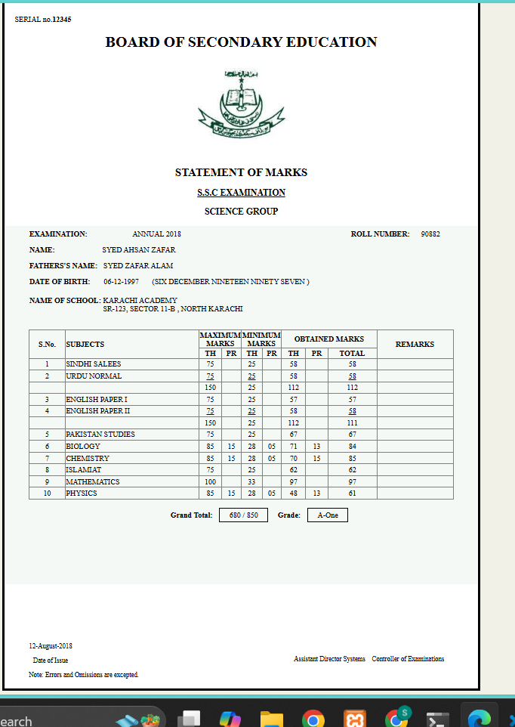

TASK#3 Intermediate marksheet  
  
  
  
<!DOCTYPE html>

<html lang="en">

<head>

<meta charset="UTF-8">

<meta name="viewport" content="width=device-width, initial-scale=1.0">

<title>Statement of Marks</title>

<link rel="stylesheet" href="INTER.CSS">

</head>

<body>

<div class="container">

<div class="header">

<div class="doc-number">900786</div>

<div class="logo">

<span><img src="board-of-intermediate-education-karachi-logo-png_seeklogo-611903.png" height="100px" alt="biek logo"></span>

</div>

<h1 class="board-name"><u>BOARD OF INTERMEDIATE EDUCATION KARACHI</u></h1>

<p class="exam-info">H.S.C PART - I & II INTERMEDIATE EXAMINATION (Annual - 2021)</p>

<h2 class="statement-title"><u>Statement of Marks</u></h2>

</div>

<div class="info-section">

<div class="info-row">

<span class="info-label">Marks Sheet No.</span>

<span class="info-value">10234561-0</span>

</div>

<div class="info-row">

<span class="info-label">Group</span>

<span class="info-value">PRE-ENGINEERING</span>

</div>

<div class="info-row">

<span class="info-label">Roll No.</span>

<span class="info-value">921550</span>

</div>

<div class="info-row">

<span class="info-label">Enrolment /Registration No</span>

<span class="info-value">CNN1/SE/E-0300/2020</span>

</div>

<div class="info-row">

<span class="info-label">Name</span>

<span class="info-value">SYED AHSAN ZAFAR</span>

</div>

<div class="info-row">

<span class="info-label">Father's Name</span>

<span class="info-value">SYED ZAFAR ALAM</span>

</div>

<div class="info-row">

<span class="info-label">College / Private</span>

<span class="info-value">GOVT. COLLEGE FOR MEN NAZIMABAD</span>

</div>

<table class="marks-table" border="1">

<thead>

<tr>

<th rowspan="3" >Subject</th>

<th colspan="4">Part I Marks</th>

<th colspan="4">Part II Marks</th>

<th colspan="4">Combined</th>

<th rowspan="3">%</th>

<th rowspan="3">Remarks</th>

</tr>

<tr>

<th colspan="2">Max.</th>

<th colspan="2">Secured</th>

<th colspan="2">Max.</th>

<th colspan="2">Secured</th>

<th colspan="2">Max.</th>

<th colspan="2">Secured</th>

</tr>

<tr>

<th>Th</th>

<th>Pr</th>

<th>Th</th>

<th>Pr</th>

<th>Th</th>

<th>Pr</th>

<th>Th</th>

<th>Pr</th>

<th>Th</th>

<th>Pr</th>

<th>Th</th>

<th>Pr</th>

</tr>

</thead>

<tbody>

<tr>

<td class="subject-col">URDU NORMAL</td>

<td>100</td>

<td>-</td>

<td>52</td>

<td>-</td>

<td>100</td>

<td>-</td>

<td>52</td>

<td>-</td>

<td>200</td>

<td>-</td>

<td>104</td>

<td>-</td>

<td>52</td>

<td class="pass">Pass</td>

</tr>

<tr>

<td class="subject-col">ENGLISH NORMAL</td>

<td>100</td>

<td>-</td>

<td>52</td>

<td>-</td>

<td>100</td>

<td>-</td>

<td>52</td>

<td>-</td>

<td>200</td>

<td>-</td>

<td>104</td>

<td>-</td>

<td>52</td>

<td class="pass">Pass</td>

</tr>

<tr>

<td class="subject-col">ISLAMIC EDUCATION</td>

<td>50</td>

<td>-</td>

<td>26</td>

<td>-</td>

<td>-</td>

<td>-</td>

<td>-</td>

<td>-</td>

<td>50</td>

<td>-</td>

<td>26</td>

<td>-</td>

<td>52</td>

<td class="pass">Pass</td>

</tr>

<tr>

<td class="subject-col">PAKISTAN STUDIES</td>

<td>-</td>

<td>-</td>

<td>-</td>

<td>-</td>

<td>50</td>

<td>-</td>

<td>26</td>

<td>-</td>

<td>50</td>

<td>-</td>

<td>26</td>

<td>-</td>

<td>52</td>

<td class="pass">Pass</td>

</tr>

<tr>

<td class="subject-col">CHEMISTRY</td>

<td>85</td>

<td>15</td>

<td>44</td>

<td>8</td>

<td>85</td>

<td>15</td>

<td>29</td>

<td>13</td>

<td>170</td>

<td>30</td>

<td>73</td>

<td>21</td>

<td>47</td>

<td class="pass">Pass</td>

</tr>

<tr>

<td class="subject-col">PHYSICS</td>

<td>85</td>

<td>15</td>

<td>44</td>

<td>8</td>

<td>85</td>

<td>15</td>

<td>42</td>

<td>14</td>

<td>170</td>

<td>30</td>

<td>86</td>

<td>22</td>

<td>64</td>

<td class="pass">Pass</td>

</tr>

<tr>

<td class="subject-col">MATHEMATICS</td>

<td>100</td>

<td>-</td>

<td>52</td>

<td>-</td>

<td>100</td>

<td>-</td>

<td>51</td>

<td>-</td>

<td>200</td>

<td>-</td>

<td>103</td>

<td>-</td>

<td>51.5</td>

<td class="pass">Pass</td>

</tr>

<tr class="total-row">

<td class="subject-col"><b>Total</b></td>

<td colspan="2"><b>Max Marks I</b></td>

<td colspan="2"><b>Secured Marks I</b></td>

<td colspan="2"><b>Max Marks II</b></td>

<td colspan="2"><b>Secured Marks II</b></td>

<td colspan="2"><b>Total Max. Marks</b></td>

<td colspan="2"><b>Total Sec. Marks</b></td>

<td><b>Over All %</b></td>

<td><b>Grade</b></td>

</tr>

<tr class="total-row">

<td></td>

<td colspan="2"><b>550</b></td>

<td colspan="2"><b>286</b></td>

<td colspan="2"><b>550</b></td>

<td colspan="2"><b>279</b></td>

<td colspan="2"><b>1100</b></td>

<td colspan="2"><b>565</b></td>

<td><b>51.36</b></td>

<td class="grade"><b>C</b></td>

</tr>

<tr>

<td class="subject-col"><b>In Words</b></td>

<td colspan="14" style="text-align: center;"><b>Five Hundred Sixty Five Only</b></td>

</tr>

<tr>

<td class="subject-col"><b>Grace/Grade Raised</b></td>

<td colspan="14"></td>

</tr>

</tbody>

</table>

<div class="footer">

<div class="signature-section">

<div class="signature-box">

<div class="signature-label">PREPARED BY IT DEPARTMENT</div>

</div>

<div class="controller-section">

<div class="controller-label">CONTROLLER OF EXAMINATIONS</div>

<div class="date"></div>

</div>

</div>

</body>

</html>



**lab#2**

**Task Table using bootstrap**

<!DOCTYPE html>

<html lang="en">

<head>

<meta charset="UTF-8">

<meta name="viewport" content="width=device-width, initial-scale=1.0">

<!-- <link href="https://cdn.jsdelivr.net/npm/bootstrap@5.3.8/dist/css/bootstrap.min.css" rel="stylesheet" -->

<!-- integrity="sha384-sRIl4kxILFvY47J16cr9ZwB07vP4J8+LH7qKQnuqkuIAvNWLzeN8tE5YBujZqJLB" crossorigin="anonymous"> -->

<!-- <script src="https://cdn.jsdelivr.net/npm/bootstrap@5.3.8/dist/js/bootstrap.bundle.min.js" -->

<!-- integrity="sha384-FKyoEForCGlyvwx9Hj09JcYn3nv7wiPVlz7YYwJrWVcXK/BmnVDxM+D2scQbITxI" crossorigin="anonymous"></script> -->

<link rel="stylesheet" href="../bootstrap/css/bootstrap.min.css">

<script src="../bootstrap/js/bootstrap.bundle.min.js"></script>

<title>wpl lab 3</title>

</head>

<body>

<table>

<!DOCTYPE html>

<html lang="en">

<head>

<meta charset="UTF-8">

<meta name="viewport" content="width=device-width, initial-scale=1.0">

<title>HTML Table Example</title>

</head>

<body >

<table class="table tbl-responsive table-hover table-bordered">

<thead class=" table-primary">

<th>ID</th>

<th>Name</th>

<th>mail</th>

<th>contact</th>

</thead>

<tbody class=" table-success">

<tr>

<td>1</td>

<td>Ali</td>

<td>ali@Gmail.com</td>

<td>090078601</td>

</tr>

<tr>

<td>2</td>

<td>Ahsan</td>

<td>ahsan.@gmail</td>

<td>090078601</td>

</tr>

<tr>

<td>3</td>

<td>Fatima</td>

<td>fatima.@gmail</td>

<td>090078601</td>

</tr>

</tbody>

</table>

</body>

</html>

</body>

</html>

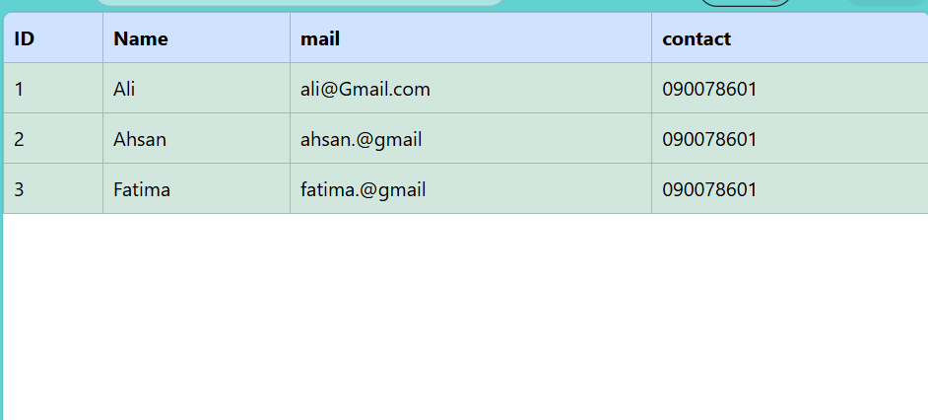

**lab#4**

**TASK SIGNUP LOGIN USING BOOTSTRAP**  
  
SIGNUP PAGE

<!doctype html>

<html lang="en">

<head>

<meta charset="utf-8">

<meta name="viewport" content="width=device-width, initial-scale=1">

<title>Signup form</title>

<link href="https://cdn.jsdelivr.net/npm/bootstrap@5.3.8/dist/css/bootstrap.min.css" rel="stylesheet"

integrity="sha384-sRIl4kxILFvY47J16cr9ZwB07vP4J8+LH7qKQnuqkuIAvNWLzeN8tE5YBujZqJLB" crossorigin="anonymous">

<script src="https://cdn.jsdelivr.net/npm/bootstrap@5.3.8/dist/js/bootstrap.bundle.min.js"

integrity="sha384-FKyoEForCGlyvwx9Hj09JcYn3nv7wiPVlz7YYwJrWVcXK/BmnVDxM+D2scQbITxI" crossorigin="anonymous"></script>

</head>

<body class="p-3 mb-2 mt-4 text-muted bg-success p-2 bg-opacity-25 ">

<h1 class="text-center">IU</h1>

<div class="container bg-light text-muted p-5 mx-auto p-2 w-50 h-25 mb-5 mt-3 fw-bold fs-7

rounded shadow-lg p-3 mb-5 " >

<div class="text-center mb-4 text-muted ">

<h1>Sign Up </h1 > </div>

<hr>

<form class="row g-3 mt-5 ">

<div class="col-md-6">

<label" >First Name</label>

<input type="text" class="form-control mt-2 border-primary" placeholder="Ahsan">

</div>

<div class="col-md-6">

<label>Last Name</label>

<input type="text" class="form-control mt-2 border-primary" placeholder="Zafar">

</div>

<div class="col-md-12 ">

<label class="mb-1">Email</label>

<input type="email" placeholder="Ahsanxyz@gmail.com" class="form-control border-primary">

</div>

<div class="col-md-6 ">

<label class="mt-2">Password</label>

<input type="password" class="form-control mt-2 border-primary" placeholder="aBc123-#@">

</div>

<div class="col-md-6 ">

<label class=" mt-2">Confirm Password</label>

<input type="password" class="form-control mt-2 border-primary" placeholder="aBc123-#@"></div>

<div class="col-md-5 ">

<label class="mt-3">Date Of Birth</label>

<input type="date" class="form-control mt-2 border-primary" placeholder="ahsan@gmail.com">

</div>

<div class="col-md-6 ms-5 mt-3">

<label class="ms-2 mb-2 mt-3">Gender</label>

<br>

<div class=" form-check-inline">

<input class="form-check-input ms-3 mt-2 border border-primary" type="radio" name="gender" id="male" value="1">

<label class=" ms-2 mt-1">Male</label>

<input class="form-check-input ms-5 mt-2 border-primary" type="radio" name="gender" id="female" value="2">

<label class=" ms-2 mt-1" >Female</label>

</div> </div>

<label class="mt-3">Interested Course</label>

<div class="col-md-12 ">

<div class="form-check-inline ">

<input class="form-check-input border-primary" type="checkbox" >

<label class="ms-1">Web programming language

</label>

</div>

<div class="form-check-inline ms-3">

<input class="form-check-input border-primary" type="checkbox">

<label class="ms-1" >Data Science</label>

</div>

<div class="form-check-inline ms-3">

<input class="form-check-input border-primary" type="checkbox" >

<label class="ms-1">Network Defense </label>

</div>

</div>

<div class="col-md-12" >

<label class="mb-3 mt-1">Profile picture </label>

<div >

<input type="file" class="form-control border-primary">

</div></div>

<br>

<br>

<div class="col-md-3 mb-3">

<div class="form-check-inline mt-3 ">

<label>Country</label>

<select class="form-select mt-2 pe-5 border-primary" >

<option selected > Country</option>

<option >Pakitsan</option>

<option >india</option>

<option >canada</option>

</select>

</div>

</div>

<div class="col-md-3 ms-5 mb-3">

<div class="form-check-inline mt-3">

<label>State</label>

<select class="form-select mt-2 pe-4 border-primary" >

<option >State</option>

<option >Sindh</option>

<option >Pujab</option>

<option >Gilgit</option>

<option >Balochistan</option>

<option > Ontario</option>

<option >Quebec</option>

<option >Mani Toba</option>

<option > Up</option>

<option >Bihar</option>

<option >Marashtra</option>

<option >gujrat</option>

</select>

</div>

</div>

<div class="col-md-3 ms-5 ">

<div class="form-check-inline ms-3 mt-3 ">

<label>City</label>

<select class="form-select mt-2 border-primary " >

<option selected>City</option>

<option >Karachii</option>

<option>lahore</option>

<option >Sukkur</option>

<option >Jacobabad</option><option>sialkot</option>

<option >Islamabad</option>

<option>Peshawar</option>

<option >Naran</option>

<option >Swat</option>

<option>Swabi</option>

<option >Shugran</option>

<option >Ahmedabad </option>

<option>Surat</option>

<option >Vadodara</option>

<option >Rajkot</option>

<option>swabi</option>

<option >shugran</option>

</select>

</div>

</div>

<button type="button" class="btn btn-success opacity-75 mt-5 mb-2 mx-auto p-2 w-50 "><b>Sign Up</b></button>

<p class="text-center fw-normal"> <a class="text-decoration-none" href="login.html" target="_blank">Already have an account ?</a></p>

</form>

</div>

</body>

</html>

**LOGIN PAGE**

<!doctype html>

<html lang="en">

<head>

<meta charset="utf-8">

<meta name="viewport" content="width=device-width, initial-scale=1">

<title>LOGIN form</title>

<link href="https://cdn.jsdelivr.net/npm/bootstrap@5.3.8/dist/css/bootstrap.min.css" rel="stylesheet"

integrity="sha384-sRIl4kxILFvY47J16cr9ZwB07vP4J8+LH7qKQnuqkuIAvNWLzeN8tE5YBujZqJLB" crossorigin="anonymous">

<script src="https://cdn.jsdelivr.net/npm/bootstrap@5.3.8/dist/js/bootstrap.bundle.min.js"

integrity="sha384-FKyoEForCGlyvwx9Hj09JcYn3nv7wiPVlz7YYwJrWVcXK/BmnVDxM+D2scQbITxI" crossorigin="anonymous"></script>

</head>

<body class="p-3 mb-2 mt-5 text-muted bg-success bg-opacity-25 ">

<h1 class="text-center">IU</h1>

<div class="container bg-light text-muted p-4 w-25 mb-5 mt-3 fw-bold fs-7

rounded shadow-lg " >

<header> <h1 class="text-center">Log in</h1> </header>

<hr>

<main>

<form class="row g-3 ">

<div class="col-md-12 text-muted ">

<label class="mb-2 ">Email</label>

<input type="Email" placeholder="Ahsanxyz@gmail.com" class="form-control border-primary ">

</div>

<div>

<label class=" col-md-12 ">Password</label>

<input type="password" class="form-control mt-2 border-primary" placeholder="aBc123-#@">

</div>

<button type="button" class="btn btn-primary mb-2 mx-auto p-2 w-100 ">Log in</button>

<p class="text-center text-muted"> <a class="text-decoration-none fw-light" href="signup.html" target="_blank">Sign up for IU</a></p>

</form>

</main>

</body>

</html>

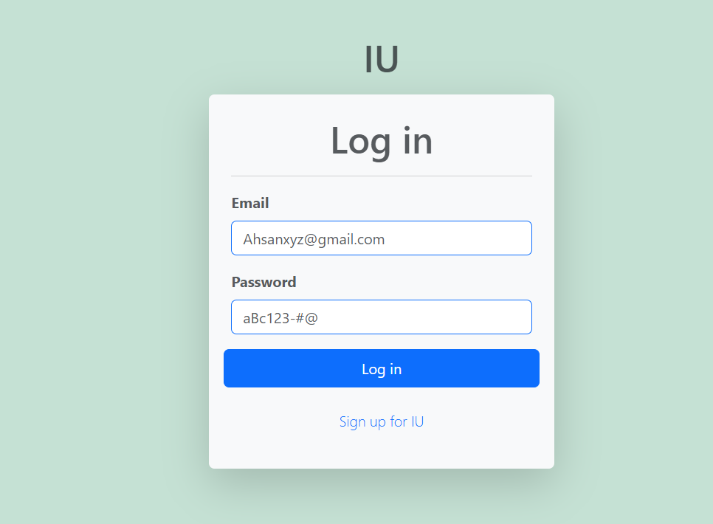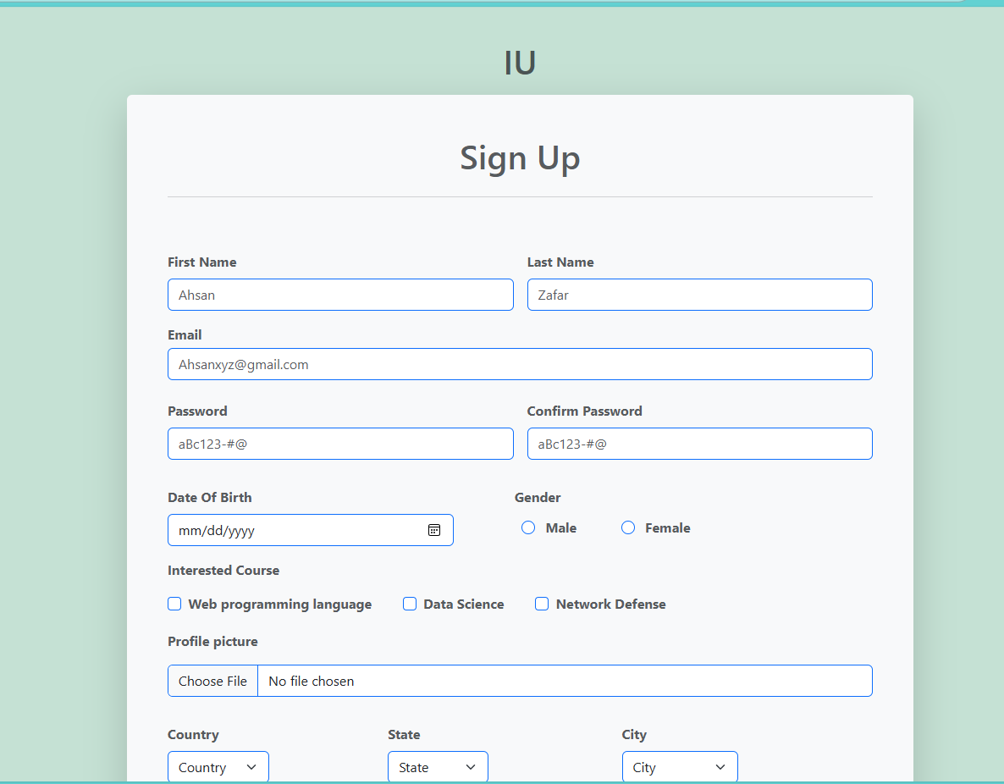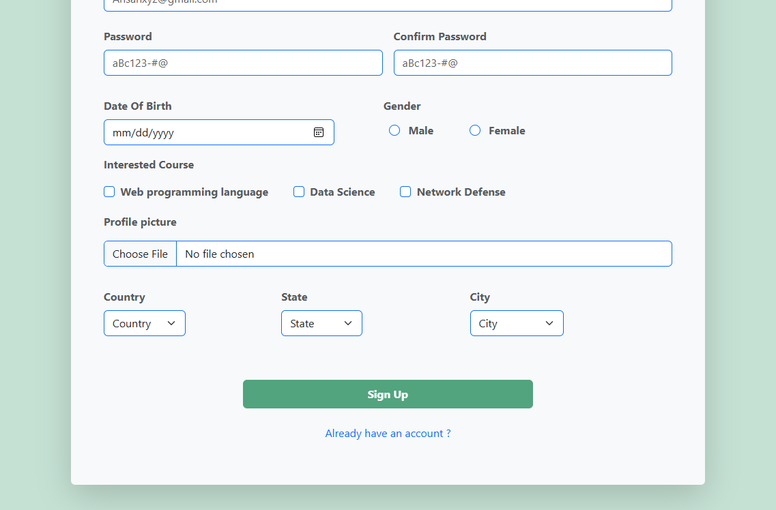

**LAB#5  
FORM VALIDATION**  
  
<!DOCTYPE html>

<html lang="en">

<head>

<meta charset="UTF-8">

<meta name="viewport" content="width=device-width, initial-scale=1.0">

<title>Facebook signup</title>

<link rel="stylesheet" href="bootstrap/css/bootstrap.min.css">

<script src="bootstrap/js/bootstrap.bundle.min.js"></script>

</head>

<body class="bg-light">

<div class="container pt-5 pb-5 w-25">

<div class="row justify-content-center">

<h1 class="text-center text-primary fw-bold " style="font-size: 66px;">facebook</h1>

<div class=" form-control card p-4">

<h2 class="fw-bold fs-4 text-center">Create a new account</h2>

<p class="text-muted small text-center">It's quick and easy.</p>

<hr class="mb-3 mt-3">

<form action="fbformsubmit.php" method="POST" >

<div class=" row g-2 mb-3">

<div class="col-6">

<div class="mb-2 "><label > First name </label></div>

<input type="text" class="form-control" id="first_name" name="first_name" placeholder="First name">

<span id="first_name_error" class="text-danger"></span>

</div>

<div class="col-6">

<div class="mb-2 "><label > last name </label></div>

<input type="text" class="form-control " placeholder="Lastname" id="last_name" name="last_name">

<span id="last_name_error" class="text-danger"></span>

</div>

</div>

<div class=" form-label mb-3">

<label >Date of birth </label>

<div class="row g-2">

<div class="col-4">

<select class="form-select" name="day" id="day">

<option>day</option>

<option>1</option>

<option>2</option>

<option>3</option>

<option>4</option>

<option>5</option>

<option>6</option>

<option>7</option>

<option>8</option>

<option>9</option>

<option>10</option>

<option>11</option>

<option>12</option>

<option>13</option>

<option>14</option>

<option>15</option>

<option>16</option>

<option>17</option>

<option>18</option>

<option>19</option>

<option>20</option>

<option>21</option>

<option>22</option>

<option>23</option>

<option>24</option>

</select>

<span id="days_error" class="text-danger"></span>

</div>

<div class="col-4">

<select class="form-select " name="month" id="month">

<option>month</option>

<option>Jan</option>

<option>Feb</option>

<option>Mar</option>

<option>Apr</option>

<option>May</option>

<option>Jun</option>

<option>Jul</option>

<option>Aug</option>

<option>Sep</option>

<option>Oct</option>

<option>Nov</option>

<option>Dec</option>

</select>

<span id="months_error" class="text-danger"></span>

</div>

<div class="col-4">

<select class="form-select " name="year" id="year">

<option>year</option>

<option>year </option>

<option>2013</option>

<option>2012</option>

<option>2011</option>

<option>2010</option>

<option>2009</option>

<option>2008</option>

<option>2007</option>

<option>2006</option>

<option>2005</option>

<option>2004</option>

<option>2003</option>

<option>2002</option>

<option>2001</option>

<option>2000</option>

<option>1999</option>

<option>1998</option>

<option>1997</option>

<option>1996</option>

<option>1995</option>

<option>1994</option>

<option>1993</option>

<option>1992</option>

<option>1991</option>

<option>1990</option>

</select>

<span id="years_error" class="text-danger"></span>

</div>

</div>

</div>

<div>

<div><label>Gender</label></div>

<div class="d-flex gap-4 ms-2">

<div><label>male</label></div>

<div class="form-check form-check-inline">

<input class="form-check-input" type="radio" name="gender" id="male" value="male" >

</div>

<div><label>female</label></div>

<div class="form-check form-check-inline">

<input class="form-check-input" type="radio" name="gender" id="female" value ="female">

</div>

<div ><label>custom</label></div>

<div class="form-check form-check-inline">

<input class="form-check-input" type="radio" name="gender" id="custom" value = "custom">

</div>

</div>

<span id="gender_error" class="text-danger"></span>

</div>

<div class="mb-3 mt-2">

<div class="mb-2 "><label > Email </label></div>

<input type="email" class="form-control" id="email" placeholder="email address" name="email">

<span id="email_error" class="text-danger"></span>

</div>

<div class="mb-2 "><label > Contact </label></div>

<div class="mb-3">

<input type="text" class="form-control border" id="contact" name="contact" placeholder="03323098292">

<span id="contact_error" class="text-danger"></span>

</div>

<div class="mb-3">

<div class="mb-2 "><label > Password </label></div>

<input type="password" class="form-control" id="password" name="password" placeholder="password">

<span id="password_error" class="text-danger"></span>

</div>

<p class="small text-muted mb-2 mt-3">

By clicking Sign Up, you agree to our Privacy Policy Cookies Policy You may receive SMS notifications from us and can opt out at any time.

</p>

<div class="mb-3 mt-4"><center> <button type="submit" onclick="formsub(event)" class="form-control w-25 text-bg-success text-center">Signup</button>

</center></div>

<div class="text-center">

<a href="https://www.facebook.com/login/?privacy_mutation_token=eyJ0eXBlIjowLCJjcmVhdGlvbl90aW1lIjoxNzYzNTk1MDUwLCJjYWxsc2l0ZV9pZCI6MjY5NTQ4NDUzMDcyMDk1MX0%3D" class="text-decoration-none fw-semibold">Already have an account?</a>

</div>

</form>

</div>

</div>

<script>

function formsub(event) {

document.getElementById('first_name_error').innerHTML = "";

document.getElementById('last_name_error').innerHTML = "";

document.getElementById('email_error').innerHTML = "";

document.getElementById('password_error').innerHTML = "";

document.getElementById('contact_error').innerHTML = "";

document.getElementById('days_error').innerHTML="";

document.getElementById('months_error').innerHTML="";

document.getElementById('years_error').innerHTML="";

document.getElementById('gender_error').innerHTML="";

var firstName = document.getElementById('first_name').value

if (firstName != ''){

var firstNameRegex = /^[a-zA-Z]{1,1000}$/

var testFirstName = firstNameRegex.test(firstName)

if(testFirstName == false){

document.getElementById('first_name_error').innerHTML = "enter valid value please"

event.preventDefault();

}

}

else

{

document.getElementById('first_name_error').innerHTML = "enter first name value please"

event.preventDefault();

}

var lastName = document.getElementById('last_name').value

if (lastName != ''){

var lastNameRegex = /^[a-zA-Z]{1,1000}$/

var testLastName = lastNameRegex.test(lastName)

if(testLastName == false){

document.getElementById('last_name_error').innerHTML = "enter valid value please"

event.preventDefault();

}

}

else

{

document.getElementById('last_name_error').innerHTML = "enter last name value please"

event.preventDefault();

}

var Email = document.getElementById('email').value

if (Email != ''){

var EmailRegex = /^[a-zA-Z0-9_.+-]+@[a-zA-Z0-9-]+\.[a-zA-Z0-9-.]{1,100}$/

var TestEmail = EmailRegex.test(Email)

if(TestEmail == false){

document.getElementById('email_error').innerHTML = "enter valid value please"

event.preventDefault();

}

}

else

{

document.getElementById('email_error').innerHTML = "enter email value please"

event.preventDefault();

}

var Pass = document.getElementById('password').value

if (Pass != ''){

var PassRegex = /^(?=.*[a-z])(?=.*[A-Z])(?=.*\d)(?=.*[#$@!%&*?])[A-Za-z\d#$@!%&*?]{8,16}$/;

var TestPass = PassRegex.test(Pass)

if(TestPass == false){

document.getElementById('password_error').innerHTML = "Minimum eight characters, at least one uppercase letter, one lowercase letter, one number and one special character:"

event.preventDefault();

}

}

else

{

document.getElementById('password_error').innerHTML = "enter password please"

event.preventDefault();

}

var Contact = document.getElementById('contact').value

if (Contact != ''){

var ContactRegex = /^\s*(?:\+?(\d{1,3}))?[-. (]*(\d{3})[-. )]*(\d{3})[-. ]*(\d{5})(?: *x(\d+))?\s*$/

var TestContact = ContactRegex.test(Contact)

if(TestContact == false){

document.getElementById('contact_error').innerHTML = "range is 11 to 12 digit use + - and numeric values"

event.preventDefault();

}

}

else

{

document.getElementById('contact_error').innerHTML = "enter Contact number please"

event.preventDefault();

}

var day = document.getElementById('day').value

if (day == 'day') {

document.getElementById('days_error').innerHTML = "please select day";

event.preventDefault();

}

var month = document.getElementById('month').value

if (month == 'month') {

document.getElementById('months_error').innerHTML = "please select month";

event.preventDefault();

}

var year = document.getElementById('year').value

if (year == 'year') {

document.getElementById('years_error').innerHTML = "please select year";

event.preventDefault();

}

var gender1 = document.getElementById('male');

var gender2 = document.getElementById('female');

var gender3 = document.getElementById('custom');

if (gender1.checked == true) {

}

else if (gender2.checked == true) {

}

else if (gender3.checked == true) {

}

else {

document.getElementById('gender_error').innerHTML = "please select a gender";

event.preventDefault();

}

}

</script>

</body>

</html>

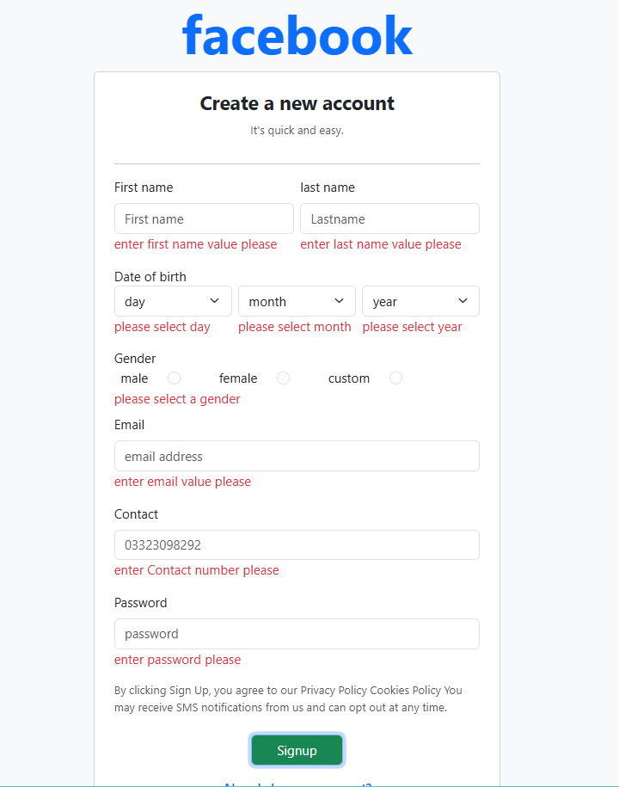

THEORY TASK  
**FORM TO TABLE**  
  
  
 <!DOCTYPE html>

<html lang="en">

<head>

<meta charset="UTF-8">

<meta name="viewport" content="width=device-width, initial-scale=1.0">

<title>Form to Table</title>

<link rel="stylesheet" href="../bootstrap/css/bootstrap.min.css">

<script src="../bootstrap/js/bootstrap.bundle.min.js"></script>

</head>

<body class="p-3">

<div class="container">

<div class="row">

<div class="col-md-6">

<div class="card" >

<div class="card-body">

<form action="ftotable.php" method="post" >

<h1>signup form</h1>

<div class="mb-3">

<label >First Name</label>

<input type="text" class="form-control" placeholder="Enter your first name" id="fname" name="fname">

<span id="first_name_error" class="text-danger"></span>

</div>

<div class="mb-3">

<label> last name

</label>

<input type="text" class="form-control" placeholder="enter last name" id="lname" name="lname">

<span id="last_name_error" class="text-danger"></span>

</div>

<div>

<label>email</label>

<input type="email" name="email" class="form-control" id="email" placeholder="ahsan@gmail.com">

<span id="email_error" class="text-danger"></span>

</div>

<div>

<label>password</label>

<input type="password" name="password" class="form-control" id="password" placeholder="abcd.123@#.com">

<span id="password" class="text-danger"></span>

</div>

<div class="col-12 mb-2 mt-2 d-inline-flex">

<select class="form-control me-5" id="year" name="year">year

<option>2015</option>

<option>2012</option>

<option>2010</option>

</select>

<select class="form-control me-5" id="day" name="day">date

<option>date</option>

<option>1</option>

<option>2</option>

<option>3</option>

</select>

<select class="form-control" id="month" name="month">date

<option>month</option>

<option>jan</option>

<option>feb</option>

<option>march</option>

</select>

</div>

<div>

<div>gender</div>

<div class="form-check form-check-inline ">

<label>male</label>

<input class="form-check-input" type="radio" name="gender" id="male" value="male">

</div>

<div class="form-check form-check-inline">

<label> female</label>

<input class="form-check-input" type="radio" name="gender" id="female" value="female">

</div>

<span id="gender_error" class="text-danger"></span>

</div>

<div>select course</div>

<div class="form-check form-check-inline ">

<label>mats</label>

<input class="form-check-input" type="checkbox" name="maths" id="maths" value="maths">

</div>

<div class="form-check form-check-inline">

<label> wpl</label>

<input class="form-check-input" type="checkbox" name="wpl" id="wpl" value="wpl">

</div>

<div class="form-check form-check-inline">

<label> vpl</label>

<input class="form-check-input" type="checkbox" name="vpl" id="vpl" value="vpl">

</div>

<div class="form-check form-check-inline">

<label> adbms</label>

<input class="form-check-input" type="checkbox" name="adbms" id="adbms" value="adbms">

</div>

<div>

<label> upload picture </label>

<input type="file" name="picture" id="picture" class="form-control">

</div>

<div >

<center> <button type="submit" class=" btn btn-success mt-2 " onclick="totable(event)" >submit</button></center>

</div>

</form>

</div>

</div>

</div>

<div class="col-lg-6 ">

<div class="card" >

<div class="card-body">

<h1>table</h1>

<table class=" table-bordered ">

<thead>

<tr>

<th >fname</th>

<th>lname</th>

<th>email</th>

<th>password</th>

<th>gender</th>

<th>course</th>

<th>file</th>

</tr>

</thead>

<tbody class="table-bordered">

<tr>

<td>ahsan</td>

<td>zafar</td>

<td>ahsan@gmail.com</td>

<td>abcx@gm</td>

<td> male</td>

<td> wpl </td>

<td>pict</td>

</tr>

</tbody>

</table>

</div>

</div>

</div>

</div>

</div>

<script src="ftotable.js"> </script>

</body>

</html>

function totable(event){

var fname = document.getElementById("fname").value

var lname = document.getElementById("lname").value

var email = document.getElementById("email").value

var password = document.getElementById("password").value

var gender = "";

if (document.getElementById("male").checked) {

gender = "male";

} else if (document.getElementById("female").checked) {

gender = "female";

}

var courses = "";

if (document.getElementById("maths").checked) {

courses += "maths ";

}

if (document.getElementById("wpl").checked) {

courses += "wpl ";

}

if (document.getElementById("vpl").checked) {

courses += "vpl ";

}

if (document.getElementById("adbms").checked) {

courses += "adbms ";

}

var fname = document.getElementById("fname").value

if(fname != ""){

firstnameregex=/^[a-zA-z]{1,100}$/

testfirstname=firstnameregex.test(fname)

if(testfirstname == false){

document.getElementById("first_name_error").innerHTML = "please write valid values";

event.preventDefault();

}

}

else{

document.getElementById("first_name_error").innerHTML = "please write any value";

event.preventDefault();

}

var lname =document.getElementById("lname").value

if(lname!=""){

lastnameregex = /^[a-zA-Z]{1,100}$/

lastnametest = lastnameregex.test(lname)

if(lastnametest == false){

document.getElementById("last_name_error").innerHTML = 'write valid values for name'

event.preventDefault();}

}

else{

document.getElementById("last_name_error").innerHTML = "write any values"

event.preventDefault();

}

var gender1 = document.getElementById('male');

var gender2 = document.getElementById('female');

if (gender1.checked == true) {

}

else if (gender2.checked == true) {

}

else {

document.getElementById('gender_error').innerHTML = "please select a gender";

event.preventDefault();

}

var table= document.getElementsByTagName('tbody')[0];

var new_row= table.insertRow(table.rows.length);

var cell1 =new_row.insertCell(0)

var cell2 =new_row.insertCell(1)

var cell3 =new_row.insertCell(2)

var cell4 =new_row.insertCell(3)

var cell5 =new_row.insertCell(4)

var cell6 =new_row.insertCell(5)

cell1.innerHTML =fname

cell2.innerHTML =lname

cell3.innerHTML =email

cell4.innerHTML =password

cell5.innerHTML =gender

cell6.innerHTML = courses

}

<!DOCTYPE html>

<html lang="en">

<head>

<meta charset="UTF-8">

<meta name="viewport" content="width=device-width, initial-scale=1.0">

<title>Ft</title>

<link rel="stylesheet" href="../bootstrap/css/bootstrap.min.css">

<script src="../bootstrap/js/bootstrap.bundle.min.js"></script>

</head>

<body class="p-3">

<div class="container">

<div class="row">

<div class="col-md-6">

<div class="card" >

<div class="card-body">

<form action="table.php" method="post" >

<h1>signup form</h1>

<div class="mb-3">

<label >First Name</label>

<input type="text" class="form-control" placeholder="Enter your first name" id="fname" name="fname">

<span id="first_name_error" class="text-danger"></span>

</div>

<div class="mb-3">

<label> last name

</label>

<input type="text" class="form-control" placeholder="enter last name" id="lname" name="lname">

<span id="last_name_error" class="text-danger"></span>

</div>

<div>

<label>email</label>

<input type="text" name="email" class="form-control" id="email" placeholder="ahsan@gmail.com">

<span id="email_error" class="text-danger"></span>

</div>

<div>

<label>password</label>

<input type="password" name="password" class="form-control" id="password" placeholder="abcd.123@#.com">

<span id="password_error" class="text-danger"></span>

</div>

<div class="col-12 mb-2 mt-2 d-inline-flex">

<select class="form-control me-5" id="year" name="year">year

<option>year</option>

<option>2015</option>

<option>2012</option>

<option>2010</option>

</select>

<span id = "year_error" class="text-danger"></span>

<select class="form-control me-5" id="day" name="day">date

<option>day</option>

<option>1</option>

<option>2</option>

<option>3</option>

</select>

<span id = "day_error" class="text-danger"></span>

<select class="form-control" id="month" name="month">date

<option>month</option>

<option>jan</option>

<option>feb</option>

<option>march</option>

</select>

<span id = "month_error" class="text-danger"></span>

</div>

<div>

<div>gender</div>

<div class="form-check form-check-inline ">

<label>male</label>

<input class="form-check-input" type="radio" name="gender" id="male" value="male">

</div>

<div class="form-check form-check-inline">

<label> female</label>

<input class="form-check-input" type="radio" name="gender" id="female" value="female">

</div>

<span id="gender_error" class="text-danger"></span>

</div>

<div>select course</div>

<div class="form-check form-check-inline ">

<label>mats</label>

<input class="form-check-input" type="checkbox" name="course[]" id="maths" value="maths">

</div>

<div class="form-check form-check-inline">

<label> wpl</label>

<input class="form-check-input" type="checkbox" name="course[]" id="wpl" value="wpl">

</div>

<div class="form-check form-check-inline">

<label> vpl</label>

<input class="form-check-input" type="checkbox" name="course[]" id="vpl" value="vpl">

</div>

<div class="form-check form-check-inline">

<label> adbms</label>

<input class="form-check-input" type="checkbox" name="course[]" id="adbms" value="adbms">

</div>

<span id =course_error class="text-danger"></span>

<div >

<center> <button type="submit" class=" btn btn-success mt-2 " onclick="totable1(event)" >submit</button></center>

</div>

</div>

</div>

</div>

</div>

</div>

<script>

function totable1(event){

firstname = document.getElementById("fname").value

if(firstname != ''){

var firstnameregex = /^[a-zA-Z]{1,100}$/

var testfirstname = firstnameregex.test(firstname)

if(testfirstname == false){

document.getElementById("first_name_error").innerHTML= "write valid value"

event.preventDefault()

}}

else{

document.getElementById("first_name_error").innerHTML= "write a value"

event.preventDefault()

}

lastname = document.getElementById("lname").value

if(lastname != ''){

var lastnameregex = /^[a-zA-Z]{1,100}$/

var testlastname = lastnameregex.test(lastname)

if(testlastname == false){

document.getElementById("last_name_error").innerHTML= "write valid value"

event.preventDefault()

}}

else{

document.getElementById("last_name_error").innerHTML= "write a value"

event.preventDefault()

}

emailn = document.getElementById("email").value

if(emailn!=''){

var emailregex=/^[^\s@]+@[^\s@]+\.[^\s@]+$/

var testemail=emailregex.test(emailn)

if(testemail==false){

document.getElementById("email_error").innerHTML = "write valid using @ mail"

event.preventDefault();

}

}

else{

document.getElementById("email_error").innerHTML = "write mail cannot leave blank"

event.preventDefault();

}

pass = document.getElementById("password").value

if(pass != ''){

var passregex = /^[^\s@]+@[^\s@]+\.[^\s@]+$/

testpassregex = passregex.test(pass)

if(testpassregex == false){

document.getElementById("password_error").innerHTML = "write valid password"

event.preventDefault();

}

}

else{

document.getElementById("password_error").innerHTML = "write password"

event.preventDefault();

}

var day = document.getElementById("day").value

if (day =='day'){

document.getElementById("day_error").innerHTML = "select a date please"

event.preventDefault();

}

var year = document.getElementById("year").value

if (year =='year'){

document.getElementById("year_error").innerHTML = "select a year please"

event.preventDefault();

}

var month = document.getElementById("month").value

if (month =='month'){

document.getElementById("month_error").innerHTML = "select a month please"

event.preventDefault();

}

gender1 = document.getElementById("male")

gender2 = document.getElementById("female")

if(gender1.checked == true){}

else if(gender2.checked == true){}

else{

document.getElementById("gender_error").innerHTML = "select any gender"

event.preventDefault();

}

var courses = "";

if (document.getElementById("maths").checked) {x

courses += "maths ";

}

if (document.getElementById("wpl").checked) {

courses += "wpl ";

}

if (document.getElementById("vpl").checked) {

courses += "vpl ";

}

if (document.getElementById("adbms").checked) {

courses += "adbms ";

}

if(courses == ''){

document.getElementById("course_error").innerHTML = "please select course"

event.preventDefault();

}

}

</script>

</body>

</html>

<?php

$fname = $_POST['fname'];

$lname = $_POST['lname'];

$email = $_POST['email'];

$password = $_POST['password'];

$gender = $_POST['gender'];

$course = implode(", ", $_POST['course']);

$day = $_POST['day'];

$year = $_POST['year'];

$month = $_POST['month'];

$dob= $day . '-'.$year . '-'.$month ;

$connection = mysqli_connect('localhost','root','', 'prac');

$query = "INSERT INTO rpc(fname,lname,email,password,gender,courses,dob) values('$fname','$lname','$email','$password','$gender','$course','$dob')";

mysqli_query($connection,$query);

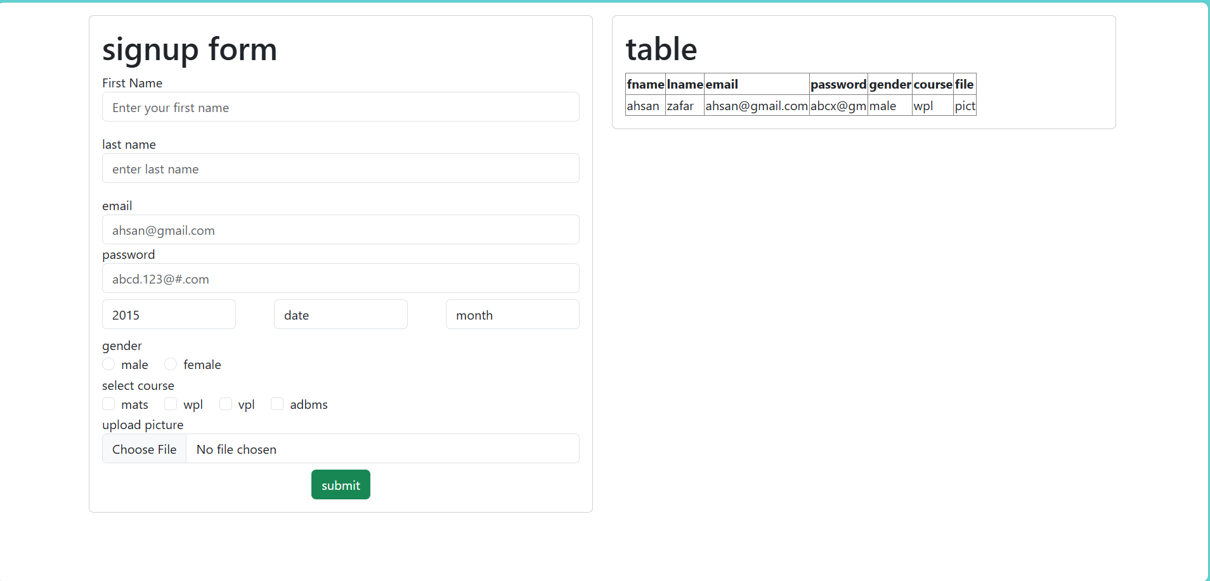

**THEORY TASK   
3 SIGNUP CLONE SENDING DATA TO DATABASE**

<!DOCTYPE html>

<html lang="en">

<head>

<meta charset="UTF-8">

<meta name="viewport" content="width=device-width, initial-scale=1.0">

<title>Facebook signup</title>

<link rel="stylesheet" href="bootstrap/css/bootstrap.min.css">

<script src="bootstrap/js/bootstrap.bundle.min.js"></script>

</head>

<body class="bg-light">

<div class="container pt-5 pb-5 w-25">

<div class="row justify-content-center">

<h1 class="text-center text-primary fw-bold " style="font-size: 66px;">facebook</h1>

<div class=" form-control card p-4">

<h2 class="fw-bold fs-4 text-center">Create a new account</h2>

<p class="text-muted small text-center">It's quick and easy.</p>

<hr class="mb-3 mt-3">

<form action="fbformsubmit.php" method="POST" >

<div class=" row g-2 mb-3">

<div class="col-6">

<div class="mb-2 "><label > First name </label></div>

<input type="text" class="form-control" id="first_name" name="first_name" placeholder="First name">

<span id="first_name_error" class="text-danger"></span>

</div>

<div class="col-6">

<div class="mb-2 "><label > last name </label></div>

<input type="text" class="form-control " placeholder="Lastname" id="last_name" name="last_name">

<span id="last_name_error" class="text-danger"></span>

</div>

</div>

<div class=" form-label mb-3">

<label >Date of birth </label>

<div class="row g-2">

<div class="col-4">

<select class="form-select" name="day" id="day">

<option>day</option>

<option>1</option>

<option>2</option>

<option>3</option>

<option>4</option>

<option>5</option>

<option>6</option>

<option>7</option>

<option>8</option>

<option>9</option>

<option>10</option>

<option>11</option>

<option>12</option>

<option>13</option>

<option>14</option>

<option>15</option>

<option>16</option>

<option>17</option>

<option>18</option>

<option>19</option>

<option>20</option>

<option>21</option>

<option>22</option>

<option>23</option>

<option>24</option>

</select>

<span id="days_error" class="text-danger"></span>

</div>

<div class="col-4">

<select class="form-select " name="month" id="month">

<option>month</option>

<option>Jan</option>

<option>Feb</option>

<option>Mar</option>

<option>Apr</option>

<option>May</option>

<option>Jun</option>

<option>Jul</option>

<option>Aug</option>

<option>Sep</option>

<option>Oct</option>

<option>Nov</option>

<option>Dec</option>

</select>

<span id="months_error" class="text-danger"></span>

</div>

<div class="col-4">

<select class="form-select " name="year" id="year">

<option>year</option>

<option>year </option>

<option>2013</option>

<option>2012</option>

<option>2011</option>

<option>2010</option>

<option>2009</option>

<option>2008</option>

<option>2007</option>

<option>2006</option>

<option>2005</option>

<option>2004</option>

<option>2003</option>

<option>2002</option>

<option>2001</option>

<option>2000</option>

<option>1999</option>

<option>1998</option>

<option>1997</option>

<option>1996</option>

<option>1995</option>

<option>1994</option>

<option>1993</option>

<option>1992</option>

<option>1991</option>

<option>1990</option>

</select>

<span id="years_error" class="text-danger"></span>

</div>

</div>

</div>

<div>

<div><label>Gender</label></div>

<div class="d-flex gap-4 ms-2">

<div><label>male</label></div>

<div class="form-check form-check-inline">

<input class="form-check-input" type="radio" name="gender" id="male" value="male" >

</div>

<div><label>female</label></div>

<div class="form-check form-check-inline">

<input class="form-check-input" type="radio" name="gender" id="female" value ="female">

</div>

<div ><label>custom</label></div>

<div class="form-check form-check-inline">

<input class="form-check-input" type="radio" name="gender" id="custom" value = "custom">

</div>

</div>

<span id="gender_error" class="text-danger"></span>

</div>

<div class="mb-3 mt-2">

<div class="mb-2 "><label > Email </label></div>

<input type="email" class="form-control" id="email" placeholder="email address" name="email">

<span id="email_error" class="text-danger"></span>

</div>

<div class="mb-2 "><label > Contact </label></div>

<div class="mb-3">

<input type="text" class="form-control border" id="contact" name="contact" placeholder="03323098292">

<span id="contact_error" class="text-danger"></span>

</div>

<div class="mb-3">

<div class="mb-2 "><label > Password </label></div>

<input type="password" class="form-control" id="password" name="password" placeholder="password">

<span id="password_error" class="text-danger"></span>

</div>

<p class="small text-muted mb-2 mt-3">

By clicking Sign Up, you agree to our Privacy Policy Cookies Policy You may receive SMS notifications from us and can opt out at any time.

</p>

<div class="mb-3 mt-4"><center> <button type="submit" onclick="formsub(event)" class="form-control w-25 text-bg-success text-center">Signup</button>

</center></div>

<div class="text-center">

<a href="https://www.facebook.com/login/?privacy_mutation_token=eyJ0eXBlIjowLCJjcmVhdGlvbl90aW1lIjoxNzYzNTk1MDUwLCJjYWxsc2l0ZV9pZCI6MjY5NTQ4NDUzMDcyMDk1MX0%3D" class="text-decoration-none fw-semibold">Already have an account?</a>

</div>

</form>

</div>

</div>

<script>

function formsub(event) {

document.getElementById('first_name_error').innerHTML = "";

document.getElementById('last_name_error').innerHTML = "";

document.getElementById('email_error').innerHTML = "";

document.getElementById('password_error').innerHTML = "";

document.getElementById('contact_error').innerHTML = "";

document.getElementById('days_error').innerHTML="";

document.getElementById('months_error').innerHTML="";

document.getElementById('years_error').innerHTML="";

document.getElementById('gender_error').innerHTML="";

var firstName = document.getElementById('first_name').value

if (firstName != ''){

var firstNameRegex = /^[a-zA-Z]{1,1000}$/

var testFirstName = firstNameRegex.test(firstName)

if(testFirstName == false){

document.getElementById('first_name_error').innerHTML = "enter valid value please"

event.preventDefault();

}

}

else

{

document.getElementById('first_name_error').innerHTML = "enter first name value please"

event.preventDefault();

}

var lastName = document.getElementById('last_name').value

if (lastName != ''){

var lastNameRegex = /^[a-zA-Z]{1,1000}$/

var testLastName = lastNameRegex.test(lastName)

if(testLastName == false){

document.getElementById('last_name_error').innerHTML = "enter valid value please"

event.preventDefault();

}

}

else

{

document.getElementById('last_name_error').innerHTML = "enter last name value please"

event.preventDefault();

}

var Email = document.getElementById('email').value

if (Email != ''){

var EmailRegex = /^[a-zA-Z0-9_.+-]+@[a-zA-Z0-9-]+\.[a-zA-Z0-9-.]{1,100}$/

var TestEmail = EmailRegex.test(Email)

if(TestEmail == false){

document.getElementById('email_error').innerHTML = "enter valid value please"

event.preventDefault();

}

}

else

{

document.getElementById('email_error').innerHTML = "enter email value please"

event.preventDefault();

}

var Pass = document.getElementById('password').value

if (Pass != ''){

var PassRegex = /^(?=.*[a-z])(?=.*[A-Z])(?=.*\d)(?=.*[#$@!%&*?])[A-Za-z\d#$@!%&*?]{8,16}$/;

var TestPass = PassRegex.test(Pass)

if(TestPass == false){

document.getElementById('password_error').innerHTML = "Minimum eight characters, at least one uppercase letter, one lowercase letter, one number and one special character:"

event.preventDefault();

}

}

else

{

document.getElementById('password_error').innerHTML = "enter password please"

event.preventDefault();

}

var Contact = document.getElementById('contact').value

if (Contact != ''){

var ContactRegex = /^\s*(?:\+?(\d{1,3}))?[-. (]*(\d{3})[-. )]*(\d{3})[-. ]*(\d{5})(?: *x(\d+))?\s*$/

var TestContact = ContactRegex.test(Contact)

if(TestContact == false){

document.getElementById('contact_error').innerHTML = "range is 11 to 12 digit use + - and numeric values"

event.preventDefault();

}

}

else

{

document.getElementById('contact_error').innerHTML = "enter Contact number please"

event.preventDefault();

}

var day = document.getElementById('day').value

if (day == 'day') {

document.getElementById('days_error').innerHTML = "please select day";

event.preventDefault();

}

var month = document.getElementById('month').value

if (month == 'month') {

document.getElementById('months_error').innerHTML = "please select month";

event.preventDefault();

}

var year = document.getElementById('year').value

if (year == 'year') {

document.getElementById('years_error').innerHTML = "please select year";

event.preventDefault();

}

var gender1 = document.getElementById('male');

var gender2 = document.getElementById('female');

var gender3 = document.getElementById('custom');

if (gender1.checked == true) {

}

else if (gender2.checked == true) {

}

else if (gender3.checked == true) {

}

else {

document.getElementById('gender_error').innerHTML = "please select a gender";

event.preventDefault();

}

}

</script>

</body>

</html>

<?php

$first_name = $_POST["first_name"];

$last_name = $_POST["last_name"];

$email = $_POST['email'];

$password = $_POST['password'];

$contact = $_POST['contact'];

$day = $_POST['day'];

$month = $_POST['month'];

$year = $_POST['year'];

$gender = $_POST['gender'];

$Dob = $day.'-'. $month.'-'. $year;

$connection = mysqli_connect('localhost', 'root','', 'abcd' );

$query = "INSERT INTO user2(first_name,last_name,email,password,contact,dateofbirth,gender) values('$first_name','$last_name','$email', '$password','$contact','$Dob','$gender')";

mysqli_query($connection,$query);

<!DOCTYPE html>

<html lang="en">

<head>

<meta charset="UTF-8">

<meta name="viewport" content="width=device-width, initial-scale=1.0">

<title>snapchat signup</title>

<link rel="stylesheet" href="bootstrap/css/bootstrap.min.css">

<script src="bootstrap/js/bootstrap.bundle.min.js"></script>

</head>

<body class="bg-light">

<div class="container pt-5 pb-5 w-75">

<div class="row justify-content-center">

<div class="col-md-6">

<div class="form-control card p-4">

<div class="text-start d-flex align-items-center ">

<a href="https://snapchat.com">

<img src="images/scp.png" alt="sc logo" width="80px">

</a>

<h2 class="fw-bold ms-2" style="font-size: 36px;">Sign up</h2>

</div>

<hr >

<center><a href="https://google.com"

class="btn w-75 p-3 bg-light ">

Login with

<img src="images/g.png" alt="google logo" style="height:20px; margin-left:5px; border-radius:20px;">

</a></center>

<p class="text-center mt-1 mb-1">Or</p>

<hr class="mt-0">

<form action="snapchatsub.php" method="POST" >

<div class=" row g-2 mb-3">

<div class="col-6">

<div class="mb-2 "><label > First name </label></div>

<input type="text" class="form-control" id="first_name" name="first_name" placeholder="First name">

<span id="first_name_error" class="text-danger"></span>

</div>

<div class="col-6">

<div class="mb-2 "><label > last name </label></div>

<input type="text" class="form-control " placeholder="Lastname" id="last_name" name="last_name">

<span id="last_name_error" class="text-danger"></span>

</div>

</div>

<div class=" form-label mb-3">

<label >Date of birth </label>

<div class="row g-2">

<div class="col-4">

<select class="form-select" name="day" id="day">

<option>day</option>

<option>1</option>

<option>2</option>

<option>3</option>

<option>4</option>

<option>5</option>

<option>6</option>

<option>7</option>

<option>8</option>

<option>9</option>

<option>10</option>

<option>11</option>

<option>12</option>

<option>13</option>

<option>14</option>

<option>15</option>

<option>16</option>

<option>17</option>

<option>18</option>

<option>19</option>

<option>20</option>

<option>21</option>

<option>22</option>

<option>23</option>

<option>24</option>

</select>

<span id="days_error" class="text-danger"></span>

</div>

<div class="col-4">

<select class="form-select " name="month" id="month">

<option>month</option>

<option>Jan</option>

<option>Feb</option>

<option>Mar</option>

<option>Apr</option>

<option>May</option>

<option>Jun</option>

<option>Jul</option>

<option>Aug</option>

<option>Sep</option>

<option>Oct</option>

<option>Nov</option>

<option>Dec</option>

</select>

<span id="months_error" class="text-danger"></span>

</div>

<div class="col-4">

<select class="form-select " name="year" id="year">

<option>year</option>

<option>2013</option>

<option>2012</option>

<option>2011</option>

<option>2010</option>

<option>2009</option>

<option>2008</option>

<option>2007</option>

<option>2006</option>

<option>2005</option>

<option>2004</option>

<option>2003</option>

<option>2002</option>

<option>2001</option>

<option>2000</option>

<option>1999</option>

<option>1998</option>

<option>1997</option>

<option>1996</option>

<option>1995</option>

<option>1994</option>

<option>1993</option>

<option>1992</option>

<option>1991</option>

<option>1990</option>

</select>

<span id="years_error" class="text-danger"></span>

</div>

</div>

</div>

<div>

<div class="mb-3 mt-2">

<div class="mb-2 "><label > Email </label></div>

<input type="email" class="form-control" id="email" placeholder="email address" name="email">

<span id="email_error" class="text-danger"></span>

</div>

<div class="mb-3">

<div class="mb-2 "><label > Password </label></div>

<input type="password" class="form-control" id="password" name="password" placeholder="password">

<span id="password_error" class="text-danger"></span>

</div>

<p class="small text-muted mb-2 mt-3" style="font-size: small;">

By tapping "Agree and Continue" below, you agree to the Terms of Service and acknowledge that you have read the Privacy Policy.

</p>

<div class="mb-3 mt-4"><center> <button type="submit" onclick="snapsub(event)" class="form-control w-50 text-bg-secondary text-center rounded-5 p-2">Sign Up</button>

</center></div>

<hr>

<div class="text-center" style="font-size: small;">

<p>Already have an account</p>

<a href="https://accounts.snapchat.com/v2/login" class="text-decoration-none fw-semibold">login</a>

</div>

</form>

</div>

</div>

</div>

</div>

<script>

function snapsub(event) {

document.getElementById('first_name_error').innerHTML = "";

document.getElementById('last_name_error').innerHTML = "";

document.getElementById('email_error').innerHTML = "";

document.getElementById('password_error').innerHTML = "";

var firstName = document.getElementById('first_name').value

if (firstName != ''){

var firstNameRegex = /^[a-zA-Z]{1,1000}$/

var testFirstName = firstNameRegex.test(firstName)

if(testFirstName == false){

document.getElementById('first_name_error').innerHTML = "enter valid value please"

event.preventDefault();

}

}

else

{

document.getElementById('first_name_error').innerHTML = "enter first name value please"

event.preventDefault();

}

var lastName = document.getElementById('last_name').value

if (lastName != ''){

var lastNameRegex = /^[a-zA-Z]{1,1000}$/

var testLastName = lastNameRegex.test(lastName)

if(testLastName == false){

document.getElementById('last_name_error').innerHTML = "enter valid value please"

event.preventDefault();

}

}

else

{

document.getElementById('last_name_error').innerHTML = "enter last name value please"

event.preventDefault();

}

var Email = document.getElementById('email').value

if (Email != ''){

var EmailRegex = /^[a-zA-Z0-9_.+-]+@[a-zA-Z0-9-]+\.[a-zA-Z0-9-.]{1,100}$/

var TestEmail = EmailRegex.test(Email)

if(TestEmail == false){

document.getElementById('email_error').innerHTML = "enter valid value please"

event.preventDefault();

}

}

else

{

document.getElementById('email_error').innerHTML = "enter email please"

event.preventDefault();

}

var Pass = document.getElementById('password').value

if (Pass != ''){

var PassRegex = /^(?=.*[a-z])(?=.*[A-Z])(?=.*\d)(?=.*[#$@!%&*?])[A-Za-z\d#$@!%&*?]{8,16}$/;

var TestPass = PassRegex.test(Pass)

if(TestPass == false){

document.getElementById('password_error').innerHTML = "Minimum eight characters, at least one uppercase letter, one lowercase letter, one number and one special character:"

event.preventDefault();

}

}

else

{

document.getElementById('password_error').innerHTML = "enter password please"

event.preventDefault();

}

var day = document.getElementById('day').value

if (day == 'day') {

document.getElementById('days_error').innerHTML = "please select day";

event.preventDefault();

}

var month = document.getElementById('month').value

if (month == 'month') {

document.getElementById('months_error').innerHTML = "please select month";

event.preventDefault();

}

var year = document.getElementById('year').value

if (year == 'year') {

document.getElementById('years_error').innerHTML = "please select year";

event.preventDefault();

}

}

</script>

</body>

</html>

<?php

$first_name = $_POST["first_name"];

$last_name = $_POST["last_name"];

$email = $_POST['email'];

$password = $_POST['password'];

$day = $_POST['day'];

$month = $_POST['month'];

$year = $_POST['year'];

$Dob = $day.'-'. $month.'-'. $year;

$connection = mysqli_connect('localhost', 'root','', 'abcd' );

$query = "INSERT INTO scusers(first_name,last_name,email,password,dateofbirth) values('$first_name','$last_name','$email', '$password','$Dob')";

mysqli_query($connection,$query);

<!DOCTYPE html>

<html lang="en">

<head>

<meta charset="UTF-8">

<meta name="viewport" content="width=device-width, initial-scale=1.0">

<title>Facebook Signup</title>

<link rel="stylesheet" href="bootstrap/css/bootstrap.min.css">

<script src="bootstrap/js/bootstrap.bundle.min.js"></script>

</head>

<body class="bg-dark">

<div class="container pt-5 pb-5" style="max-width: 600px;">

<div class="card bg-black p-4 mx-auto">

<div class="text-center mb-3">

<a href="https://x.com"><img src="images/xtw.jpg" alt="twitter logo" width="100"></a>

</div>

<h2 class="fw-bold fs-4 text-white mb-4 text-start ms-5">Create a new account</h2>

<form action="tformsub.php" method="POST">

<div class="mb-3 px-5">

<label class="form-label text-white">Name</label>

<input type="text" class="form-control" id="name" name="name" placeholder="Name">

<span id="first_name_error" class="text-danger"></span>

</div>

<div class="mb-3 px-5">

<label class="form-label text-white">Email</label>

<input type="email" class="form-control" id="email" name="email" placeholder="Email address">

<span id="email_error" class="text-danger"></span>

</div>

<div class=" form-label mb-3 px-5 py-2">

<label class="text-white mb-2">Date of birth </label>

<p class="small text-white-50">This will not be shown publicly. Confirm your own age, even if this account is for a business, a pet, or something else.

</p>

<div class="row g-2">

<div class="col-4">

<select class="form-select" name="day" id="day">

<option>day</option>

<option>1</option>

<option>2</option>

<option>3</option>

<option>4</option>

<option>5</option>

<option>6</option>

<option>7</option>

<option>8</option>

<option>9</option>

<option>10</option>

<option>11</option>

<option>12</option>

<option>13</option>

<option>14</option>

<option>15</option>

<option>16</option>

<option>17</option>

<option>18</option>

<option>19</option>

<option>20</option>

<option>21</option>

<option>22</option>

<option>23</option>

<option>24</option>

</select>

<span id="days_error" class="text-danger"></span>

</div>

<div class="col-4">

<select class="form-select " name="month" id="month">

<option>month</option>

<option>Jan</option>

<option>Feb</option>

<option>Mar</option>

<option>Apr</option>

<option>May</option>

<option>Jun</option>

<option>Jul</option>

<option>Aug</option>

<option>Sep</option>

<option>Oct</option>

<option>Nov</option>

<option>Dec</option>

</select>

<span id="months_error" class="text-danger"></span>

</div>

<div class="col-4">

<select class="form-select " name="year" id="year">

<option>year</option>

<option>year </option>

<option>2013</option>

<option>2012</option>

<option>2011</option>

<option>2010</option>

<option>2009</option>

<option>2008</option>

<option>2007</option>

<option>2006</option>

<option>2005</option>

<option>2004</option>

<option>2003</option>

<option>2002</option>

<option>2001</option>

<option>2000</option>

<option>1999</option>

<option>1998</option>

<option>1997</option>

<option>1996</option>

<option>1995</option>

<option>1994</option>

<option>1993</option>

<option>1992</option>

<option>1991</option>

<option>1990</option>

</select>

<span id="years_error" class="text-danger"></span>

</div>

</div>

</div>

<div>

<div class="mb-3 text-center">

<button type="submit" onclick="tsub(event)" class="btn btn-dark w-25">Sign up</button>

</div>

<div class="text-center">

<a href="https://x.com/" class="text-decoration-none text-white">

Already have an account?

</a>

<hr class="bg-white p2">

<p class="mb-3 text-center text-white-50"> OR</p>

<div class="mb-3 text-center">

<center><a href="https://google.com"

class="btn btn-dark w-50 p-3 rounded-5 d-flex justify-content-center ">

Login with

<img src="images/g.png" alt="google logo" style="height:20px; margin-left:5px; border-radius:20px;">

</a></center>

</div>

</div>

</form>

</div>

</div>

<script>

function tsub(event) {

document.getElementById('first_name_error').innerHTML = "";

document.getElementById('email_error').innerHTML = "";

var firstName = document.getElementById('name').value

if (firstName != ''){

var firstNameRegex = /^[a-zA-Z ]{1,1000}$/

var testFirstName = firstNameRegex.test(firstName)

if(testFirstName == false){

document.getElementById('first_name_error').innerHTML = "enter valid value please"

event.preventDefault();

}

}

else

{

document.getElementById('first_name_error').innerHTML = "enter name value please"

event.preventDefault();

}

var Email = document.getElementById('email').value

if (Email != ''){

var EmailRegex = /^[a-zA-Z0-9_.+-]+@[a-zA-Z0-9-]+\.[a-zA-Z0-9-.]{1,100}$/

var TestEmail = EmailRegex.test(Email)

if(TestEmail == false){

document.getElementById('email_error').innerHTML = "enter valid value please"

event.preventDefault();

}

}

else

{

document.getElementById('email_error').innerHTML = "enter email value please"

event.preventDefault();

}

var day = document.getElementById('day').value

if (day == 'day') {

document.getElementById('days_error').innerHTML = "please select day";

event.preventDefault();

}

var month = document.getElementById('month').value

if (month == 'month') {

document.getElementById('months_error').innerHTML = "please select month";

event.preventDefault();

}

var year = document.getElementById('year').value

if (year == 'year') {

document.getElementById('years_error').innerHTML = "please select year";

event.preventDefault();

}

}

</script>

</body>

</html>

<?php

$name = $_POST["name"];

$email = $_POST['email'];

$day = $_POST['day'];

$month = $_POST['month'];

$year = $_POST['year'];

$Dob = $day.'-'. $month.'-'. $year;

$connection = mysqli_connect('localhost', 'root','', 'abcd' );

$query = "INSERT INTO twitterx(name,email,dateofbirth) values('$name','$email','$Dob')";

mysqli_query($connection,$query);

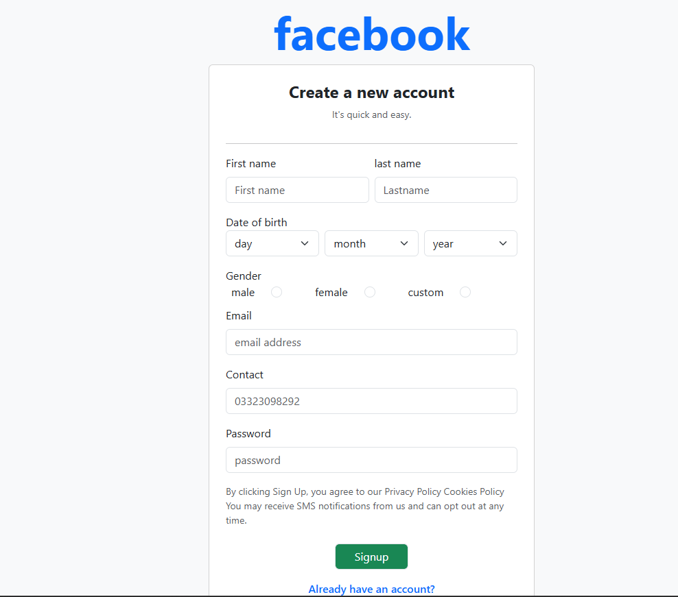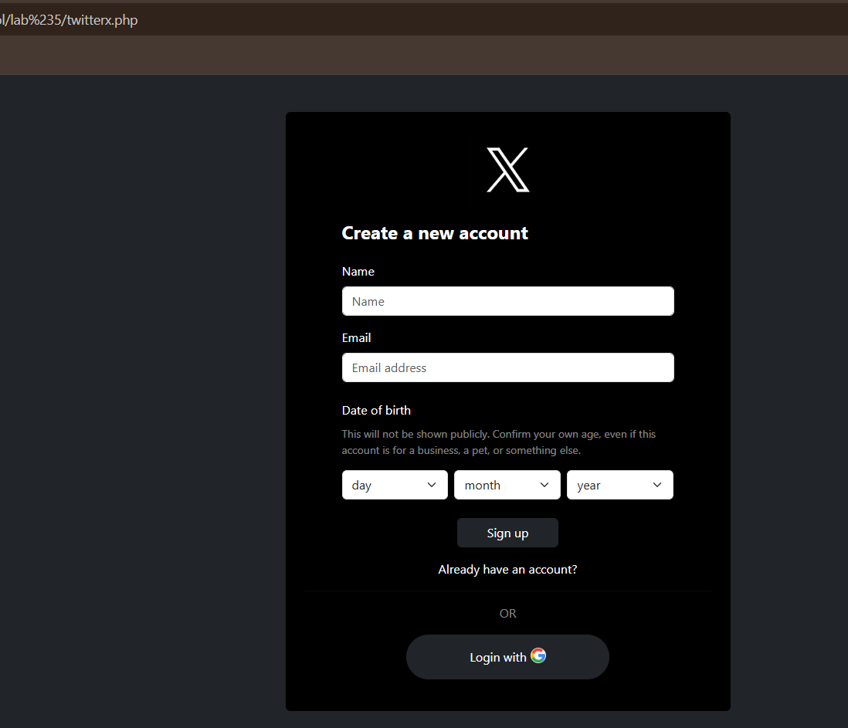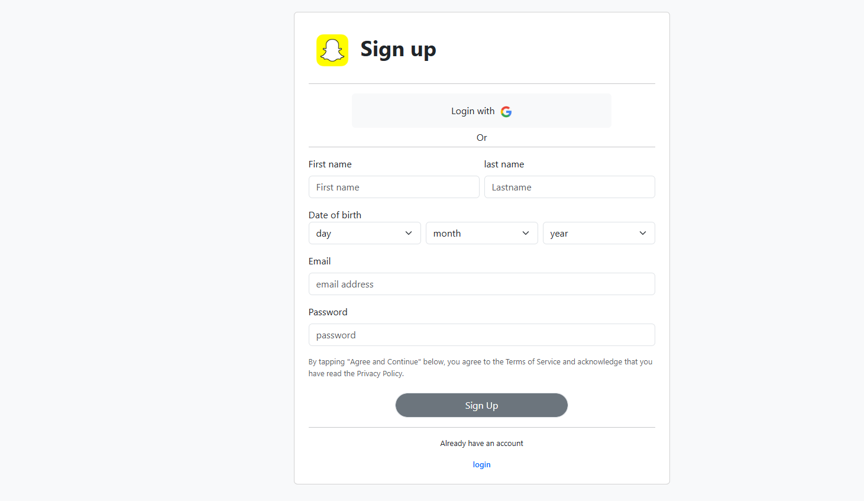

Lab # 7 CRUD  
DELETE AND EDIT

EDIT FORM  
 <?php

$id = $_GET["product_id"];

$connection= mysqli_connect('localhost','root','','products');

$query= "select * from product where product_id=$id";

$result = mysqli_query($connection,$query);

$data = mysqli_fetch_all($result,MYSQLI_ASSOC);

?>

<!DOCTYPE html>

<html lang="en">

<head>

<meta charset="UTF-8">

<meta name="viewport" content="width=device-width, initial-scale=1.0">

<title>Document</title>

<link rel="stylesheet" href="bootstrap/css/bootstrap.min.css">

<script src="bootstrap/js/bootstrap.bundle.min.js"></script>

</head>

<body>

<div class="container ">

<div class="row">

<div class="col-6">

<div class="card d-flex justify-content-start">

<div class="card-body">

<h1>product form</h1>

<form action="editformsubmit.php" method="post">

<div class="form-group">

<label>product id</label>

<input type="hidden" value="<?php echo $data[0]['product_id']?>" name="product_id" id="product_id" class="form-control" >

</div>

<div class="form-group">

<label>product name</label>

<input type="text" value="<?php echo $data[0]['product_name']?>" name="product_name" id="product_name" class="form-control" >

</div>

<div class="form-group">

<label>product category</label>

<input type="text" value="<?php echo $data[0]['product_category']?>" name="product_category" id="product_category" class="form-control" >

</div>

<div class="form-group">

<label>product quantity</label>

<input type="number" value="<?php echo $data[0]['product_quantity']?>" name="product_quantity" id="product_quantity" class="form-control" >

</div>

<div class="form-group">

<label>product price</label>

<input type="text" value="<?php echo $data[0]['product_price']?>" name="product_price" id="product_price" class="form-control" >

</div>

<div class="d-flex justify-content-center">

<input type="submit" class="btn btn-primary " value="submit">

</div>

</form>

</div>

</div>

</div>

</div>

</div>

</body>

</html>

EDIT FORM SUBMIT  
  
  
<?php

$id = $_POST['product_id'];

$product_name =$_POST['product_name'];

$product_category = $_POST['product_category'];

$product_quantity = $_POST['product_quantity'];

$product_price = $_POST['product_price'];

$connection=mysqli_connect('localhost','root','','products');

$query= "update product set

product_name = '$product_name',

product_category = '$product_category',

product_quantity ='$product_quantity',

product_price= '$product_price'

where product_id = '$id'

";

mysqli_query($connection,$query);

header('Location: '.'tableshow.php');

DELETE   
  
<?php

$id = $_GET['product_id'];

$connection = mysqli_connect('localhost', 'root', '', 'products');

$query = "delete from product where product_id = '$id' ";

$result = mysqli_query($connection, $query);

header('Location: '.'tableshow.php');

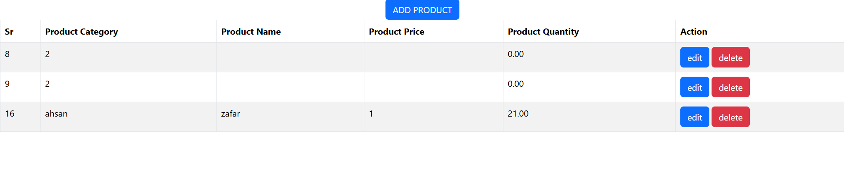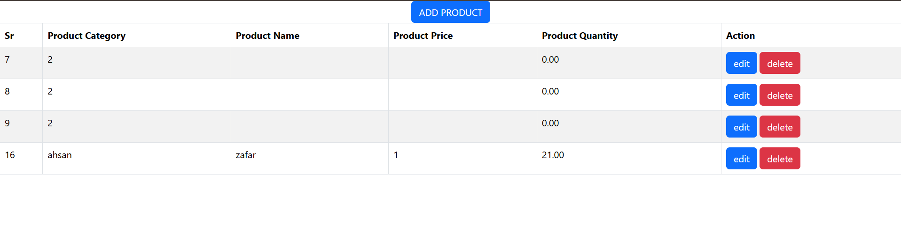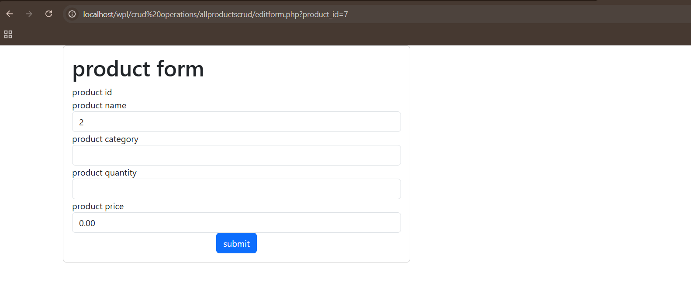

lab#8   
MASTER TEMPLATING

<?php include 'userheader.php'; ?>

<div id="promobanner" class="carousel slide" data-bs-ride="carousel" style="margin-top: 70px;">

<div class="carousel-inner w-100">

<div class="carousel-item active">

<img src="images/60bd647d-0f8f-49f6-b53c-90370462d209.jpg" class="w-100" alt="sale"

style="height: 620px; ">

</div>

<div class="carousel-item">

<img src="images/1.jpg" class="w-100" alt="xbox" style="height: 620px; ">

</div>

<div class="carousel-item">

<img src="images/cb44e938bef3d877aa115fdba8968b18.jpg" class="w-100" alt="ps5" style="height: 620px;">

</div>

</div>

<button class="carousel-control-prev" type="button" data-bs-target="#promobanner" data-bs-slide="prev">

<span class="carousel-control-prev-icon"></span>

</button>

<button class="carousel-control-next" type="button" data-bs-target="#promobanner" data-bs-slide="next">

<span class="carousel-control-next-icon"></span>

</button>

</div>

<div class="container my-5">

<div class="d-flex justify-content-between align-items-center mb-4">

<h2 class="fw-bold mb-0 border-bottom border-danger border-3 pb-2">NEW ARRIVAL</h2>

<a href="#" class="btn border-black">View All</a>

</div>

<div id="newarrival" class="carousel slide" data-bs-ride="carousel">

<div class="carousel-inner">

<div class="carousel-item active">

<div class="row g-4">

<div class="col-lg-3 col-md-4">

<div class="card border shadow-sm h-100">

<a class="text-decoration-none text-dark" href="">

<img src="images/images (2).jpg" class="card-img-top" alt="Product" style="height: 300px; ">

<div class="card-body d-flex flex-column ">

<div class="card-title" style="min-height: 48px;">Red Dead Redemption 2 PS4</div>

</a>

<p class="text-danger fw-bold mb-3">$56.00</p>

<button class="btn btn-danger w-100 mt-auto" type="submit" >

<i class="fa-solid fa-cart-arrow-down"></i> Add to Cart

</button>

</div>

</div>

</div>

<div class="col-lg-3 col-md-4 ">

<div class="card border shadow-sm h-100">

<a class="text-decoration-none text-dark" href="">

<img src="images/images (3).jpg" class="card-img-top" alt="Product" style="height: 300px; ">

<div class="card-body d-flex flex-column">

<div class="card-title" style="min-height: 48px;">Forza Horizon 5</div> </a>

<p class="text-danger fw-bold mb-3">$49.00</p>

<button class="btn btn-danger w-100 mt-auto">

<i class="fa-solid fa-cart-arrow-down"></i> Add to Cart

</button>

</div>

</div>

</div>

<div class="col-lg-3 col-md-4">

<div class="card border shadow-sm h-100">

<a class="text-decoration-none text-dark" href="">

<img src="images/mario kart.jpg" class="card-img-top" alt="Product" style="height: 300px; ">

<div class="card-body d-flex flex-column">

<div class="card-title" style="min-height: 48px;">Mario Kart World SWITCH 2</div> </a>

<p class="text-danger fw-bold mb-3">$61.00</p>

<button class="btn btn-danger w-100 mt-auto">

<i class="fa-solid fa-cart-arrow-down"></i> Add to Cart

</button>

</div>

</div>

</div>

<div class="col-lg-3 col-md-4">

<div class="card border shadow-sm h-100">

<a class="text-decoration-none text-dark" href="">

<img src="images/pokemon legends z-a .jpg" class="card-img-top" alt="Product" style="height: 300px; ">

<div class="card-body d-flex flex-column">

<div class="card-title" style="min-height: 48px;">POKEMON LEGENDS Z-A Switch 2</div> </a>

<p class="text-danger fw-bold mb-3">$25.00</p>

<button class="btn btn-danger w-100 mt-auto">

<i class="fa-solid fa-cart-arrow-down"></i> Add to Cart

</button>

</div>

</div>

</div>

</div>

</div>

<div class="carousel-item">

<div class="row g-4">

<div class="col-lg-3 col-md-4 ">

<div class="card border shadow-sm h-100">

<a class="text-decoration-none text-dark" href="">

<img src="images/elden ring shadow of erd tree.jpg" class="card-img-top" alt="Product" style="height: 300px; ">

<div class="card-body d-flex flex-column">

<div class="card-title" style="min-height: 48px;">Elden Ring Shadow of the Erdtree PS5</div> </a>

<p class="text-danger fw-bold mb-3">$45.00</p>

<button class="btn btn-danger w-100 mt-auto">

<i class="fa-solid fa-cart-arrow-down"></i> Add to Cart

</button>

</div>

</div>

</div>

<div class="col-lg-3 col-md-4 ">

<div class="card border shadow-sm h-100">

<a class="text-decoration-none text-dark" href="">

<img src="images/resident evil 4.jpg" class="card-img-top" alt="Product" style="height: 300px; ">

<div class="card-body d-flex flex-column">

<div class="card-title" style="min-height: 48px;">Resident Evil 4 Remake PS5</div> </a>

<p class="text-danger fw-bold mb-3">$43.00</p>

<button class="btn btn-danger w-100 mt-auto">

<i class="fa-solid fa-cart-arrow-down"></i>Add to Cart

</button>

</div>

</div>

</div>

<div class="col-lg-3 col-md-4">

<div class="card border shadow-sm h-100">

<a class="text-decoration-none text-dark" href="">

<img src="images/Animal_Crossing_New_Horizons.jpg"

class="card-img-top" alt="Product" style="height: 300px; ">

<div class="card-body d-flex flex-column">

<div class="card-title" style="min-height: 48px;">Animal Crossing: New Horizons Switch</div> </a>

<p class="text-danger fw-bold mb-3">$36.00</p>

<button class="btn btn-danger w-100 mt-auto">

<i class="fa-solid fa-cart-arrow-down"></i> Add to Cart

</button>

</div>

</div>

</div>

<div class="col-lg-3 col-md-4 ">

<div class="card border shadow-sm h-100">

<a class="text-decoration-none text-dark" href="">

<img src="images/spiderman 2.jpg" class="card-img-top" alt="Product" style="height: 300px; ">

<div class="card-body d-flex flex-column">

<div class="card-title" style="min-height: 48px;">Marvel's Spider-Man 2 PS5</div> </a>

<p class="text-danger fw-bold mb-3">$70.00</p>

<button class="btn btn-danger w-100 mt-auto">

<i class="fa-solid fa-cart-arrow-down"></i> Add to Cart

</button>

</div>

</div>

</div>

</div>

</div>

</div>

<button class="carousel-control-prev" type="button" data-bs-target="#newarrival" data-bs-slide="prev"

style="width: 0px;">

<span class="carousel-control-prev-icon bg-dark rounded-circle p-3" ></span>

</button>

<button class="carousel-control-next " type="button" data-bs-target="#newarrival" data-bs-slide="next"

style="width: 0px ;">

<span class="carousel-control-next-icon bg-dark rounded-circle p-3" ></span>

</button>

</div>

</div>

<div class="container my-5">

<div class="d-flex justify-content-between align-items-center mb-4">

<h2 class="fw-bold mb-0 border-bottom border-danger border-3 pb-2">PS5 GAMES</h2>

<a href="#" class="btn border-black">View All</a>

</div>

<div id="ps5games" class="carousel slide" data-bs-ride="false">

<div class="carousel-inner">

<div class="carousel-item active">

<div class="row g-4">

<div class="col-lg-3 col-md-4">

<div class="card border shadow-sm h-100">

<a class="text-decoration-none text-dark" href="">

<img src="images/god of war ragnarok.jpg" class="card-img-top" alt="Product" style="height: 300px; ">

<div class="card-body d-flex flex-column ">

<div class="card-title" style="min-height: 48px;">God of War Ragnarok PS5</div>

</a>

<p class="text-danger fw-bold mb-3">$69.00</p>

<button class="btn btn-danger w-100 mt-auto" type="submit" >

<i class="fa-solid fa-cart-arrow-down"></i> Add to Cart

</button>

</div>

</div>

</div>

<div class="col-lg-3 col-md-4 ">

<div class="card border shadow-sm h-100">

<a class="text-decoration-none text-dark" href="">

<img src="images/horizon forbidden west.jpg" class="card-img-top" alt="Product" style="height: 300px; ">

<div class="card-body d-flex flex-column">

<div class="card-title" style="min-height: 48px;">Horizon Forbidden West PS5</div> </a>

<p class="text-danger fw-bold mb-3">$59.00</p>

<button class="btn btn-danger w-100 mt-auto">

<i class="fa-solid fa-cart-arrow-down"></i> Add to Cart

</button>

</div>

</div>

</div>

<div class="col-lg-3 col-md-4">

<div class="card border shadow-sm h-100">

<a class="text-decoration-none text-dark" href="">

<img src="images/ratchet and clank rift apart.jpg" class="card-img-top" alt="Product" style="height: 300px; ">

<div class="card-body d-flex flex-column">

<div class="card-title" style="min-height: 48px;">Ratchet & Clank: Rift Apart PS5</div> </a>

<p class="text-danger fw-bold mb-3">$54.00</p>

<button class="btn btn-danger w-100 mt-auto">

<i class="fa-solid fa-cart-arrow-down"></i> Add to Cart

</button>

</div>

</div>

</div>

<div class="col-lg-3 col-md-4">

<div class="card border shadow-sm h-100">

<a class="text-decoration-none text-dark" href="">

<img src="images/demon souls.jpg" class="card-img-top" alt="Product" style="height: 300px; ">

<div class="card-body d-flex flex-column">

<div class="card-title" style="min-height: 48px;">Demon's Souls Remake PS5</div> </a>

<p class="text-danger fw-bold mb-3">$64.00</p>

<button class="btn btn-danger w-100 mt-auto">

<i class="fa-solid fa-cart-arrow-down"></i> Add to Cart

</button>

</div>

</div>

</div>

</div>

</div>

<div class="carousel-item">

<div class="row g-4">

<div class="col-lg-3 col-md-4 ">

<div class="card border shadow-sm h-100">

<a class="text-decoration-none text-dark" href="">

<img src="images/returnal ps5.jpg" class="card-img-top" alt="Product" style="height: 300px; ">

<div class="card-body d-flex flex-column">

<div class="card-title" style="min-height: 48px;">Returnal PS5</div> </a>

<p class="text-danger fw-bold mb-3">$49.00</p>

<button class="btn btn-danger w-100 mt-auto">

<i class="fa-solid fa-cart-arrow-down"></i> Add to Cart

</button>

</div>

</div>

</div>

<div class="col-lg-3 col-md-4 ">

<div class="card border shadow-sm h-100">

<a class="text-decoration-none text-dark" href="">

<img src="images/ghost of tshushma.jpg" class="card-img-top" alt="Product" style="height: 300px; ">

<div class="card-body d-flex flex-column">

<div class="card-title" style="min-height: 48px;">Ghost of Tsushima Director's Cut PS5</div> </a>

<p class="text-danger fw-bold mb-3">$59.00</p>

<button class="btn btn-danger w-100 mt-auto">

<i class="fa-solid fa-cart-arrow-down"></i>Add to Cart

</button>

</div>

</div>

</div>

<div class="col-lg-3 col-md-4">

<div class="card border shadow-sm h-100">

<a class="text-decoration-none text-dark" href="">

<img src="images/final fantasy xvi .jpg"

class="card-img-top" alt="Product" style="height: 300px; ">

<div class="card-body d-flex flex-column">

<div class="card-title" style="min-height: 48px;">Final Fantasy XVI PS5</div> </a>

<p class="text-danger fw-bold mb-3">$69.00</p>

<button class="btn btn-danger w-100 mt-auto">

<i class="fa-solid fa-cart-arrow-down"></i> Add to Cart

</button>

</div>

</div>

</div>

<div class="col-lg-3 col-md-4 ">

<div class="card border shadow-sm h-100">

<a class="text-decoration-none text-dark" href="">

<img src="images/grand tursimo 7.jpg" class="card-img-top" alt="Product" style="height: 300px; ">

<div class="card-body d-flex flex-column">

<div class="card-title" style="min-height: 48px;">Gran Turismo 7 PS5</div> </a>

<p class="text-danger fw-bold mb-3">$59.00</p>

<button class="btn btn-danger w-100 mt-auto">

<i class="fa-solid fa-cart-arrow-down"></i> Add to Cart

</button>

</div>

</div>

</div>

</div>

</div>

</div>

<button class="carousel-control-prev" type="button" data-bs-target="#ps5games" data-bs-slide="prev"

style="width: 0px;">

<span class="carousel-control-prev-icon bg-dark rounded-circle p-3" ></span>

</button>

<button class="carousel-control-next " type="button" data-bs-target="#ps5games" data-bs-slide="next"

style="width: 0px ;">

<span class="carousel-control-next-icon bg-dark rounded-circle p-3" ></span>

</button>

</div>

</div>

<div class="container my-5">

<div class="d-flex justify-content-between align-items-center mb-4">

<h2 class="fw-bold mb-0 border-bottom border-danger border-3 pb-2">PS4 GAMES</h2>

<a href="#" class="btn border-black">View All</a>

</div>

<div id="ps4games" class="carousel slide" data-bs-ride="false">

<div class="carousel-inner">

<div class="carousel-item active">

<div class="row g-4">

<div class="col-lg-3 col-md-4">

<div class="card border shadow-sm h-100">

<a href="" class="text-decoration-none text-dark">

<img src="images/god of war 2018_.jpg" class="card-img-top" style="height: 300px;" alt="Product">

<div class="card-body d-flex flex-column">

<div class="card-title" style="min-height: 48px;">God of War PS4</div>

</a>

<p class="text-danger fw-bold mb-3">$29.00</p>

<button class="btn btn-danger w-100 mt-auto">

<i class="fa-solid fa-cart-arrow-down"></i> Add to Cart

</button>

</div>

</div>

</div>

<div class="col-lg-3 col-md-4">

<div class="card border shadow-sm h-100">

<a href="" class="text-decoration-none text-dark">

<img src="images/spiderman_.jpg" class="card-img-top" style="height: 300px;" alt="Product">

<div class="card-body d-flex flex-column">

<div class="card-title" style="min-height: 48px;">Marvelâ€™s Spider-Man PS4</div>

</a>

<p class="text-danger fw-bold mb-3">$39.00</p>

<button class="btn btn-danger w-100 mt-auto">

<i class="fa-solid fa-cart-arrow-down"></i> Add to Cart

</button>

</div>

</div>

</div>

<div class="col-lg-3 col-md-4">

<div class="card border shadow-sm h-100">

<a href="" class="text-decoration-none text-dark">

<img src="images/last of us part 2.jpg" class="card-img-top" style="height: 300px;" alt="Product">

<div class="card-body d-flex flex-column">

<div class="card-title" style="min-height: 48px;">The Last of Us Part II PS4</div>

</a>

<p class="text-danger fw-bold mb-3">$34.00</p>

<button class="btn btn-danger w-100 mt-auto">

<i class="fa-solid fa-cart-arrow-down"></i> Add to Cart

</button>

</div>

</div>

</div>

<div class="col-lg-3 col-md-4">

<div class="card border shadow-sm h-100">

<a href="" class="text-decoration-none text-dark">

<img src="images/uncharted 4.jpg" class="card-img-top" style="height: 300px;" alt="Product">

<div class="card-body d-flex flex-column">

<div class="card-title" style="min-height: 48px;">Uncharted 4: A Thiefâ€™s End PS4</div>

</a>

<p class="text-danger fw-bold mb-3">$19.00</p>

<button class="btn btn-danger w-100 mt-auto">

<i class="fa-solid fa-cart-arrow-down"></i> Add to Cart

</button>

</div>

</div>

</div>

</div>

</div>

<div class="carousel-item">

<div class="row g-4">

<div class="col-lg-3 col-md-4">

<div class="card border shadow-sm h-100">

<a href="" class="text-decoration-none text-dark">

<img src="images/ghost of tshushma.jpg" class="card-img-top" style="height: 300px;" alt="Product">

<div class="card-body d-flex flex-column">

<div class="card-title" style="min-height: 48px;">Ghost of Tsushima PS4</div>

</a>

<p class="text-danger fw-bold mb-3">$39.00</p>

<button class="btn btn-danger w-100 mt-auto">

<i class="fa-solid fa-cart-arrow-down"></i> Add to Cart

</button>

</div>

</div>

</div>

<div class="col-lg-3 col-md-4">

<div class="card border shadow-sm h-100">

<a href="" class="text-decoration-none text-dark">

<img src="images/images (2).jpg" class="card-img-top" style="height: 300px;" alt="Product">

<div class="card-body d-flex flex-column">

<div class="card-title" style="min-height: 48px;">Red Dead Redemption 2 PS4</div>

</a>

<p class="text-danger fw-bold mb-3">$29.00</p>

<button class="btn btn-danger w-100 mt-auto">

<i class="fa-solid fa-cart-arrow-down"></i> Add to Cart

</button>

</div>

</div>

</div>

<div class="col-lg-3 col-md-4">

<div class="card border shadow-sm h-100">

<a href="" class="text-decoration-none text-dark">

<img src="images/fifa 23.jpg" class="card-img-top" style="height: 300px;" alt="Product">

<div class="card-body d-flex flex-column">

<div class="card-title" style="min-height: 48px;">FIFA 23 PS4</div>

</a>

<p class="text-danger fw-bold mb-3">$39.00</p>

<button class="btn btn-danger w-100 mt-auto">

<i class="fa-solid fa-cart-arrow-down"></i> Add to Cart

</button>

</div>

</div>

</div>

<div class="col-lg-3 col-md-4">

<div class="card border shadow-sm h-100">

<a href="" class="text-decoration-none text-dark">

<img src="images/wwe 2k22.jpg" class="card-img-top" style="height: 300px;" alt="Product">

<div class="card-body d-flex flex-column">

<div class="card-title" style="min-height: 48px;">WWE 2K22 PS4</div>

</a>

<p class="text-danger fw-bold mb-3">$34.00</p>

<button class="btn btn-danger w-100 mt-auto">

<i class="fa-solid fa-cart-arrow-down"></i> Add to Cart

</button>

</div>

</div>

</div>

</div>

</div>

</div>

<button class="carousel-control-prev" type="button" data-bs-target="#ps4games" data-bs-slide="prev" style="width: 0px;">

<span class="carousel-control-prev-icon bg-dark rounded-circle p-3"></span>

</button>

<button class="carousel-control-next" type="button" data-bs-target="#ps4games" data-bs-slide="next" style="width: 0px;">

<span class="carousel-control-next-icon bg-dark rounded-circle p-3"></span>

</button>

</div>

</div>

<div class="container my-5">

<div class="d-flex justify-content-between align-items-center mb-4">

<h2 class="fw-bold mb-0 border-bottom border-danger border-3 pb-2">XBOX SERIES X</h2>

<a href="#" class="btn border-black">View All</a>

</div>

<div id="xboxseriesx" class="carousel slide" data-bs-ride="false">

<div class="carousel-inner">

<div class="carousel-item active">

<div class="row g-4">

<div class="col-lg-3 col-md-4">

<div class="card border shadow-sm h-100">

<a class="text-decoration-none text-dark" href="">

<img src="images/Halo infinite.jpg" class="card-img-top" alt="Product" style="height: 300px; ">

<div class="card-body d-flex flex-column ">

<div class="card-title" style="min-height: 48px;">Halo Infinite Xbox Series X</div>

</a>

<p class="text-danger fw-bold mb-3">$59.00</p>

<button class="btn btn-danger w-100 mt-auto" type="submit" >

<i class="fa-solid fa-cart-arrow-down"></i> Add to Cart

</button>

</div>

</div>

</div>

<div class="col-lg-3 col-md-4 ">

<div class="card border shadow-sm h-100">

<a class="text-decoration-none text-dark" href="">

<img src="images/FORZA MOTORSPORT.jpg" class="card-img-top" alt="Product" style="height: 300px; ">

<div class="card-body d-flex flex-column">

<div class="card-title" style="min-height: 48px;">Forza Motorsport Xbox Series X</div> </a>

<p class="text-danger fw-bold mb-3">$69.00</p>

<button class="btn btn-danger w-100 mt-auto">

<i class="fa-solid fa-cart-arrow-down"></i> Add to Cart

</button>

</div>

</div>

</div>

<div class="col-lg-3 col-md-4">

<div class="card border shadow-sm h-100">

<a class="text-decoration-none text-dark" href="">

<img src="images/starfield.jpg" class="card-img-top" alt="Product" style="height: 300px; ">

<div class="card-body d-flex flex-column">

<div class="card-title" style="min-height: 48px;">Starfield Xbox Series X</div> </a>

<p class="text-danger fw-bold mb-3">$69.00</p>

<button class="btn btn-danger w-100 mt-auto">

<i class="fa-solid fa-cart-arrow-down"></i> Add to Cart

</button>

</div>

</div>

</div>

<div class="col-lg-3 col-md-4">

<div class="card border shadow-sm h-100">

<a class="text-decoration-none text-dark" href="">

<img src="images/GEARS5.jpg" class="card-img-top" alt="Product" style="height: 300px; ">

<div class="card-body d-flex flex-column">

<div class="card-title" style="min-height: 48px;">Gears 5 Xbox Series X</div> </a>

<p class="text-danger fw-bold mb-3">$39.00</p>

<button class="btn btn-danger w-100 mt-auto">

<i class="fa-solid fa-cart-arrow-down"></i> Add to Cart

</button>

</div>

</div>

</div>

</div>

</div>

<div class="carousel-item">

<div class="row g-4">

<div class="col-lg-3 col-md-4 ">

<div class="card border shadow-sm h-100">

<a class="text-decoration-none text-dark" href="">

<img src="images/MICROFOST FLIGHT SIMULATOR.jpg" class="card-img-top" alt="Product" style="height: 300px; ">

<div class="card-body d-flex flex-column">

<div class="card-title" style="min-height: 48px;">Microsoft Flight Simulator Xbox Series X</div> </a>

<p class="text-danger fw-bold mb-3">$59.00</p>

<button class="btn btn-danger w-100 mt-auto">

<i class="fa-solid fa-cart-arrow-down"></i> Add to Cart

</button>

</div>

</div>

</div>

<div class="col-lg-3 col-md-4 ">

<div class="card border shadow-sm h-100">

<a class="text-decoration-none text-dark" href="">

<img src="images/FABLE.jpg" class="card-img-top" alt="Product" style="height: 300px; ">

<div class="card-body d-flex flex-column">

<div class="card-title" style="min-height: 48px;">Fable Xbox Series X</div> </a>

<p class="text-danger fw-bold mb-3">$69.00</p>

<button class="btn btn-danger w-100 mt-auto">

<i class="fa-solid fa-cart-arrow-down"></i>Add to Cart

</button>

</div>

</div>

</div>

<div class="col-lg-3 col-md-4">

<div class="card border shadow-sm h-100">

<a class="text-decoration-none text-dark" href="">

<img src="images/SEA OF THEIVES.jpg"class="card-img-top" alt="Product" style="height: 300px; ">

<div class="card-body d-flex flex-column">

<div class="card-title" style="min-height: 48px;">Sea of Thieves Xbox Series X</div> </a>

<p class="text-danger fw-bold mb-3">$39.00</p>

<button class="btn btn-danger w-100 mt-auto">

<i class="fa-solid fa-cart-arrow-down"></i> Add to Cart

</button>

</div>

</div>

</div>

<div class="col-lg-3 col-md-4 ">

<div class="card border shadow-sm h-100">

<a class="text-decoration-none text-dark" href="">

<img src="images/PERFECT DARK.jpg" class="card-img-top" alt="Product" style="height: 300px; ">

<div class="card-body d-flex flex-column">

<div class="card-title" style="min-height: 48px;">Perfect Dark Xbox Series X</div> </a>

<p class="text-danger fw-bold mb-3">$69.00</p>

<button class="btn btn-danger w-100 mt-auto">

<i class="fa-solid fa-cart-arrow-down"></i> Add to Cart

</button>

</div>

</div>

</div>

</div>

</div>

</div>

<button class="carousel-control-prev" type="button" data-bs-target="#xboxseriesx" data-bs-slide="prev"

style="width: 0px;">

<span class="carousel-control-prev-icon bg-dark rounded-circle p-3" ></span>

</button>

<button class="carousel-control-next " type="button" data-bs-target="#xboxseriesx" data-bs-slide="next"

style="width: 0px ;">

<span class="carousel-control-next-icon bg-dark rounded-circle p-3" ></span>

</button>

</div>

</div>

<div class="container my-5">

<div class="d-flex justify-content-between align-items-center mb-4">

<h2 class="fw-bold mb-0 border-bottom border-danger border-3 pb-2">NINTENDO SWITCH</h2>

<a href="#" class="btn border-black">View All</a>

</div>

<div id="nintendoswitch" class="carousel slide" data-bs-ride="false">

<div class="carousel-inner">

<div class="carousel-item active">

<div class="row g-4">

<div class="col-lg-3 col-md-4">

<div class="card border shadow-sm h-100">

<a class="text-decoration-none text-dark" href="">

<img src="images/LEGEND OF ZELDA.jpg" class="card-img-top" alt="Product" style="height: 300px; ">

<div class="card-body d-flex flex-column ">

<div class="card-title" style="min-height: 48px;">The Legend of Zelda: Tears of the Kingdom</div>

</a>

<p class="text-danger fw-bold mb-3">$69.00</p>

<button class="btn btn-danger w-100 mt-auto" type="submit" >

<i class="fa-solid fa-cart-arrow-down"></i> Add to Cart

</button>

</div>

</div>

</div>

<div class="col-lg-3 col-md-4 ">

<div class="card border shadow-sm h-100">

<a class="text-decoration-none text-dark" href="">

<img src="images/SUPERMARIO ODYSSEY_.jpg" class="card-img-top" alt="Product" style="height: 300px; ">

<div class="card-body d-flex flex-column">

<div class="card-title" style="min-height: 48px;">Super Mario Odyssey Switch</div> </a>

<p class="text-danger fw-bold mb-3">$59.00</p>

<button class="btn btn-danger w-100 mt-auto">

<i class="fa-solid fa-cart-arrow-down"></i> Add to Cart

</button>

</div>

</div>

</div>

<div class="col-lg-3 col-md-4">

<div class="card border shadow-sm h-100">

<a class="text-decoration-none text-dark" href="">

<img src="images/SPLATOON 3.jpg" class="card-img-top" alt="Product" style="height: 300px; ">

<div class="card-body d-flex flex-column">

<div class="card-title" style="min-height: 48px;">Splatoon 3 Switch</div> </a>

<p class="text-danger fw-bold mb-3">$59.00</p>

<button class="btn btn-danger w-100 mt-auto">

<i class="fa-solid fa-cart-arrow-down"></i> Add to Cart

</button>

</div>

</div>

</div>

<div class="col-lg-3 col-md-4">

<div class="card border shadow-sm h-100">

<a class="text-decoration-none text-dark" href="">

<img src="images/METROID DREAD.jpg" class="card-img-top" alt="Product" style="height: 300px; ">

<div class="card-body d-flex flex-column">

<div class="card-title" style="min-height: 48px;">Metroid Dread Switch</div> </a>

<p class="text-danger fw-bold mb-3">$59.00</p>

<button class="btn btn-danger w-100 mt-auto">

<i class="fa-solid fa-cart-arrow-down"></i> Add to Cart

</button>

</div>

</div>

</div>

</div>

</div>

<div class="carousel-item">

<div class="row g-4">

<div class="col-lg-3 col-md-4 ">

<div class="card border shadow-sm h-100">

<a class="text-decoration-none text-dark" href="">

<img src="images/KIRBY THE FORGOTTEN LAND.jpg" class="card-img-top" alt="Product" style="height: 300px; ">

<div class="card-body d-flex flex-column">

<div class="card-title" style="min-height: 48px;">Kirby and the Forgotten Land Switch</div> </a>

<p class="text-danger fw-bold mb-3">$59.00</p>

<button class="btn btn-danger w-100 mt-auto">

<i class="fa-solid fa-cart-arrow-down"></i> Add to Cart

</button>

</div>

</div>

</div>

<div class="col-lg-3 col-md-4 ">

<div class="card border shadow-sm h-100">

<a class="text-decoration-none text-dark" href="">

<img src="images/SUPER SMASH BRO ULTIMATE SWITCH.jpg" class="card-img-top" alt="Product" style="height: 300px; ">

<div class="card-body d-flex flex-column">

<div class="card-title" style="min-height: 48px;">Super Smash Bros. Ultimate Switch</div> </a>

<p class="text-danger fw-bold mb-3">$59.00</p>

<button class="btn btn-danger w-100 mt-auto">

<i class="fa-solid fa-cart-arrow-down"></i>Add to Cart

</button>

</div>

</div>

</div>

<div class="col-lg-3 col-md-4">

<div class="card border shadow-sm h-100">

<a class="text-decoration-none text-dark" href="">

<img src="images/POKEMON SCARLETjpg.jpg"

class="card-img-top" alt="Product" style="height: 300px; ">

<div class="card-body d-flex flex-column">

<div class="card-title" style="min-height: 48px;">PokÃ©mon Scarlet Switch</div> </a>

<p class="text-danger fw-bold mb-3">$59.00</p>

<button class="btn btn-danger w-100 mt-auto">

<i class="fa-solid fa-cart-arrow-down"></i> Add to Cart

</button>

</div>

</div>

</div>

<div class="col-lg-3 col-md-4 ">

<div class="card border shadow-sm h-100">

<a class="text-decoration-none text-dark" href="">

<img src="images/LUIGI MANSION 3.jpg" class="card-img-top" alt="Product" style="height: 300px; ">

<div class="card-body d-flex flex-column">

<div class="card-title" style="min-height: 48px;">Luigi's Mansion 3 Switch</div> </a>

<p class="text-danger fw-bold mb-3">$59.00</p>

<button class="btn btn-danger w-100 mt-auto">

<i class="fa-solid fa-cart-arrow-down"></i> Add to Cart

</button>

</div>

</div>

</div>

</div>

</div>

</div>

<button class="carousel-control-prev" type="button" data-bs-target="#nintendoswitch" data-bs-slide="prev"

style="width: 0px;">

<span class="carousel-control-prev-icon bg-dark rounded-circle p-3" ></span>

</button>

<button class="carousel-control-next " type="button" data-bs-target="#nintendoswitch" data-bs-slide="next"

style="width: 0px ;">

<span class="carousel-control-next-icon bg-dark rounded-circle p-3" ></span>

</button>

</div>

</div>

<div class="container my-5">

<h2 class="fw-bold mb-4 border-bottom border-danger border-3 pb-2 JSU">Shop by Category</h2>

<div class="row g-4 text-center justify-content-center g-lg-5">

<div class="col-lg-2 col-md-4 col-6">

<a href="#" class="text-decoration-none text-dark">

<div class="card border shadow-sm h-100">

<div class="card-body">

<i class="fa-brands fa-xbox fs-1 text-success mb-3 mt-3" style="color: #199421;"></i>

<h6 class="card-title">Xbox</h6>

</div>

</div>

</a>

</div>

<div class="col-lg-2 col-md-4 col-6">

<a href="#" class="text-decoration-none text-dark">

<div class="card border shadow-sm h-100">

<div class="card-body">

<i class="fa-brands fa-playstation fs-1 text-primary mb-3 mt-3"></i>

<h6 class="card-title">PS4</h6>

</div>

</div>

</a>

</div>

<div class="col-lg-2 col-md-4 col-6">

<a href="#" class="text-decoration-none text-dark">

<div class="card border shadow-sm h-100">

<div class="card-body">

<i class="fa-brands fa-steam fs-1 text-danger mb-3 mt-3 " style="color: #ce0909"; ></i>

<h6 class="card-title">Nintendo Switch</h6>

</div>

</div>

</a>

</div>

<div class="col-lg-2 col-md-4 col-6">

<a href="#" class="text-decoration-none text-dark">

<div class="card border shadow-sm h-100">

<div class="card-body">

<i class="fa-brands fa-playstation fs-1 text-info mb-3 mt-3"></i>

<h6 class="card-title">PS5</h6>

</div>

</div>

</a>

</div>

</div>

</div>

<?php include 'footer.php'; ?>

<!DOCTYPE html>

<html lang="en">

<head>

<meta charset="UTF-8">

<meta name="viewport" content="width=device-width, initial-scale=1.0">

<title>Game Vault - Navigation</title>

<link rel="stylesheet" href="bootstrap/css/bootstrap.min.css">

<script src="bootstrap/js/bootstrap.bundle.min.js"></script>

<link rel="stylesheet" href="css/all.min.css">

<link rel="stylesheet" href="css/fontawesome.min.css">

</head>

<body style="font-family: 'Montreal', sans-serif; margin-left: 300px;" class="d-flex flex-column min-vh-100">

<div class="fixed-top" style="background-color: #020003; margin-left: 300px;">

<nav class="navbar">

<a class="navbar-brand ms-2 text-white fw-bold fst-italic form-text ms-3 fs-4" href="#">GAMEVAULT</a>

<form class="d-flex mx-auto" style="width: 500px;">

<div class="input-group">

<input type="search" class="form-control" placeholder="Search entire store here..." id="search"

name="search">

<button class="btn btn-danger" type="submit">

<i class="fa-solid fa-magnifying-glass"></i>

</button>

</div>

</form>

<ul class="navbar-nav d-flex flex-row gap-3 me-4">

<li class="nav-item form-text">

<a class="nav-link text-white fs-6 fw-semibold" href="storefront.php">Home</a>

</li>

<li class="nav-item form-text">

<a class="nav-link text-white fs-6 fw-semibold" href="products.php">Product</a>

</li>

<li class="nav-item form-text">

<a class="nav-link text-white fs-6 fw-semibold" href="contact.php">Contact</a>

</li>

<li class="nav-item form-text">

<a class="nav-link text-white fs-6 fw-semibold" href="signin.php">

<i class="fa-solid fa-right-to-bracket me-1"></i> Sign In

</a>

</li>

<li class="nav-item form-text">

<a class="nav-link text-white fs-6 fw-semibold" href="#">

<i class="fa-solid fa-right-from-bracket me-1"></i> Sign Out

</a>

</li>

</ul>

</nav>

</div>

<div class="position-fixed start-0 top-0 h-100" style="width: 300px; background-color: #ffffff; z-index: 1050;">

<div class="text-white p-3" style="background-color: #08010e;">

<h5>Admin Panel</h5>

</div>

<div class="p-0">

<div class="list-group list-group-flush">

<a href="dashboard.php" class="list-group-item list-group-item-action ps-4">

<i class="fa-solid fa-grip me-2"></i> dashboard

</a>

<a href="users.php" class="list-group-item list-group-item-action ps-4">

<i class="fa-solid fa-users me-2"></i> users

</a>

<a href="admin.php" class="list-group-item list-group-item-action ps-4">

<i class="fa-solid fa-user-tie me-2"></i> admins </a>

<a href="orders.php" class="list-group-item list-group-item-action ps-4">

<i class="fa-solid fa-basket-shopping me-2"></i>orders

</a>

<a href="ps5discs.php" class="list-group-item list-group-item-action ps-4">

<i class="fa-brands fa-playstation me-2"></i> PlayStation 5 discs

</a>

<a href="ps4discs.php" class="list-group-item list-group-item-action ps-4">

<i class="fa-brands fa-playstation me-2" style="color: #1521a4;"></i> PlayStation 4 discs

</a>

<a href="xboxdiscs.php" class="list-group-item list-group-item-action ps-4">

<i class="fa-brands fa-xbox me-2"></i> Xbox discs

</a>

<a href="nintendodiscs.php" class="list-group-item list-group-item-action ps-4">

<i class="fa-brands fa-steam-symbol me-2" style="color: red;"></i> Nintendo Switch discs

</a>

<a href="listings.php" class="list-group-item list-group-item-action ps-4">

<i class="fa-solid fa-gamepad me-2" style="color: #902e23;"></i> product listings

</a>

</div>

</div>

</div>

<div class="offcanvas offcanvas-end" tabindex="-1" id="shoppingcart"

style="width: 400px; background-color: rgb(255, 255, 255);">

<div class="offcanvas-header text-white" style="background-color: #0d0117;">

<h5 class="offcanvas-title">Cart</h5>

<button type="button" class="btn-close btn-close-white" data-bs-dismiss="offcanvas"></button>

</div>

<div class="offcanvas-body p-0">

<div class="text-center py-5">

<i class="fa-solid fa-cart-shopping fs-1 text-muted mb-3"></i>

<p class="text-muted">Your cart is empty</p>

</div>

</div>

</div>

</body>

</html>

<!DOCTYPE html>

<html lang="en">

<head>

<meta charset="UTF-8">

<meta name="viewport" content="width=device-width, initial-scale=1.0">

<title>Game Vault - Navigation</title>

<link rel="stylesheet" href="bootstrap/css/bootstrap.min.css">

<script src="bootstrap/js/bootstrap.bundle.min.js"></script>

<link rel="stylesheet" href="css/all.min.css">

<link rel="stylesheet" href="css/fontawesome.min.css">

</head>

<body style="font-family: 'Montreal', sans-serif;" class="d-flex flex-column min-vh-100">

<div class="fixed-top" style="background-color: #020003;">

<nav class="navbar">

<button class="btn btn-link text-white form-text" type="button" data-bs-toggle="offcanvas"

data-bs-target="#sidebar">

<i class="fa-solid fa-bars fw-bold fs-4"></i>

</button>

<a class="navbar-brand ms-2 text-white fw-bold fst-italic form-text ms-3 fs-4" href="storefront.php">GAMEVAULT</a>

<form class="d-flex mx-auto" style="width: 500px;">

<div class="input-group">

<input type="search" class="form-control" placeholder="Search entire store here..." id="search"

name="search">

<button class="btn btn-danger" type="submit">

<i class="fa-solid fa-magnifying-glass"></i>

</button>

</div>

</form>

<ul class="navbar-nav d-flex flex-row gap-4 me-5">

<li class="nav-item form-text">

<a class="nav-link text-white fs-6 fw-semibold" href="storefront.php">Home</a>

</li>

<li class="nav-item form-text">

<a class="nav-link text-white fs-6 fw-semibold" href="products.php">Product</a>

</li>

<li class="nav-item form-text">

<a class="nav-link text-white fs-6 fw-semibold" href="contact.php">Contact</a>

</li>

<li class="nav-item form-text">

<a class="nav-link text-white fs-6 fw-semibold" href="signin.php">

<i class="fa-solid fa-right-to-bracket me-1"></i> Sign In

</a>

</li>

<li class="nav-item form-text">

<a class="nav-link text-white fs-6 fw-semibold" href="signup.php">

<i class="fa-solid fa-user-plus me-1"></i> Sign Up

</a>

</li>

<li class="nav-item form-text">

<a class="nav-link text-white fs-6 fw-semibold" href="#" data-bs-toggle="offcanvas"

data-bs-target="#shoppingcart">

<i class="fa-solid fa-cart-shopping"></i> (0)

</a>

</li>

</ul>

</nav>

</div>

<div class="offcanvas offcanvas-start" tabindex="-1" id="sidebar" style="width: 300px; background-color: #ffffff;">

<div class="offcanvas-header text-white" style="background-color: #08010e;">

<h5 class="offcanvas-title">Categories</h5>

<button type="button" class="btn-close btn-close-white" data-bs-dismiss="offcanvas"></button>

</div>

<div class="offcanvas-body p-0">

<div class="list-group list-group-flush">

<a href="ps5.php" class="list-group-item list-group-item-action ps-4">

<i class="fa-brands fa-playstation me-2"></i> PlayStation 5

</a>

<a href="ps4.php" class="list-group-item list-group-item-action ps-4">

<i class="fa-brands fa-playstation me-2" style="color: #1521a4;"></i> PlayStation 4

</a>

<a href="xbox.php" class="list-group-item list-group-item-action ps-4">

<i class="fa-brands fa-xbox me-2"></i> Xbox

</a>

<a href="nintendo.php" class="list-group-item list-group-item-action ps-4">

<i class="fa-brands fa-steam-symbol me-2" style="color: red;"></i> Nintendo Switch

</a>

</div>

</div>

</div>

<div class="offcanvas offcanvas-end" tabindex="-1" id="shoppingcart"

style="width: 400px; background-color: rgb(255, 255, 255);">

<div class="offcanvas-header text-white" style="background-color: #0d0117;">

<h5 class="offcanvas-title">Cart</h5>

<button type="button" class="btn-close btn-close-white" data-bs-dismiss="offcanvas"></button>

</div>

<div class="offcanvas-body p-0">

<div class="text-center py-5">

<i class="fa-solid fa-cart-shopping fs-1 text-muted mb-3"></i>

<p class="text-muted">Your cart is empty</p>

</div>

</div>

</div>

</body>

</html>

<!DOCTYPE html>

<html lang="en">

<head>

<meta charset="UTF-8">

<meta name="viewport" content="width=device-width, initial-scale=1.0">

<title>Document</title>

</head>

<footer class="bg-dark text-white pt-5 pb-3 mt-auto">

<div class="container">

<div class="row">

<div class="col-lg-3 col-md-6 mb-4">

<h5 class="text-danger">About Us</h5>

<p>Deals in all kind of games Discs, Xbox Playstation 5, nintendo.</p>

<p class="mb-2"><i class="fa-solid fa-phone me-2" style="color: #bec6d5;"></i> +923303098292</p>

<p class="mb-2"><i class="fa-solid fa-phone me-2" style="color: #bec6d5;"></i> +923090078601</p>

<p><i class="fa-solid fa-envelope me-2" style="color: #bec6d5;"></i> sahsanzafar@gmail.com</p>

<p><i class="fa-solid fa-envelope me-2" style="color: #bec6d5;"></i> Rayyanjaved@gmail.com</p>

</div>

<div class="col-lg-3 col-md-6 mb-4">

<h5 class="text-danger">Discs</h5>

<ul class="list-unstyled">

<li class="mb-2"><a href="#" class="text-white-50 text-decoration-none">Xbox</a></li>

<li class="mb-2"><a href="#" class="text-white-50 text-decoration-none">Nintendo</a></li>

<li class="mb-2"><a href="#" class="text-white-50 text-decoration-none">Playstation 5</a></li>

<li class="mb-2"><a href="#" class="text-white-50 text-decoration-none">Playstation 4</a></li>

</ul>

</div>

<div class="col-lg-3 col-md-6 mb-4">

</div>

<div class="col-lg-3 col-md-6 mb-4">

<h5 class="text-danger">Follow Us</h5>

<div class="d-flex gap-3 fs-3 mb-4">

<a href="https://www.facebook.com/r.php?entry_point=login" target="_blank" class="text-white"><i

class="fa-brands fa-facebook-f"></i></a>

<a href="https://www.instagram.com/" class="text-white" target="_blank"><i

class="fa-brands fa-square-instagram"></i></a>

<a href="https://x.com/" class="text-white" target="_blank"><i

class="fa-brands fa-x-twitter"></i></a>

</div>

<div class="mt-4">

<h5 class="text-danger">For GameVault Updates</h5>

<div class="input-group">

<input type="email" class="form-control" placeholder="Your email">

<button class="btn btn-danger" type="button">

<i class="fa-solid fa-paper-plane"></i>

</button>

</div>

</div>

</div>

</div>

<hr class="border-secondary my-4">

<div class="text-center">

<p class="mb-0">© 2025 Game Vault. All Rights Reserved.</p>

</div>

</div>

</footer>

</html>

<?php

include 'userheader.php'

?>

<!DOCTYPE html>

<html lang="en">

<head>

<meta charset="UTF-8">

<title>contact Form</title>

</head>

<body>

<div class="container my-5 py-5 mt-5">

<div class="row justify-content-center">

<div class="col-md-6">

<center><I>

<h1 class="fw-bold mb-4">GAMEVAULT</h1>

</I></center>

<div style="border: none;" class="card border rounded shadow">

<h3 class="d-flex justify-content-center mt-3">Contact form</h3>

<div class="card-body">

<form>

<div class="input-group mb-3">

<!--<label class="form-label">Name</label>

<input type="text" class="form-control" placeholder="Enter your name">-->

<span class="input-group-text">Name</span>

<input type="text" class="form-control" placeholder="Enter your name">

</div>

<div class="input-group mb-3">

<span class="input-group-text">Email</span>

<input type="text" class="form-control" placeholder="Enter your email">

</div>

<div class="input-group mb-3">

<span class="input-group-text">Contact</span>

<input type="text" class="form-control" placeholder="Enter your contact">

</div>

<button type="submit" class="btn btn-danger w-100">

Submit

</button>

</form>

</div>

</div>

</div>

</div>

</div>

</body>

</html>

<?php

include 'footer.php';

?>

<?php

include 'adminheader.php';

?>

<div class="container my-5 py-5">

<h1 class="text-center mb-4">listings</h1>

<table class="table table-bordered table-striped text-center">

<thead class="table-dark">

<th>ID</th>

<th>title</th>

<th>console</th>

<th>price</th>

<th>edit/delete</th>

</thead>

<tbody>

<tr>

<td>1</td>

<td>dead or alive 6</td>

<td> ps4</td>

<td>$78.00</td>

<td class="btn btn-primary text-primary"> edit</td><td class="btn btn-danger text-danger"> delete</td>

</tr>

</tbody>

</table>

</div>

<?php

include 'footer.php';

?>

<?php

include 'header.php';

?>

<!DOCTYPE html>

<html lang="en">

<head>

<meta charset="UTF-8">

<meta name="viewport" content="width=device-width, initial-scale=1.0">

<title>Document</title>

</head>

<body>

<div class="container my-5 py-5">

<center>

<h1>WELCOME TO GAME VAULT</h1>

</center>

</div>

</body>

</html>

<?php

include 'footer.php';

?>

<?php

include 'adminheader.php';

?>

<div class="container my-5 py-5">

<h1 class="text-center mb-4">listings</h1>

<table class="table table-bordered table-striped text-center">

<thead class="table-dark">

<th>ID</th>

<th>title</th>

<th>console</th>

<th>price</th>

<th>edit/delete</th>

</thead>

<tbody>

<tr>

<td>1</td>

<td>dead or alive 6</td>

<td> ps4</td>

<td>$78.00</td>

<td class="btn btn-primary text-primary"> edit</td>

<td class="btn btn-danger text-danger"> delete</td>

</tr>

</tbody>

</table>

</div>

<?php

include 'footer.php';

?>

<?php

include 'adminheader.php';

?>

<div class="container my-5 py-5">

<h1 class="text-center mb-4">orders </h1>

<table class="table table-bordered table-striped text-center">

<thead class="table-dark">

<th>ID</th>

<th>Name</th>

<th>Contact</th>

<th>Email</th>

<th>location</th>

</thead>

<tbody>

<tr>

<td>1</td>

<td>Ahsan</td>

<td>090078601</td>

<td>ahsan.15911_n@email.com</td>

<td>north khi 11c/3 r-386</td>

</tr>

</tbody>

</table>

</div>

<?php

include 'footer.php';

?>

<?php

include 'userheader.php'

?>

<!DOCTYPE html>

<html lang="en">

<head>

<meta charset="UTF-8">

<meta name="viewport" content="width=device-width, initial-scale=1.0">

<title>Product Details</title>

</head>

<body>

<div class="container my-5 py-5">

<div class="row">

<div class="col-md-6">

<h1>Product Details</h1>

<h3 class="mt-4">Description</h3>

<p>Lorem ipsum dolor sit amet consectetur adipisicing elit. Numquam deserunt vero aut ut fugiat

laboriosam dolorem labore ipsa, commodi, voluptates asperiores pariatur eos velit quasi dolore vitae

nihil odit quas.</p>

<h3 class="mt-4">Features</h3>

<p>ipsum dolor sit amet consectetur adipisicing elit. Numquam deserunt vero aut ut fugiat</p>

<h3 class="mt-4">Specifications</h3>

<p>ipsum dolor sit amet consectetur adipisicing elit. Numquam deserunt vero aut ut fugiat</p>

</div>

<div class="col-md-6 d-flex align-items-start justify-content-center">

<div class="card">

<img src="images\images (2).jpg" class="card-img-top" alt="Red Dead Redemption">

<div class="card-body">

<h5 class="card-title">Red Dead Redemption</h5>

<p class="card-text">Play as Arthur Morgan in this action adventure.</p>

</div>

<ul class="list-group list-group-flush">

<li class="list-group-item">Platform: PS4</li>

<li class="list-group-item">Price: $67.00</li>

</ul>

<div class="card-body d-flex justify-content-center">

<a href="#" class="card-link text-white text-decoration-none btn btn-danger w-100">

<i class="fa-solid fa-cart-plus"></i> Add to Cart

</a>

</div>

</div>

</div>

</div>

</div>

</body>

</html>

<?php

include 'footer.php';

?>

<?php

include 'header.php';

?>

<!DOCTYPE html>

<html lang="en">

<head>

<meta charset="UTF-8">

<meta name="viewport" content="width=device-width, initial-scale=1.0">

<title>all Products</title>

</head>

<body>

<div class="container my-5 py-5 mt-4">

<div class="row g-3 mb-5 mt-3">

<h1 class="mb-3 mt-3 text-center text-decoration-underline"> playstaion 5 Discs </h1>

<?php

for ($i = 1; $i <= 20; $i++) {

?>

<div class="col-md-4 py-5 px-3">

<div class="card text-center p-2">

<h5 class="mt-2">item <?php echo $i ?></h5>

<div class="d-flex justify-content-center">

<p class="mb-0 btn btn-danger w-50 ">$ <?php echo 30.00 + $i ?></p>

</div>

</div>

</div>

<?php

}

?>

</div>

</div>

</div>

</body>

</html>

<?php

include 'footer.php';

?>

<?php

include 'userheader.php'

?>

<!DOCTYPE html>

<html lang="en">

<head>

<meta charset="UTF-8">

<meta name="viewport" content="width=device-width, initial-scale=1.0">

<title>GAMEVAULT - Sign In</title>

<style>

body {

background-image: url('images/ChatGPT%20Image%20Dec%209,%202025,%2002_36_10%20PM.png');

background-size: cover;

background-position: center;

background-repeat: no-repeat;

background-attachment: fixed;

min-height: 100vh;

}

</style>

</head>

<body >

<div class="container pt-3 pt-md-5 pb-3 pb-md-5 py-5 mt-5">

<div class="row justify-content-center">

<div class="col-md-6 col-lg-5">

<h1 class="text-dark fw-bold text-center mb-3 mb-md-4" style="font-size: 48px; font-style: italic;">

GAMEVAULT</h1>

<div class="card p-3 p-md-4">

<h2 class="fw-bold fs-4 text-center">Sign In to your account</h2>

<hr class="mb-3 mt-3">

<form action="#" method="#">

<div class="mb-3">

<label class="form-label">Email</label>

<input type="email" class="form-control" id="email" placeholder="email address"

name="email">

<span id="email_error" class="text-danger small d-block"></span>

</div>

<div class="mb-3">

<label class="form-label">Password</label>

<input type="password" class="form-control" id="password" name="password"

placeholder="password">

<span id="password_error" class="text-danger small d-block"></span>

</div>

<div class="text-center mb-3">

<button type="submit" onclick="formsub(event)" class="btn btn-dark px-4 px-md-5 mt-3">Sign

In</button>

</div>

<div class="text-center">

<a href="singup.html" target="_blank"

class="text-decoration-none fw-semibold text-black">Don't have an account? Sign Up</a>

</div>

</form>

</div>

</div>

</div>

</div>

<script>

function formsub(event) {

document.getElementById('email_error').innerHTML = "";

document.getElementById('password_error').innerHTML = "";

var Email = document.getElementById('email').value

if (Email != '') {

var EmailRegex = /^[a-zA-Z0-9_.+-]+@[a-zA-Z0-9-]+\.[a-zA-Z0-9-.]{1,100}$/

var TestEmail = EmailRegex.test(Email)

if (TestEmail == false) {

document.getElementById('email_error').innerHTML = "enter valid value please"

event.preventDefault();

}

}

else {

document.getElementById('email_error').innerHTML = "enter email value please"

event.preventDefault();

}

var Pass = document.getElementById('password').value

if (Pass != '') {

var PassRegex = /^(?=.*[a-z])(?=.*[A-Z])(?=.*\d)(?=.*[#$@!%&*?])[A-Za-z\d#$@!%&*?]{8,16}$/;

var TestPass = PassRegex.test(Pass)

if (TestPass == false) {

document.getElementById('password_error').innerHTML = "Minimum eight characters, at least one uppercase letter, one lowercase letter, one number and one special character:"

event.preventDefault();

}

}

else {

document.getElementById('password_error').innerHTML = "enter password please"

event.preventDefault();

}

}

</script>

</body>

</html>

<?php

include 'footer.php'

?>

<?php

include 'userheader.php'

?>

<!DOCTYPE html>

<html lang="en">

<head>

<meta charset="UTF-8">

<meta name="viewport" content="width=device-width, initial-scale=1.0">

<title>GAMEVAULT sign in</title>

<style>

body {

background-image: url('images/rockstar-games-officially-announces-red-dead-redemption-2-maad1e2f619t85vx.jpg');

background-size: cover;

padding top: 100px;

background-position: center;

background-repeat: no-repeat;

background-attachment: fixed;

min-height: 100vh;

}

</style>

</head>

<body >

<div class="container pt-3 pt-md-5 pb-3 pb-md-5 mt-5">

<div class="row justify-content-end">

<div class=" col-md-8 col-lg-6 ">

<h1 class="text-dark fw-bold text-center mb-3 mb-md-4" style="font-size: 48px; font-style: italic;">

GAMEVAULT</h1>

<div class="card p-3 p-md-4">

<h2 class="fw-bold fs-4 text-center">Create a new account</h2>

<hr class="mb-3 mt-3">

<form action="#" method="#">

<div class="row g-2 mb-3">

<div class="col-12 col-sm-6">

<label class="form-label">First name</label>

<input type="text" class="form-control" id="first_name" name="first_name"

placeholder="First name">

<span id="first_name_error" class="text-danger small"></span>

</div>

<div class="col-12 col-sm-6">

<label class="form-label">Last name</label>

<input type="text" class="form-control" placeholder="Last name" id="last_name"

name="last_name">

<span id="last_name_error" class="text-danger small"></span>

</div>

</div>

<div class="mb-3">

<label class="form-label">Date of birth</label>

<div class="row g-2">

<div class="col-4">

<select class="form-select" name="day" id="day">

<option>day</option>

<option>1</option>

<option>2</option>

<option>3</option>

<option>4</option>

<option>5</option>

<option>6</option>

<option>7</option>

<option>8</option>

<option>9</option>

<option>10</option>

<option>11</option>

<option>12</option>

<option>13</option>

<option>14</option>

<option>15</option>

<option>16</option>

<option>17</option>

<option>18</option>

<option>19</option>

<option>20</option>

<option>21</option>

<option>22</option>

<option>23</option>

<option>24</option>

</select>

<span id="days_error" class="text-danger small d-block"></span>

</div>

<div class="col-4">

<select class="form-select" name="month" id="month">

<option>month</option>

<option>Jan</option>

<option>Feb</option>

<option>Mar</option>

<option>Apr</option>

<option>May</option>

<option>Jun</option>

<option>Jul</option>

<option>Aug</option>

<option>Sep</option>

<option>Oct</option>

<option>Nov</option>

<option>Dec</option>

</select>

<span id="months_error" class="text-danger small d-block"></span>

</div>

<div class="col-4">

<select class="form-select" name="year" id="year">

<option>year</option>

<option>2013</option>

<option>2012</option>

<option>2011</option>

<option>2010</option>

<option>2009</option>

<option>2008</option>

<option>2007</option>

<option>2006</option>

<option>2005</option>

<option>2004</option>

<option>2003</option>

<option>2002</option>

<option>2001</option>

<option>2000</option>

<option>1999</option>

<option>1998</option>

<option>1997</option>

<option>1996</option>

<option>1995</option>

<option>1994</option>

<option>1993</option>

<option>1992</option>

<option>1991</option>

<option>1990</option>

</select>

<span id="years_error" class="text-danger small d-block"></span>

</div>

</div>

</div>

<div class="mb-3">

<label class="form-label d-block">Gender</label>

<div class="d-flex flex-wrap gap-2 gap-sm-3">

<div class="form-check">

<input class="form-check-input" type="radio" name="gender" id="male" value="male">

<label class="form-check-label">Male</label>

</div>

<div class="form-check">

<input class="form-check-input" type="radio" name="gender" id="female"

value="female">

<label class="form-check-label">Female</label>

</div>

<div class="form-check">

<input class="form-check-input" type="radio" name="gender" id="custom"

value="custom">

<label class="form-check-label">Custom</label>

</div>

</div>

<span id="gender_error" class="text-danger small d-block"></span>

</div>

<div class="mb-3">

<label class="form-label">Email</label>

<input type="email" class="form-control" id="email" placeholder="email address"

name="email">

<span id="email_error" class="text-danger small d-block"></span>

</div>

<div class="mb-3">

<label class="form-label">Contact</label>

<input type="text" class="form-control" id="contact" name="contact"

placeholder="03323098292">

<span id="contact_error" class="text-danger small d-block"></span>

</div>

<div class="mb-3">

<label class="form-label">Password</label>

<input type="password" class="form-control" id="password" name="password"

placeholder="password">

<span id="password_error" class="text-danger small d-block"></span>

</div>

<div class="text-center mb-3 ">

<button type="submit" onclick="formsub(event)" class="btn btn-dark px-4 px-md-5 mt-3">Sign

Up</button>

</div>

<div class="text-center">

<a href="sign in.html" target="_blank"

class="text-decoration-none fw-semibold text-black">Already have an account?</a>

</div>

</form>

</div>

</div>

</div>

</div>

<script>

function formsub(event) {

document.getElementById('first_name_error').innerHTML = "";

document.getElementById('last_name_error').innerHTML = "";

document.getElementById('email_error').innerHTML = "";

document.getElementById('password_error').innerHTML = "";

document.getElementById('contact_error').innerHTML = "";

document.getElementById('days_error').innerHTML = "";

document.getElementById('months_error').innerHTML = "";

document.getElementById('years_error').innerHTML = "";

document.getElementById('gender_error').innerHTML = "";

var firstName = document.getElementById('first_name').value

if (firstName != '') {

var firstNameRegex = /^[a-zA-Z]{1,1000}$/

var testFirstName = firstNameRegex.test(firstName)

if (testFirstName == false) {

document.getElementById('first_name_error').innerHTML = "enter valid value please"

event.preventDefault();

}

}

else {

document.getElementById('first_name_error').innerHTML = "enter first name value please"

event.preventDefault();

}

var lastName = document.getElementById('last_name').value

if (lastName != '') {

var lastNameRegex = /^[a-zA-Z]{1,1000}$/

var testLastName = lastNameRegex.test(lastName)

if (testLastName == false) {

document.getElementById('last_name_error').innerHTML = "enter valid value please"

event.preventDefault();

}

}

else {

document.getElementById('last_name_error').innerHTML = "enter last name value please"

event.preventDefault();

}

var Email = document.getElementById('email').value

if (Email != '') {

var EmailRegex = /^[a-zA-Z0-9_.+-]+@[a-zA-Z0-9-]+\.[a-zA-Z0-9-.]{1,100}$/

var TestEmail = EmailRegex.test(Email)

if (TestEmail == false) {

document.getElementById('email_error').innerHTML = "enter valid value please"

event.preventDefault();

}

}

else {

document.getElementById('email_error').innerHTML = "enter email value please"

event.preventDefault();

}

var Pass = document.getElementById('password').value

if (Pass != '') {

var PassRegex = /^(?=.*[a-z])(?=.*[A-Z])(?=.*\d)(?=.*[#$@!%&*?])[A-Za-z\d#$@!%&*?]{8,16}$/;

var TestPass = PassRegex.test(Pass)

if (TestPass == false) {

document.getElementById('password_error').innerHTML = "Minimum eight characters, at least one uppercase letter, one lowercase letter, one number and one special character:"

event.preventDefault();

}

}

else {

document.getElementById('password_error').innerHTML = "enter password please"

event.preventDefault();

}

var Contact = document.getElementById('contact').value

if (Contact != '') {

var ContactRegex = /^\s*(?:\+?(\d{1,3}))?[-. (]*(\d{3})[-. )]*(\d{3})[-. ]*(\d{5})(?: *x(\d+))?\s*$/

var TestContact = ContactRegex.test(Contact)

if (TestContact == false) {

document.getElementById('contact_error').innerHTML = "range is 11 to 12 digit use + - and numeric values"

event.preventDefault();

}

}

else {

document.getElementById('contact_error').innerHTML = "enter Contact number please"

event.preventDefault();

}

var day = document.getElementById('day').value

if (day == 'day') {

document.getElementById('days_error').innerHTML = "please select day";

event.preventDefault();

}

var month = document.getElementById('month').value

if (month == 'month') {

document.getElementById('months_error').innerHTML = "please select month";

event.preventDefault();

}

var year = document.getElementById('year').value

if (year == 'year') {

document.getElementById('years_error').innerHTML = "please select year";

event.preventDefault();

}

var gender1 = document.getElementById('male');

var gender2 = document.getElementById('female');

var gender3 = document.getElementById('custom');

if (gender1.checked == true) {

}

else if (gender2.checked == true) {

}

else if (gender3.checked == true) {

}

else {

document.getElementById('gender_error').innerHTML = "please select a gender";

event.preventDefault();

}

}

</script>

</body>

</html>

<?php

include 'footer.php'

?>

<?php include 'userheader.php'; ?>

<div id="promobanner" class="carousel slide" data-bs-ride="carousel" style="margin-top: 70px;">

<div class="carousel-inner w-100">

<div class="carousel-item active">

<img src="images/60bd647d-0f8f-49f6-b53c-90370462d209.jpg" class="w-100" alt="sale"

style="height: 620px; ">

</div>

<div class="carousel-item">

<img src="images/1.jpg" class="w-100" alt="xbox" style="height: 620px; ">

</div>

<div class="carousel-item">

<img src="images/cb44e938bef3d877aa115fdba8968b18.jpg" class="w-100" alt="ps5" style="height: 620px;">

</div>

</div>

<button class="carousel-control-prev" type="button" data-bs-target="#promobanner" data-bs-slide="prev">

<span class="carousel-control-prev-icon"></span>

</button>

<button class="carousel-control-next" type="button" data-bs-target="#promobanner" data-bs-slide="next">

<span class="carousel-control-next-icon"></span>

</button>

</div>

<div class="container my-5">

<div class="d-flex justify-content-between align-items-center mb-4">

<h2 class="fw-bold mb-0 border-bottom border-danger border-3 pb-2">NEW ARRIVAL</h2>

<a href="#" class="btn border-black">View All</a>

</div>

<div id="newarrival" class="carousel slide" data-bs-ride="carousel">

<div class="carousel-inner">

<div class="carousel-item active">

<div class="row g-4">

<div class="col-lg-3 col-md-4">

<div class="card border shadow-sm h-100">

<a class="text-decoration-none text-dark" href="">

<img src="images/images (2).jpg" class="card-img-top" alt="Product" style="height: 300px; ">

<div class="card-body d-flex flex-column ">

<div class="card-title" style="min-height: 48px;">Red Dead Redemption 2 PS4</div>

</a>

<p class="text-danger fw-bold mb-3">$56.00</p>

<button class="btn btn-danger w-100 mt-auto" type="submit" >

<i class="fa-solid fa-cart-arrow-down"></i> Add to Cart

</button>

</div>

</div>

</div>

<div class="col-lg-3 col-md-4 ">

<div class="card border shadow-sm h-100">

<a class="text-decoration-none text-dark" href="">

<img src="images/images (3).jpg" class="card-img-top" alt="Product" style="height: 300px; ">

<div class="card-body d-flex flex-column">

<div class="card-title" style="min-height: 48px;">Forza Horizon 5</div> </a>

<p class="text-danger fw-bold mb-3">$49.00</p>

<button class="btn btn-danger w-100 mt-auto">

<i class="fa-solid fa-cart-arrow-down"></i> Add to Cart

</button>

</div>

</div>

</div>

<div class="col-lg-3 col-md-4">

<div class="card border shadow-sm h-100">

<a class="text-decoration-none text-dark" href="">

<img src="images/mario kart.jpg" class="card-img-top" alt="Product" style="height: 300px; ">

<div class="card-body d-flex flex-column">

<div class="card-title" style="min-height: 48px;">Mario Kart World SWITCH 2</div> </a>

<p class="text-danger fw-bold mb-3">$61.00</p>

<button class="btn btn-danger w-100 mt-auto">

<i class="fa-solid fa-cart-arrow-down"></i> Add to Cart

</button>

</div>

</div>

</div>

<div class="col-lg-3 col-md-4">

<div class="card border shadow-sm h-100">

<a class="text-decoration-none text-dark" href="">

<img src="images/pokemon legends z-a .jpg" class="card-img-top" alt="Product" style="height: 300px; ">

<div class="card-body d-flex flex-column">

<div class="card-title" style="min-height: 48px;">POKEMON LEGENDS Z-A Switch 2</div> </a>

<p class="text-danger fw-bold mb-3">$25.00</p>

<button class="btn btn-danger w-100 mt-auto">

<i class="fa-solid fa-cart-arrow-down"></i> Add to Cart

</button>

</div>

</div>

</div>

</div>

</div>

<div class="carousel-item">

<div class="row g-4">

<div class="col-lg-3 col-md-4 ">

<div class="card border shadow-sm h-100">

<a class="text-decoration-none text-dark" href="">

<img src="images/elden ring shadow of erd tree.jpg" class="card-img-top" alt="Product" style="height: 300px; ">

<div class="card-body d-flex flex-column">

<div class="card-title" style="min-height: 48px;">Elden Ring Shadow of the Erdtree PS5</div> </a>

<p class="text-danger fw-bold mb-3">$45.00</p>

<button class="btn btn-danger w-100 mt-auto">

<i class="fa-solid fa-cart-arrow-down"></i> Add to Cart

</button>

</div>

</div>

</div>

<div class="col-lg-3 col-md-4 ">

<div class="card border shadow-sm h-100">

<a class="text-decoration-none text-dark" href="">

<img src="images/resident evil 4.jpg" class="card-img-top" alt="Product" style="height: 300px; ">

<div class="card-body d-flex flex-column">

<div class="card-title" style="min-height: 48px;">Resident Evil 4 Remake PS5</div> </a>

<p class="text-danger fw-bold mb-3">$43.00</p>

<button class="btn btn-danger w-100 mt-auto">

<i class="fa-solid fa-cart-arrow-down"></i>Add to Cart

</button>

</div>

</div>

</div>

<div class="col-lg-3 col-md-4">

<div class="card border shadow-sm h-100">

<a class="text-decoration-none text-dark" href="">

<img src="images/Animal_Crossing_New_Horizons.jpg"

class="card-img-top" alt="Product" style="height: 300px; ">

<div class="card-body d-flex flex-column">

<div class="card-title" style="min-height: 48px;">Animal Crossing: New Horizons Switch</div> </a>

<p class="text-danger fw-bold mb-3">$36.00</p>

<button class="btn btn-danger w-100 mt-auto">

<i class="fa-solid fa-cart-arrow-down"></i> Add to Cart

</button>

</div>

</div>

</div>

<div class="col-lg-3 col-md-4 ">

<div class="card border shadow-sm h-100">

<a class="text-decoration-none text-dark" href="">

<img src="images/spiderman 2.jpg" class="card-img-top" alt="Product" style="height: 300px; ">

<div class="card-body d-flex flex-column">

<div class="card-title" style="min-height: 48px;">Marvel's Spider-Man 2 PS5</div> </a>

<p class="text-danger fw-bold mb-3">$70.00</p>

<button class="btn btn-danger w-100 mt-auto">

<i class="fa-solid fa-cart-arrow-down"></i> Add to Cart

</button>

</div>

</div>

</div>

</div>

</div>

</div>

<button class="carousel-control-prev" type="button" data-bs-target="#newarrival" data-bs-slide="prev"

style="width: 0px;">

<span class="carousel-control-prev-icon bg-dark rounded-circle p-3" ></span>

</button>

<button class="carousel-control-next " type="button" data-bs-target="#newarrival" data-bs-slide="next"

style="width: 0px ;">

<span class="carousel-control-next-icon bg-dark rounded-circle p-3" ></span>

</button>

</div>

</div>

<div class="container my-5">

<div class="d-flex justify-content-between align-items-center mb-4">

<h2 class="fw-bold mb-0 border-bottom border-danger border-3 pb-2">PS5 GAMES</h2>

<a href="#" class="btn border-black">View All</a>

</div>

<div id="ps5games" class="carousel slide" data-bs-ride="false">

<div class="carousel-inner">

<div class="carousel-item active">

<div class="row g-4">

<div class="col-lg-3 col-md-4">

<div class="card border shadow-sm h-100">

<a class="text-decoration-none text-dark" href="">

<img src="images/god of war ragnarok.jpg" class="card-img-top" alt="Product" style="height: 300px; ">

<div class="card-body d-flex flex-column ">

<div class="card-title" style="min-height: 48px;">God of War Ragnarok PS5</div>

</a>

<p class="text-danger fw-bold mb-3">$69.00</p>

<button class="btn btn-danger w-100 mt-auto" type="submit" >

<i class="fa-solid fa-cart-arrow-down"></i> Add to Cart

</button>

</div>

</div>

</div>

<div class="col-lg-3 col-md-4 ">

<div class="card border shadow-sm h-100">

<a class="text-decoration-none text-dark" href="">

<img src="images/horizon forbidden west.jpg" class="card-img-top" alt="Product" style="height: 300px; ">

<div class="card-body d-flex flex-column">

<div class="card-title" style="min-height: 48px;">Horizon Forbidden West PS5</div> </a>

<p class="text-danger fw-bold mb-3">$59.00</p>

<button class="btn btn-danger w-100 mt-auto">

<i class="fa-solid fa-cart-arrow-down"></i> Add to Cart

</button>

</div>

</div>

</div>

<div class="col-lg-3 col-md-4">

<div class="card border shadow-sm h-100">

<a class="text-decoration-none text-dark" href="">

<img src="images/ratchet and clank rift apart.jpg" class="card-img-top" alt="Product" style="height: 300px; ">

<div class="card-body d-flex flex-column">

<div class="card-title" style="min-height: 48px;">Ratchet & Clank: Rift Apart PS5</div> </a>

<p class="text-danger fw-bold mb-3">$54.00</p>

<button class="btn btn-danger w-100 mt-auto">

<i class="fa-solid fa-cart-arrow-down"></i> Add to Cart

</button>

</div>

</div>

</div>

<div class="col-lg-3 col-md-4">

<div class="card border shadow-sm h-100">

<a class="text-decoration-none text-dark" href="">

<img src="images/demon souls.jpg" class="card-img-top" alt="Product" style="height: 300px; ">

<div class="card-body d-flex flex-column">

<div class="card-title" style="min-height: 48px;">Demon's Souls Remake PS5</div> </a>

<p class="text-danger fw-bold mb-3">$64.00</p>

<button class="btn btn-danger w-100 mt-auto">

<i class="fa-solid fa-cart-arrow-down"></i> Add to Cart

</button>

</div>

</div>

</div>

</div>

</div>

<div class="carousel-item">

<div class="row g-4">

<div class="col-lg-3 col-md-4 ">

<div class="card border shadow-sm h-100">

<a class="text-decoration-none text-dark" href="">

<img src="images/returnal ps5.jpg" class="card-img-top" alt="Product" style="height: 300px; ">

<div class="card-body d-flex flex-column">

<div class="card-title" style="min-height: 48px;">Returnal PS5</div> </a>

<p class="text-danger fw-bold mb-3">$49.00</p>

<button class="btn btn-danger w-100 mt-auto">

<i class="fa-solid fa-cart-arrow-down"></i> Add to Cart

</button>

</div>

</div>

</div>

<div class="col-lg-3 col-md-4 ">

<div class="card border shadow-sm h-100">

<a class="text-decoration-none text-dark" href="">

<img src="images/ghost of tshushma.jpg" class="card-img-top" alt="Product" style="height: 300px; ">

<div class="card-body d-flex flex-column">

<div class="card-title" style="min-height: 48px;">Ghost of Tsushima Director's Cut PS5</div> </a>

<p class="text-danger fw-bold mb-3">$59.00</p>

<button class="btn btn-danger w-100 mt-auto">

<i class="fa-solid fa-cart-arrow-down"></i>Add to Cart

</button>

</div>

</div>

</div>

<div class="col-lg-3 col-md-4">

<div class="card border shadow-sm h-100">

<a class="text-decoration-none text-dark" href="">

<img src="images/final fantasy xvi .jpg"

class="card-img-top" alt="Product" style="height: 300px; ">

<div class="card-body d-flex flex-column">

<div class="card-title" style="min-height: 48px;">Final Fantasy XVI PS5</div> </a>

<p class="text-danger fw-bold mb-3">$69.00</p>

<button class="btn btn-danger w-100 mt-auto">

<i class="fa-solid fa-cart-arrow-down"></i> Add to Cart

</button>

</div>

</div>

</div>

<div class="col-lg-3 col-md-4 ">

<div class="card border shadow-sm h-100">

<a class="text-decoration-none text-dark" href="">

<img src="images/grand tursimo 7.jpg" class="card-img-top" alt="Product" style="height: 300px; ">

<div class="card-body d-flex flex-column">

<div class="card-title" style="min-height: 48px;">Gran Turismo 7 PS5</div> </a>

<p class="text-danger fw-bold mb-3">$59.00</p>

<button class="btn btn-danger w-100 mt-auto">

<i class="fa-solid fa-cart-arrow-down"></i> Add to Cart

</button>

</div>

</div>

</div>

</div>

</div>

</div>

<button class="carousel-control-prev" type="button" data-bs-target="#ps5games" data-bs-slide="prev"

style="width: 0px;">

<span class="carousel-control-prev-icon bg-dark rounded-circle p-3" ></span>

</button>

<button class="carousel-control-next " type="button" data-bs-target="#ps5games" data-bs-slide="next"

style="width: 0px ;">

<span class="carousel-control-next-icon bg-dark rounded-circle p-3" ></span>

</button>

</div>

</div>

<div class="container my-5">

<div class="d-flex justify-content-between align-items-center mb-4">

<h2 class="fw-bold mb-0 border-bottom border-danger border-3 pb-2">PS4 GAMES</h2>

<a href="#" class="btn border-black">View All</a>

</div>

<div id="ps4games" class="carousel slide" data-bs-ride="false">

<div class="carousel-inner">

<div class="carousel-item active">

<div class="row g-4">

<div class="col-lg-3 col-md-4">

<div class="card border shadow-sm h-100">

<a href="" class="text-decoration-none text-dark">

<img src="images/god of war 2018_.jpg" class="card-img-top" style="height: 300px;" alt="Product">

<div class="card-body d-flex flex-column">

<div class="card-title" style="min-height: 48px;">God of War PS4</div>

</a>

<p class="text-danger fw-bold mb-3">$29.00</p>

<button class="btn btn-danger w-100 mt-auto">

<i class="fa-solid fa-cart-arrow-down"></i> Add to Cart

</button>

</div>

</div>

</div>

<div class="col-lg-3 col-md-4">

<div class="card border shadow-sm h-100">

<a href="" class="text-decoration-none text-dark">

<img src="images/spiderman_.jpg" class="card-img-top" style="height: 300px;" alt="Product">

<div class="card-body d-flex flex-column">

<div class="card-title" style="min-height: 48px;">Marvelâ€™s Spider-Man PS4</div>

</a>

<p class="text-danger fw-bold mb-3">$39.00</p>

<button class="btn btn-danger w-100 mt-auto">

<i class="fa-solid fa-cart-arrow-down"></i> Add to Cart

</button>

</div>

</div>

</div>

<div class="col-lg-3 col-md-4">

<div class="card border shadow-sm h-100">

<a href="" class="text-decoration-none text-dark">

<img src="images/last of us part 2.jpg" class="card-img-top" style="height: 300px;" alt="Product">

<div class="card-body d-flex flex-column">

<div class="card-title" style="min-height: 48px;">The Last of Us Part II PS4</div>

</a>

<p class="text-danger fw-bold mb-3">$34.00</p>

<button class="btn btn-danger w-100 mt-auto">

<i class="fa-solid fa-cart-arrow-down"></i> Add to Cart

</button>

</div>

</div>

</div>

<div class="col-lg-3 col-md-4">

<div class="card border shadow-sm h-100">

<a href="" class="text-decoration-none text-dark">

<img src="images/uncharted 4.jpg" class="card-img-top" style="height: 300px;" alt="Product">

<div class="card-body d-flex flex-column">

<div class="card-title" style="min-height: 48px;">Uncharted 4: A Thiefâ€™s End PS4</div>

</a>

<p class="text-danger fw-bold mb-3">$19.00</p>

<button class="btn btn-danger w-100 mt-auto">

<i class="fa-solid fa-cart-arrow-down"></i> Add to Cart

</button>

</div>

</div>

</div>

</div>

</div>

<div class="carousel-item">

<div class="row g-4">

<div class="col-lg-3 col-md-4">

<div class="card border shadow-sm h-100">

<a href="" class="text-decoration-none text-dark">

<img src="images/ghost of tshushma.jpg" class="card-img-top" style="height: 300px;" alt="Product">

<div class="card-body d-flex flex-column">

<div class="card-title" style="min-height: 48px;">Ghost of Tsushima PS4</div>

</a>

<p class="text-danger fw-bold mb-3">$39.00</p>

<button class="btn btn-danger w-100 mt-auto">

<i class="fa-solid fa-cart-arrow-down"></i> Add to Cart

</button>

</div>

</div>

</div>

<div class="col-lg-3 col-md-4">

<div class="card border shadow-sm h-100">

<a href="" class="text-decoration-none text-dark">

<img src="images/images (2).jpg" class="card-img-top" style="height: 300px;" alt="Product">

<div class="card-body d-flex flex-column">

<div class="card-title" style="min-height: 48px;">Red Dead Redemption 2 PS4</div>

</a>

<p class="text-danger fw-bold mb-3">$29.00</p>

<button class="btn btn-danger w-100 mt-auto">

<i class="fa-solid fa-cart-arrow-down"></i> Add to Cart

</button>

</div>

</div>

</div>

<div class="col-lg-3 col-md-4">

<div class="card border shadow-sm h-100">

<a href="" class="text-decoration-none text-dark">

<img src="images/fifa 23.jpg" class="card-img-top" style="height: 300px;" alt="Product">

<div class="card-body d-flex flex-column">

<div class="card-title" style="min-height: 48px;">FIFA 23 PS4</div>

</a>

<p class="text-danger fw-bold mb-3">$39.00</p>

<button class="btn btn-danger w-100 mt-auto">

<i class="fa-solid fa-cart-arrow-down"></i> Add to Cart

</button>

</div>

</div>

</div>

<div class="col-lg-3 col-md-4">

<div class="card border shadow-sm h-100">

<a href="" class="text-decoration-none text-dark">

<img src="images/wwe 2k22.jpg" class="card-img-top" style="height: 300px;" alt="Product">

<div class="card-body d-flex flex-column">

<div class="card-title" style="min-height: 48px;">WWE 2K22 PS4</div>

</a>

<p class="text-danger fw-bold mb-3">$34.00</p>

<button class="btn btn-danger w-100 mt-auto">

<i class="fa-solid fa-cart-arrow-down"></i> Add to Cart

</button>

</div>

</div>

</div>

</div>

</div>

</div>

<button class="carousel-control-prev" type="button" data-bs-target="#ps4games" data-bs-slide="prev" style="width: 0px;">

<span class="carousel-control-prev-icon bg-dark rounded-circle p-3"></span>

</button>

<button class="carousel-control-next" type="button" data-bs-target="#ps4games" data-bs-slide="next" style="width: 0px;">

<span class="carousel-control-next-icon bg-dark rounded-circle p-3"></span>

</button>

</div>

</div>

<div class="container my-5">

<div class="d-flex justify-content-between align-items-center mb-4">

<h2 class="fw-bold mb-0 border-bottom border-danger border-3 pb-2">XBOX SERIES X</h2>

<a href="#" class="btn border-black">View All</a>

</div>

<div id="xboxseriesx" class="carousel slide" data-bs-ride="false">

<div class="carousel-inner">

<div class="carousel-item active">

<div class="row g-4">

<div class="col-lg-3 col-md-4">

<div class="card border shadow-sm h-100">

<a class="text-decoration-none text-dark" href="">

<img src="images/Halo infinite.jpg" class="card-img-top" alt="Product" style="height: 300px; ">

<div class="card-body d-flex flex-column ">

<div class="card-title" style="min-height: 48px;">Halo Infinite Xbox Series X</div>

</a>

<p class="text-danger fw-bold mb-3">$59.00</p>

<button class="btn btn-danger w-100 mt-auto" type="submit" >

<i class="fa-solid fa-cart-arrow-down"></i> Add to Cart

</button>

</div>

</div>

</div>

<div class="col-lg-3 col-md-4 ">

<div class="card border shadow-sm h-100">

<a class="text-decoration-none text-dark" href="">

<img src="images/FORZA MOTORSPORT.jpg" class="card-img-top" alt="Product" style="height: 300px; ">

<div class="card-body d-flex flex-column">

<div class="card-title" style="min-height: 48px;">Forza Motorsport Xbox Series X</div> </a>

<p class="text-danger fw-bold mb-3">$69.00</p>

<button class="btn btn-danger w-100 mt-auto">

<i class="fa-solid fa-cart-arrow-down"></i> Add to Cart

</button>

</div>

</div>

</div>

<div class="col-lg-3 col-md-4">

<div class="card border shadow-sm h-100">

<a class="text-decoration-none text-dark" href="">

<img src="images/starfield.jpg" class="card-img-top" alt="Product" style="height: 300px; ">

<div class="card-body d-flex flex-column">

<div class="card-title" style="min-height: 48px;">Starfield Xbox Series X</div> </a>

<p class="text-danger fw-bold mb-3">$69.00</p>

<button class="btn btn-danger w-100 mt-auto">

<i class="fa-solid fa-cart-arrow-down"></i> Add to Cart

</button>

</div>

</div>

</div>

<div class="col-lg-3 col-md-4">

<div class="card border shadow-sm h-100">

<a class="text-decoration-none text-dark" href="">

<img src="images/GEARS5.jpg" class="card-img-top" alt="Product" style="height: 300px; ">

<div class="card-body d-flex flex-column">

<div class="card-title" style="min-height: 48px;">Gears 5 Xbox Series X</div> </a>

<p class="text-danger fw-bold mb-3">$39.00</p>

<button class="btn btn-danger w-100 mt-auto">

<i class="fa-solid fa-cart-arrow-down"></i> Add to Cart

</button>

</div>

</div>

</div>

</div>

</div>

<div class="carousel-item">

<div class="row g-4">

<div class="col-lg-3 col-md-4 ">

<div class="card border shadow-sm h-100">

<a class="text-decoration-none text-dark" href="">

<img src="images/MICROFOST FLIGHT SIMULATOR.jpg" class="card-img-top" alt="Product" style="height: 300px; ">

<div class="card-body d-flex flex-column">

<div class="card-title" style="min-height: 48px;">Microsoft Flight Simulator Xbox Series X</div> </a>

<p class="text-danger fw-bold mb-3">$59.00</p>

<button class="btn btn-danger w-100 mt-auto">

<i class="fa-solid fa-cart-arrow-down"></i> Add to Cart

</button>

</div>

</div>

</div>

<div class="col-lg-3 col-md-4 ">

<div class="card border shadow-sm h-100">

<a class="text-decoration-none text-dark" href="">

<img src="images/FABLE.jpg" class="card-img-top" alt="Product" style="height: 300px; ">

<div class="card-body d-flex flex-column">

<div class="card-title" style="min-height: 48px;">Fable Xbox Series X</div> </a>

<p class="text-danger fw-bold mb-3">$69.00</p>

<button class="btn btn-danger w-100 mt-auto">

<i class="fa-solid fa-cart-arrow-down"></i>Add to Cart

</button>

</div>

</div>

</div>

<div class="col-lg-3 col-md-4">

<div class="card border shadow-sm h-100">

<a class="text-decoration-none text-dark" href="">

<img src="images/SEA OF THEIVES.jpg"class="card-img-top" alt="Product" style="height: 300px; ">

<div class="card-body d-flex flex-column">

<div class="card-title" style="min-height: 48px;">Sea of Thieves Xbox Series X</div> </a>

<p class="text-danger fw-bold mb-3">$39.00</p>

<button class="btn btn-danger w-100 mt-auto">

<i class="fa-solid fa-cart-arrow-down"></i> Add to Cart

</button>

</div>

</div>

</div>

<div class="col-lg-3 col-md-4 ">

<div class="card border shadow-sm h-100">

<a class="text-decoration-none text-dark" href="">

<img src="images/PERFECT DARK.jpg" class="card-img-top" alt="Product" style="height: 300px; ">

<div class="card-body d-flex flex-column">

<div class="card-title" style="min-height: 48px;">Perfect Dark Xbox Series X</div> </a>

<p class="text-danger fw-bold mb-3">$69.00</p>

<button class="btn btn-danger w-100 mt-auto">

<i class="fa-solid fa-cart-arrow-down"></i> Add to Cart

</button>

</div>

</div>

</div>

</div>

</div>

</div>

<button class="carousel-control-prev" type="button" data-bs-target="#xboxseriesx" data-bs-slide="prev"

style="width: 0px;">

<span class="carousel-control-prev-icon bg-dark rounded-circle p-3" ></span>

</button>

<button class="carousel-control-next " type="button" data-bs-target="#xboxseriesx" data-bs-slide="next"

style="width: 0px ;">

<span class="carousel-control-next-icon bg-dark rounded-circle p-3" ></span>

</button>

</div>

</div>

<div class="container my-5">

<div class="d-flex justify-content-between align-items-center mb-4">

<h2 class="fw-bold mb-0 border-bottom border-danger border-3 pb-2">NINTENDO SWITCH</h2>

<a href="#" class="btn border-black">View All</a>

</div>

<div id="nintendoswitch" class="carousel slide" data-bs-ride="false">

<div class="carousel-inner">

<div class="carousel-item active">

<div class="row g-4">

<div class="col-lg-3 col-md-4">

<div class="card border shadow-sm h-100">

<a class="text-decoration-none text-dark" href="">

<img src="images/LEGEND OF ZELDA.jpg" class="card-img-top" alt="Product" style="height: 300px; ">

<div class="card-body d-flex flex-column ">

<div class="card-title" style="min-height: 48px;">The Legend of Zelda: Tears of the Kingdom</div>

</a>

<p class="text-danger fw-bold mb-3">$69.00</p>

<button class="btn btn-danger w-100 mt-auto" type="submit" >

<i class="fa-solid fa-cart-arrow-down"></i> Add to Cart

</button>

</div>

</div>

</div>

<div class="col-lg-3 col-md-4 ">

<div class="card border shadow-sm h-100">

<a class="text-decoration-none text-dark" href="">

<img src="images/SUPERMARIO ODYSSEY_.jpg" class="card-img-top" alt="Product" style="height: 300px; ">

<div class="card-body d-flex flex-column">

<div class="card-title" style="min-height: 48px;">Super Mario Odyssey Switch</div> </a>

<p class="text-danger fw-bold mb-3">$59.00</p>

<button class="btn btn-danger w-100 mt-auto">

<i class="fa-solid fa-cart-arrow-down"></i> Add to Cart

</button>

</div>

</div>

</div>

<div class="col-lg-3 col-md-4">

<div class="card border shadow-sm h-100">

<a class="text-decoration-none text-dark" href="">

<img src="images/SPLATOON 3.jpg" class="card-img-top" alt="Product" style="height: 300px; ">

<div class="card-body d-flex flex-column">

<div class="card-title" style="min-height: 48px;">Splatoon 3 Switch</div> </a>

<p class="text-danger fw-bold mb-3">$59.00</p>

<button class="btn btn-danger w-100 mt-auto">

<i class="fa-solid fa-cart-arrow-down"></i> Add to Cart

</button>

</div>

</div>

</div>

<div class="col-lg-3 col-md-4">

<div class="card border shadow-sm h-100">

<a class="text-decoration-none text-dark" href="">

<img src="images/METROID DREAD.jpg" class="card-img-top" alt="Product" style="height: 300px; ">

<div class="card-body d-flex flex-column">

<div class="card-title" style="min-height: 48px;">Metroid Dread Switch</div> </a>

<p class="text-danger fw-bold mb-3">$59.00</p>

<button class="btn btn-danger w-100 mt-auto">

<i class="fa-solid fa-cart-arrow-down"></i> Add to Cart

</button>

</div>

</div>

</div>

</div>

</div>

<div class="carousel-item">

<div class="row g-4">

<div class="col-lg-3 col-md-4 ">

<div class="card border shadow-sm h-100">

<a class="text-decoration-none text-dark" href="">

<img src="images/KIRBY THE FORGOTTEN LAND.jpg" class="card-img-top" alt="Product" style="height: 300px; ">

<div class="card-body d-flex flex-column">

<div class="card-title" style="min-height: 48px;">Kirby and the Forgotten Land Switch</div> </a>

<p class="text-danger fw-bold mb-3">$59.00</p>

<button class="btn btn-danger w-100 mt-auto">

<i class="fa-solid fa-cart-arrow-down"></i> Add to Cart

</button>

</div>

</div>

</div>

<div class="col-lg-3 col-md-4 ">

<div class="card border shadow-sm h-100">

<a class="text-decoration-none text-dark" href="">

<img src="images/SUPER SMASH BRO ULTIMATE SWITCH.jpg" class="card-img-top" alt="Product" style="height: 300px; ">

<div class="card-body d-flex flex-column">

<div class="card-title" style="min-height: 48px;">Super Smash Bros. Ultimate Switch</div> </a>

<p class="text-danger fw-bold mb-3">$59.00</p>

<button class="btn btn-danger w-100 mt-auto">

<i class="fa-solid fa-cart-arrow-down"></i>Add to Cart

</button>

</div>

</div>

</div>

<div class="col-lg-3 col-md-4">

<div class="card border shadow-sm h-100">

<a class="text-decoration-none text-dark" href="">

<img src="images/POKEMON SCARLETjpg.jpg"

class="card-img-top" alt="Product" style="height: 300px; ">

<div class="card-body d-flex flex-column">

<div class="card-title" style="min-height: 48px;">PokÃ©mon Scarlet Switch</div> </a>

<p class="text-danger fw-bold mb-3">$59.00</p>

<button class="btn btn-danger w-100 mt-auto">

<i class="fa-solid fa-cart-arrow-down"></i> Add to Cart

</button>

</div>

</div>

</div>

<div class="col-lg-3 col-md-4 ">

<div class="card border shadow-sm h-100">

<a class="text-decoration-none text-dark" href="">

<img src="images/LUIGI MANSION 3.jpg" class="card-img-top" alt="Product" style="height: 300px; ">

<div class="card-body d-flex flex-column">

<div class="card-title" style="min-height: 48px;">Luigi's Mansion 3 Switch</div> </a>

<p class="text-danger fw-bold mb-3">$59.00</p>

<button class="btn btn-danger w-100 mt-auto">

<i class="fa-solid fa-cart-arrow-down"></i> Add to Cart

</button>

</div>

</div>

</div>

</div>

</div>

</div>

<button class="carousel-control-prev" type="button" data-bs-target="#nintendoswitch" data-bs-slide="prev"

style="width: 0px;">

<span class="carousel-control-prev-icon bg-dark rounded-circle p-3" ></span>

</button>

<button class="carousel-control-next " type="button" data-bs-target="#nintendoswitch" data-bs-slide="next"

style="width: 0px ;">

<span class="carousel-control-next-icon bg-dark rounded-circle p-3" ></span>

</button>

</div>

</div>

<div class="container my-5">

<h2 class="fw-bold mb-4 border-bottom border-danger border-3 pb-2 JSU">Shop by Category</h2>

<div class="row g-4 text-center justify-content-center g-lg-5">

<div class="col-lg-2 col-md-4 col-6">

<a href="#" class="text-decoration-none text-dark">

<div class="card border shadow-sm h-100">

<div class="card-body">

<i class="fa-brands fa-xbox fs-1 text-success mb-3 mt-3" style="color: #199421;"></i>

<h6 class="card-title">Xbox</h6>

</div>

</div>

</a>

</div>

<div class="col-lg-2 col-md-4 col-6">

<a href="#" class="text-decoration-none text-dark">

<div class="card border shadow-sm h-100">

<div class="card-body">

<i class="fa-brands fa-playstation fs-1 text-primary mb-3 mt-3"></i>

<h6 class="card-title">PS4</h6>

</div>

</div>

</a>

</div>

<div class="col-lg-2 col-md-4 col-6">

<a href="#" class="text-decoration-none text-dark">

<div class="card border shadow-sm h-100">

<div class="card-body">

<i class="fa-brands fa-steam fs-1 text-danger mb-3 mt-3 " style="color: #ce0909"; ></i>

<h6 class="card-title">Nintendo Switch</h6>

</div>

</div>

</a>

</div>

<div class="col-lg-2 col-md-4 col-6">

<a href="#" class="text-decoration-none text-dark">

<div class="card border shadow-sm h-100">

<div class="card-body">

<i class="fa-brands fa-playstation fs-1 text-info mb-3 mt-3"></i>

<h6 class="card-title">PS5</h6>

</div>

</div>

</a>

</div>

</div>

</div>

<?php include 'footer.php'; ?>

<!DOCTYPE html>

<html lang="en">

<head>

<meta charset="UTF-8">

<meta name="viewport" content="width=device-width, initial-scale=1.0">

<title>Game Vault - Navigation</title>

<link rel="stylesheet" href="bootstrap/css/bootstrap.min.css">

<script src="bootstrap/js/bootstrap.bundle.min.js"></script>

<link rel="stylesheet" href="css/all.min.css">

<link rel="stylesheet" href="css/fontawesome.min.css">

</head>

<body style="font-family: 'Montreal', sans-serif;" class="d-flex flex-column min-vh-100">

<div class="fixed-top" style="background-color: #020003;">

<nav class="navbar">

<button class="btn btn-link text-white form-text" type="button" data-bs-toggle="offcanvas"

data-bs-target="#sidebar">

<i class="fa-solid fa-bars fw-bold fs-4"></i>

</button>

<a class="navbar-brand ms-2 text-white fw-bold fst-italic form-text ms-3 fs-4" href="storefront.php">GAMEVAULT</a>

<form class="d-flex mx-auto" style="width: 500px;">

<div class="input-group">

<input type="search" class="form-control" placeholder="Search entire store here..." id="search"

name="search">

<button class="btn btn-danger" type="submit">

<i class="fa-solid fa-magnifying-glass"></i>

</button>

</div>

</form>

<ul class="navbar-nav d-flex flex-row gap-4 me-5">

<li class="nav-item form-text">

<a class="nav-link text-white fs-6 fw-semibold" href="storefront.php">Home</a>

</li>

<li class="nav-item form-text">

<a class="nav-link text-white fs-6 fw-semibold" href="products.php">Product</a>

</li>

<li class="nav-item form-text">

<a class="nav-link text-white fs-6 fw-semibold" href="contact.php">Contact</a>

</li>

<li class="nav-item form-text">

<a class="nav-link text-white fs-6 fw-semibold" href="signin.php">

<i class="fa-solid fa-right-to-bracket me-1"></i> Sign In

</a>

</li>

<li class="nav-item form-text">

<a class="nav-link text-white fs-6 fw-semibold" href="signup.php">

<i class="fa-solid fa-user-plus me-1"></i> Sign Up

</a>

</li>

<li class="nav-item form-text">

<a class="nav-link text-white fs-6 fw-semibold" href="#" data-bs-toggle="offcanvas"

data-bs-target="#shoppingcart">

<i class="fa-solid fa-cart-shopping"></i> (0)

</a>

</li>

</ul>

</nav>

</div>

<div class="offcanvas offcanvas-start" tabindex="-1" id="sidebar" style="width: 300px; background-color: #ffffff;">

<div class="offcanvas-header text-white" style="background-color: #08010e;">

<h5 class="offcanvas-title">Categories</h5>

<button type="button" class="btn-close btn-close-white" data-bs-dismiss="offcanvas"></button>

</div>

<div class="offcanvas-body p-0">

<div class="list-group list-group-flush">

<a href="ps5.php" class="list-group-item list-group-item-action ps-4">

<i class="fa-brands fa-playstation me-2"></i> PlayStation 5

</a>

<a href="ps4.php" class="list-group-item list-group-item-action ps-4">

<i class="fa-brands fa-playstation me-2" style="color: #1521a4;"></i> PlayStation 4

</a>

<a href="xbox.php" class="list-group-item list-group-item-action ps-4">

<i class="fa-brands fa-xbox me-2"></i> Xbox

</a>

<a href="nintendo.php" class="list-group-item list-group-item-action ps-4">

<i class="fa-brands fa-steam-symbol me-2" style="color: red;"></i> Nintendo Switch

</a>

</div>

</div>

</div>

<div class="offcanvas offcanvas-end" tabindex="-1" id="shoppingcart"

style="width: 400px; background-color: rgb(255, 255, 255);">

<div class="offcanvas-header text-white" style="background-color: #0d0117;">

<h5 class="offcanvas-title">Cart</h5>

<button type="button" class="btn-close btn-close-white" data-bs-dismiss="offcanvas"></button>

</div>

<div class="offcanvas-body p-0">

<div class="text-center py-5">

<i class="fa-solid fa-cart-shopping fs-1 text-muted mb-3"></i>

<p class="text-muted">Your cart is empty</p>

</div>

</div>

</div>

</body>

</html>

<?php

include 'userheader.php'

?>

<!DOCTYPE html>

<html lang="en">

<head>

<meta charset="UTF-8">

<meta name="viewport" content="width=device-width, initial-scale=1.0">

<title>all Products</title>

</head>

<body>

<div class="container my-5 py-5 mt-4">

<div class="row g-3 mb-5 mt-3">

<h1 class="mb-3 mt-3 text-center text-decoration-underline">xbox discs</h1>

<?php

for ($i = 1; $i <= 20; $i++) {

?>

<div class="col-md-4 py-5 px-3">

<div class="card text-center p-2">

<h5 class="mt-2">item <?php echo $i ?></h5>

<div class="d-flex justify-content-center">

<p class="mb-0 btn btn-danger w-50 ">$ <?php echo 30.00 + $i ?></p>

</div>

</div>

</div>

<?php

}

?>

</div>

</div>

</div>

</body>

</html>

<?php

include 'footer.php';

?>

<?php

include 'adminheader.php';

?>

<div class="container my-5 py-5">

<h1 class="text-center mb-4">xbox listings</h1>

<table class="table table-bordered table-striped text-center">

<thead class="table-dark">

<th>ID</th>

<th>title</th>

<th>console</th>

<th>price</th>

<th>edit/delete</th>

</thead>

<tbody>

<tr>

<td>1</td>

<td>dead or alive 6</td>

<td> ps4</td>

<td>$78.00</td>

<td class="btn btn-primary text-primary"> edit</td>

<td class="btn btn-danger text-danger"> delete</td>

</tr>

</tbody>

</table>

</div>

<?php

include 'footer.php';

?>

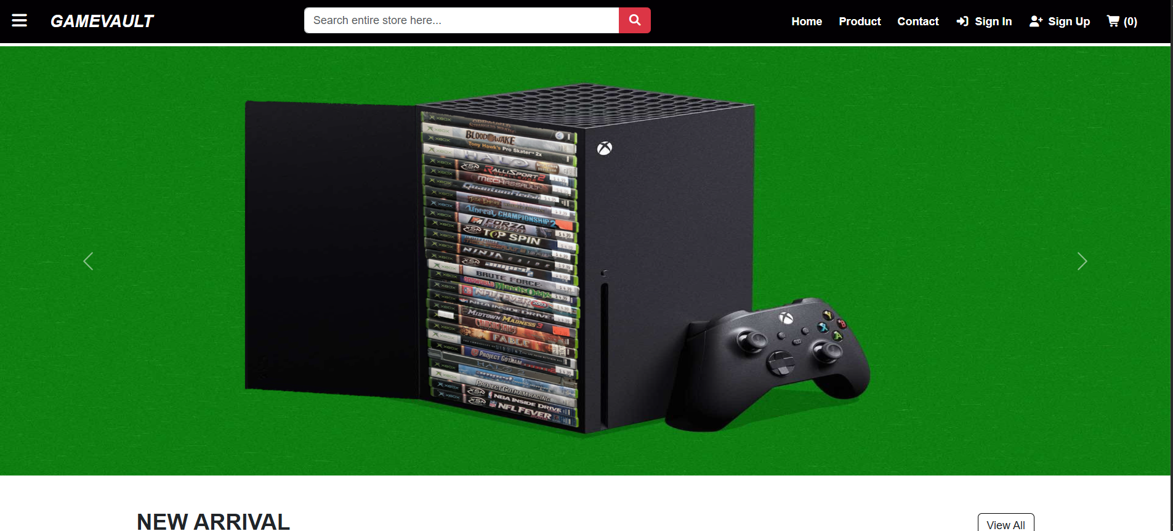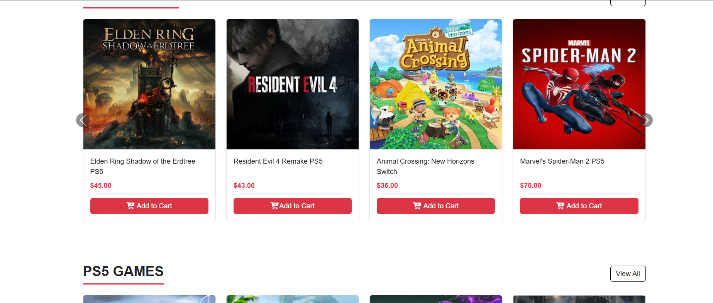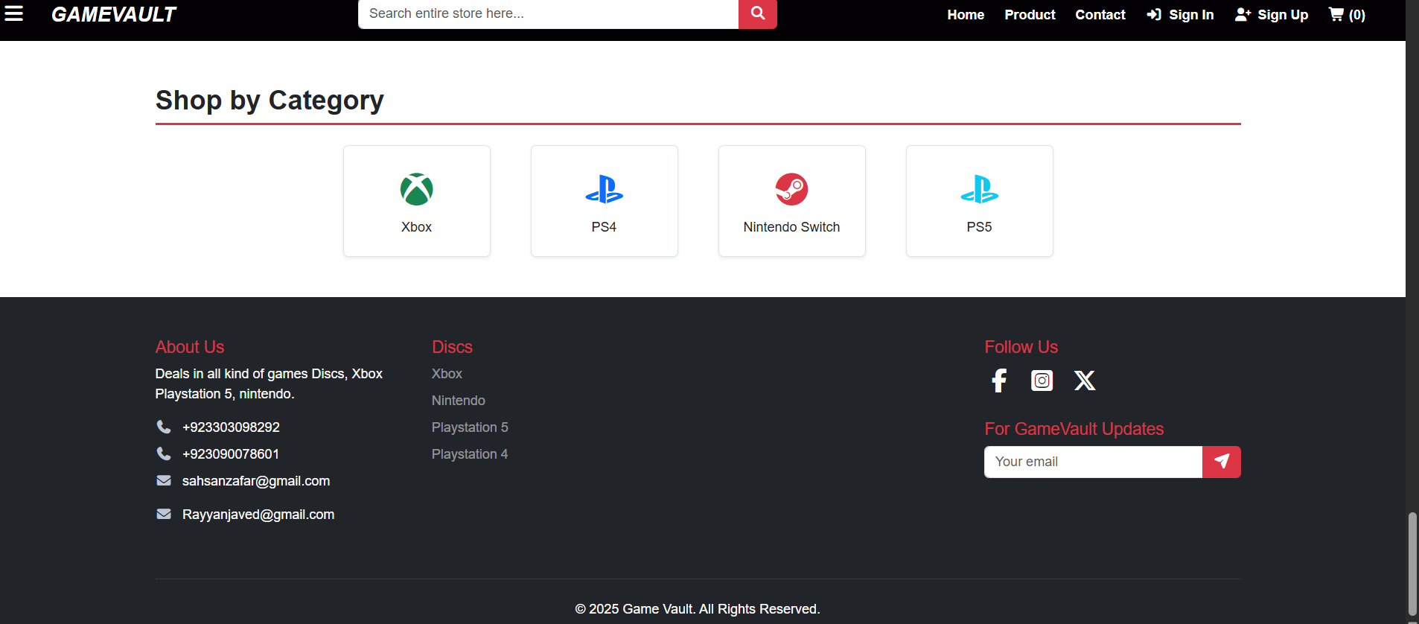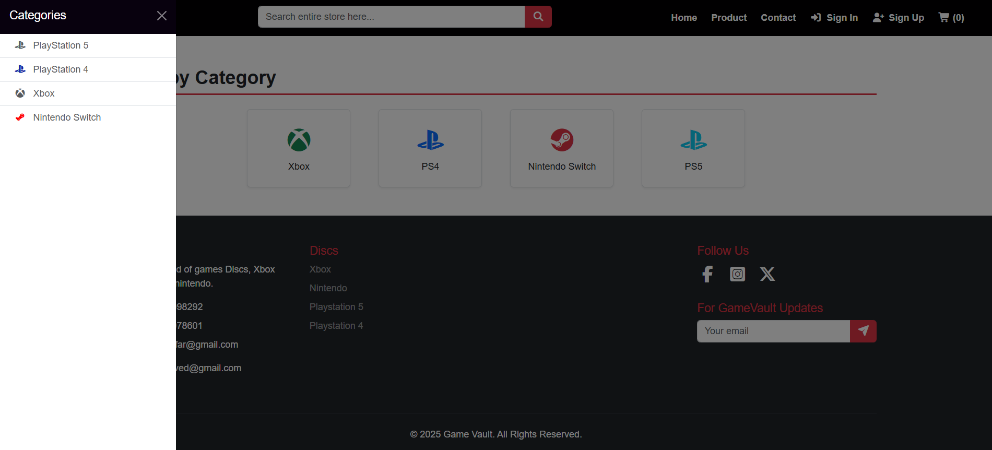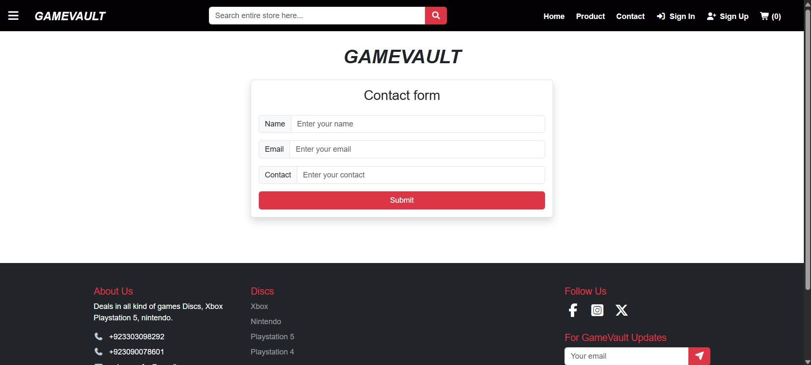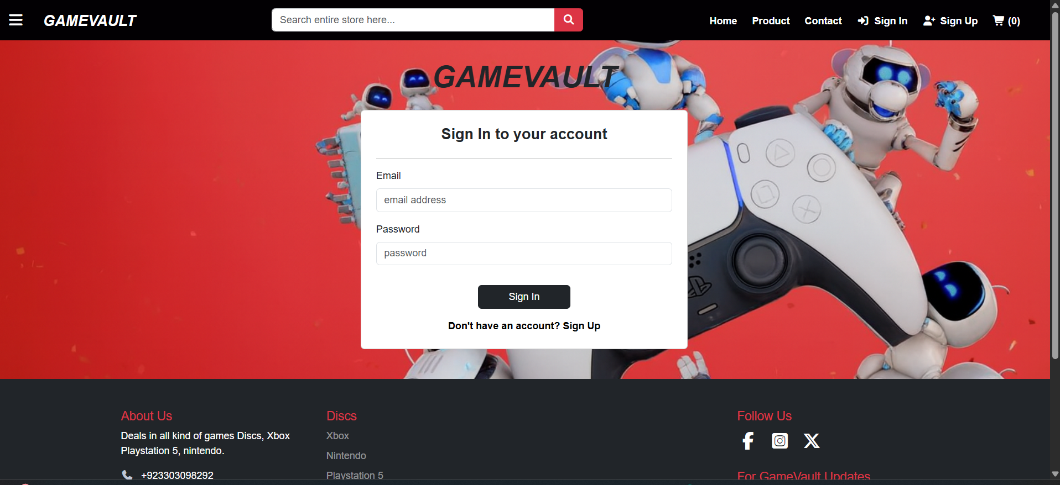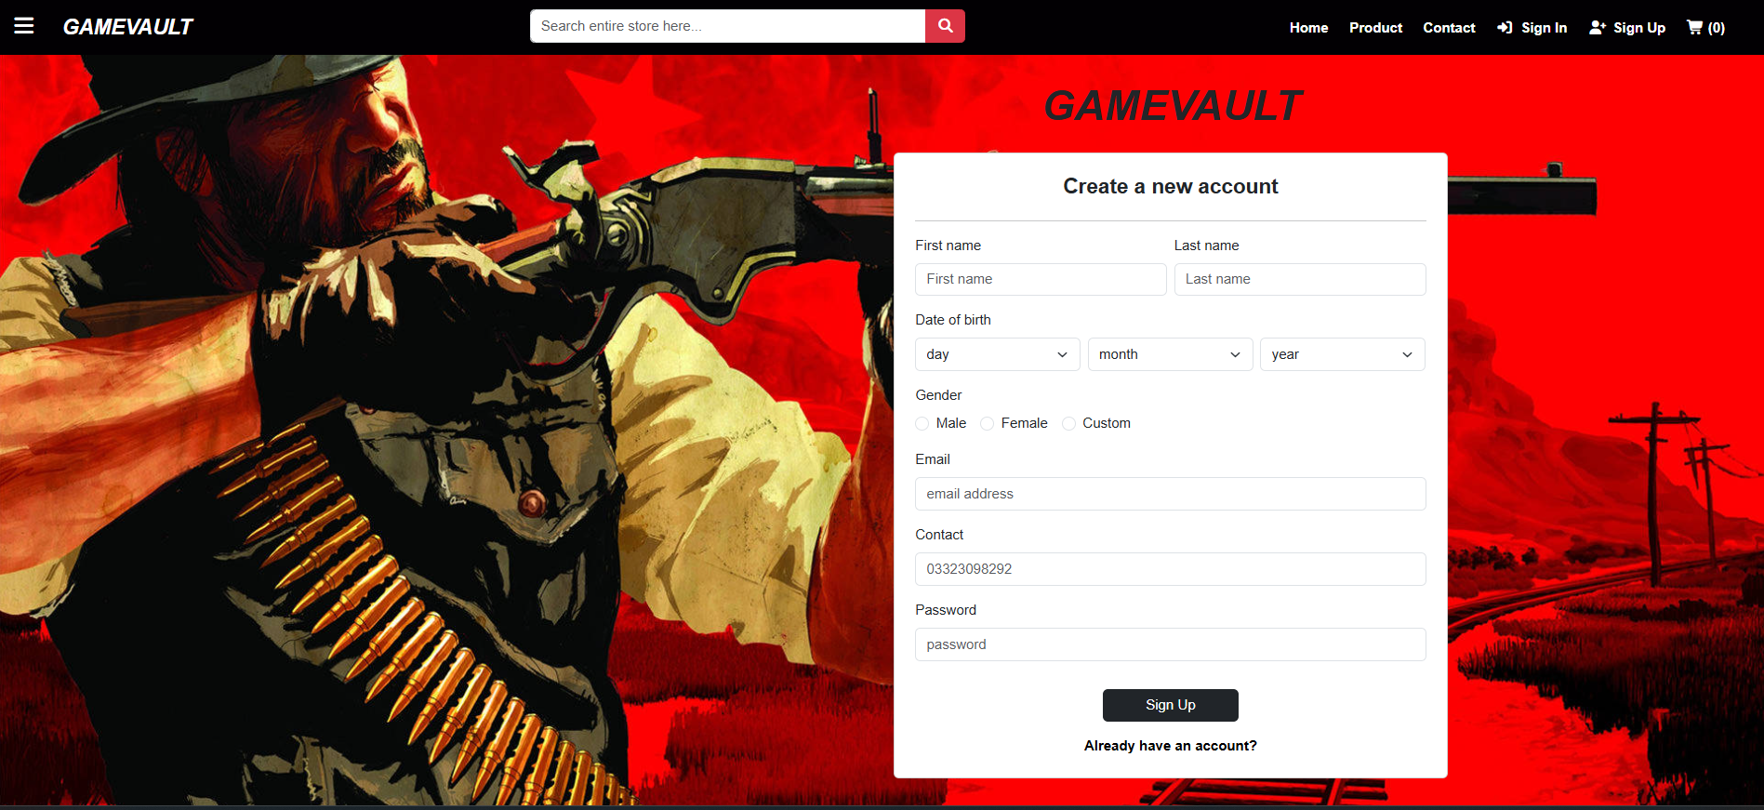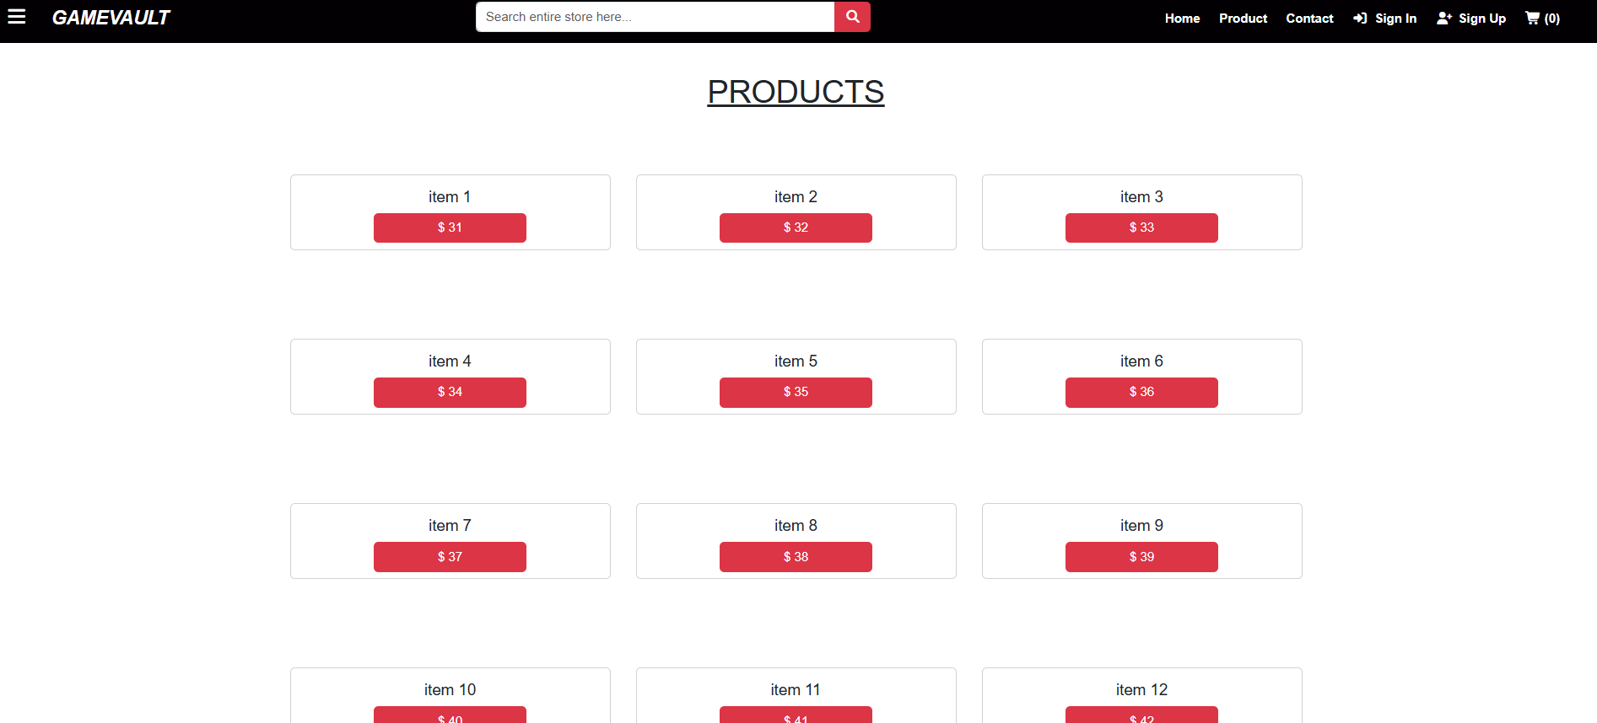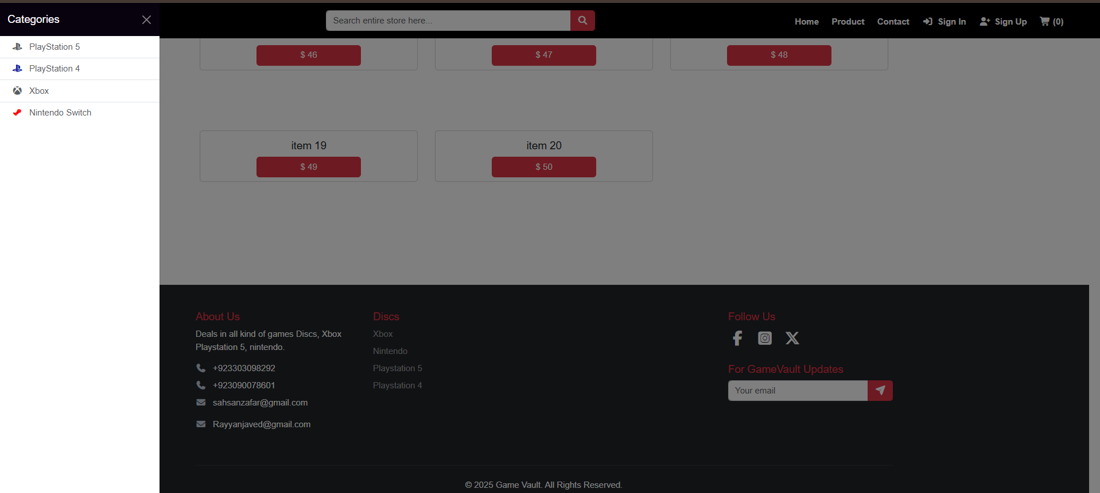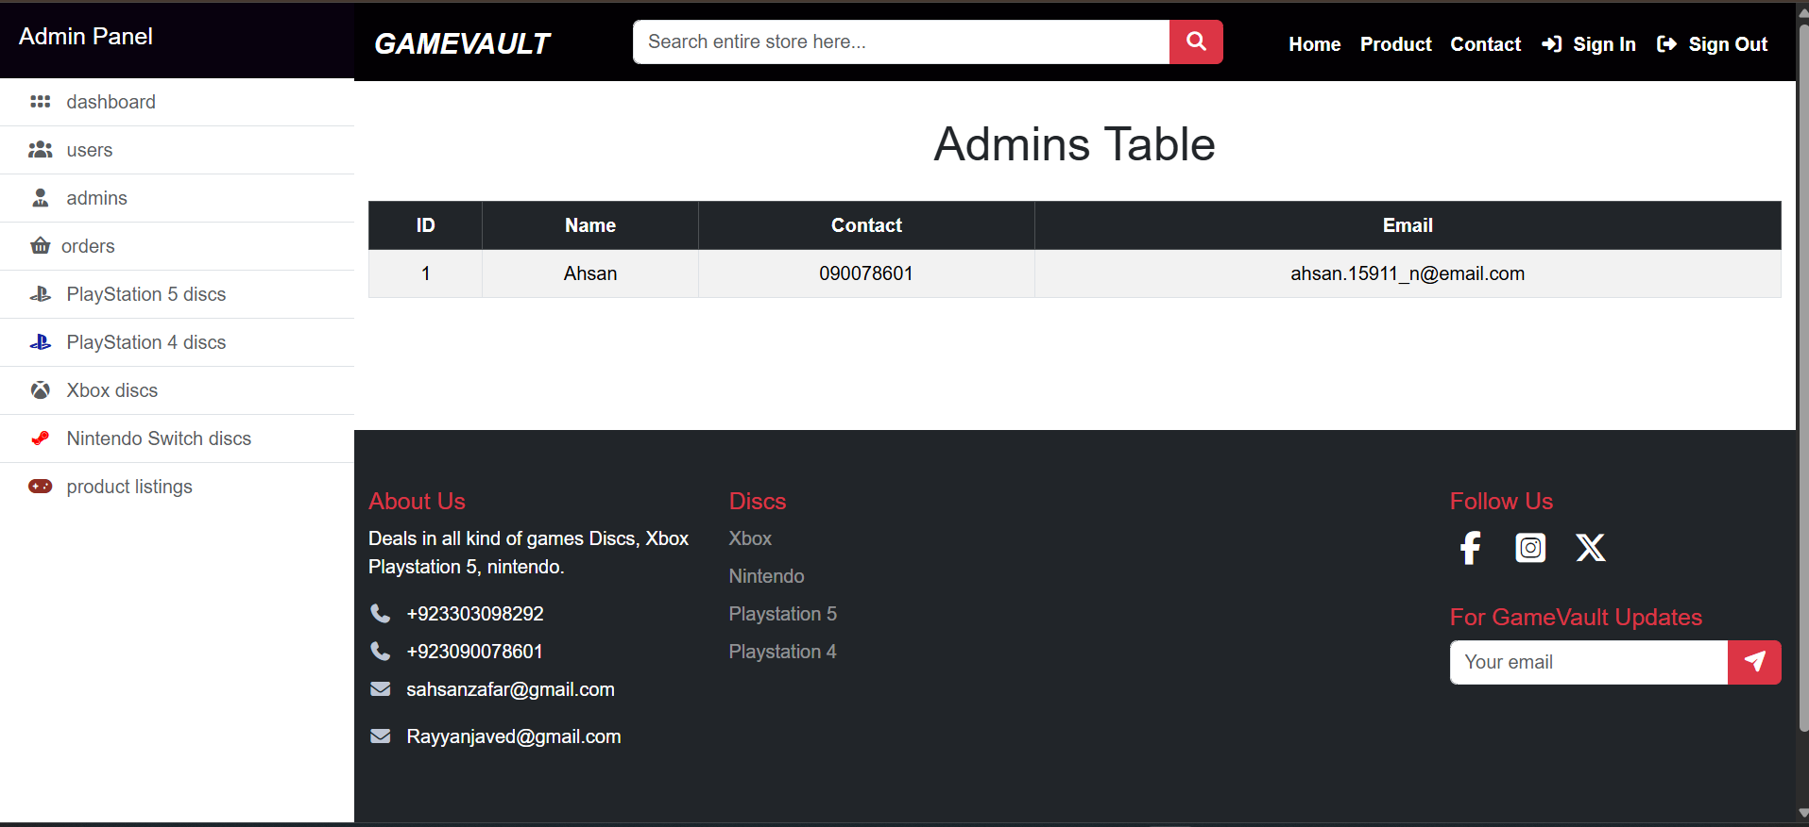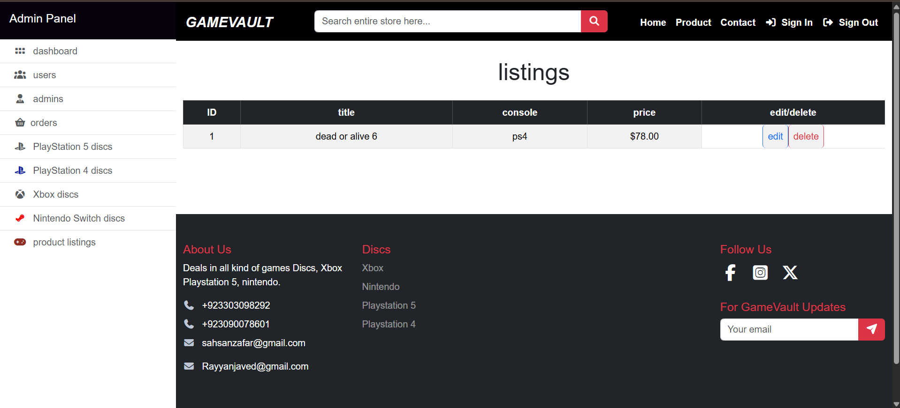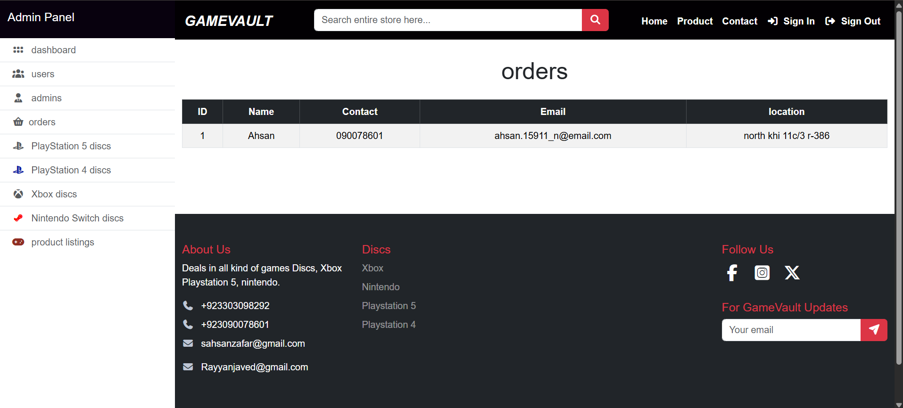

LAB # 9  
CRUD WITH AJAX

<?php

$p_name = $_POST['p_name'];

$p_category = $_POST['p_category'];

$p_type = $_POST['p_type'];

$p_price= $_POST['p_price'];

$conn = mysqli_connect('localhost', 'root', '', 'products');

$query = "INSERT INTO producs(p_name,p_category,p_type,p_price) values('$p_name','$p_category','$p_type','$p_price')";

if(mysqli_query($conn, $query)){

$response['msg'] = 'successful';

$response['code'] = '201';

echo json_encode($response);

}

else{

$error['msg'] = 'failed';

$error['code'] = '500';

echo json_encode($error);

}

?>

<?php

$conn = mysqli_connect('localhost', 'root', '', 'products');

$id = $_GET['p_id'];

$query = "DELETE FROM producs WHERE p_id = $id";

mysqli_query($conn, $query);

header("Location: webpage.php");

?>

<?php

$conn = mysqli_connect('localhost', 'root', '', 'products');

$id = $_GET['p_id'];

$query = "SELECT * FROM producs WHERE p_id = $id";

$result = mysqli_query($conn, $query);

$row = mysqli_num_rows($result);

$data = mysqli_fetch_assoc($result);

include 'main.html';

?>

<html>

<head>

<title>Document</title>

</head>

<body>

<h3 class="text-center mt-5 mb-4">Edit Info: <?php echo $data['p_name']; ?></h3>

<div class="container">

<div style="border: none;" class="card w-50 mx-auto">

<div class="row">

<form id="edit_form" class="mx-auto mt-4">

<div class="input-group mb-4 mt-4">

<input type="hidden" class="form-control" value="<?php echo $data['p_id']; ?>">

</div>

<div class="input-group mb-4">

<label >product name</label>

<input name="p_name" id="p_name" type="text" class="form-control" value="<?php echo $data['p_name']; ?>">

</div>

<div class="input-group mb-4">

<label>product category</label>

<input name="p_category" id="p_category" type="text" class="form-control" value="<?php echo $data['p_category']; ?>">

</div>

<div class="input-group mb-4">

<label >product type</label>

<input name="p_type" id="p_type" type="number" class="form-control" value="<?php echo $data['p_type']; ?>">

</div>

<div class="input-group mb-4">

<label>product price</label>

<input name="p_price" id="p_price" type="number" class="form-control" value="<?php echo $data['p_price']; ?>">

</div>

<button id="submitButton" class="btn btn-primary w-100" onclick="return confirm('you sure?')">Confirm</button>

</form>

</div>

</div>

</div>

<script>

$(document).ready(function(){

$('#edit_form').on('submit', function(e){

e.preventDefault()

let jsonFile = {

'p_id': $('#p_id').val(),

'p_name': $('#p_name').val(),

'p_category': $('#p_category').val(),

'p_type': $('#p_type').val(),

'p_price': $('#p_price').val(),

}

console.log(jsonFile)

$.ajax({

type: 'POST',

url: 'update.php?p_id=<?php echo $data['p_id'];?>',

data: jsonFile,

success: function(response){

window.location.href = 'webpage.php';

console.log(response)

},

error: function(error){

console.log(error)

}

})

})

})

</script>

</body>

</html>

<?php

$id = $_GET['p_id'];

$p_name = $_POST['p_name'];

$p_category = $_POST['p_category'];

$p_type = $_POST['p_type'];

$p_price= $_POST['p_price'];

$conn = mysqli_connect('localhost', 'root','', 'products');

$query = "UPDATE producs SET p_name = '$p_name', p_category = '$p_Category', p_type = '$p_type', p_price = '$p_price' WHERE p_id = $id";

if(mysqli_query($conn, $query)){

$response['msg'] = "SUCCESSFUL!";

$response['code'] = '201';

echo json_encode($response);

}

else{

$error['response'] = 'Failed';

$error['code'] = '500';

echo json_encode($error);

}

?>

<?php

$conn = mysqli_connect('localhost', 'root', '', 'products');

include 'main.html';

?>

<html>

<head>

<title>T&F</title>

</head>

<body>

<div class="container mt-3">

<div class="row col-12 g-3">

<div class="col col-md-6">

<h3 class="text-center">Form</h3>

<form id="form">

<div class="input-group mt-4 mb-4">

<label>product name</label>

<input name="p_name" id="p_name" type="text" class="form-control">

</div>

<div class="input-group mb-4">

<label>product category</label>

<input name="p_category" id="p_category" type="text" class="form-control">

</div>

<div class="input-group mb-4">

<label>product type</label>

<input name="p_type" id="p_type" type="number" class="form-control">

</div>

<div class="input-group mb-4">

<label>product price</label >

<input name="p_price" id="p_price" type="number" class="form-control">

</div>

<button class="btn btn-primary w-100 " id="btn" type="submit">Submit</button>

</form>

</div>

<div class="col col-md-6">

<h3 class="text-center">Table</h3>

<div class="table-responsive">

<table class="table table-light text-center">

<thead>

<tr>

<td>S.no</td>

<td>product name</td>

<td>product category</td>

<td>product type</td>

<td>product Price</td>

<td>Actions</td>

</tr>

</thead>

<tbody>

<?php

$fetch_query = "SELECT * FROM producs";

$result = mysqli_query($conn, $fetch_query);

$row = mysqli_num_rows($result);

for ($i = 0; $i < $row; $i++) {

$data = mysqli_fetch_assoc($result);

?>

<tr>

<td><?php echo $i + 1 ?></td>

<td><?php echo $data['p_name']; ?></td>

<td><?php echo $data['p_category']; ?></td>

<td><?php echo $data['p_type']; ?></td>

<td><?php echo $data['p_price']; ?></td>

<td>

<div class="d-flex gap-2 justify-content-center">

<a href="edit.php?p_id=<?php echo $data['p_id']; ?>"><button class="btn btn-text-muted btn-sm">Edit</button></a>

<a href="delete.php?p_id=<?php echo $data['p_id']; ?>"><button onclick="return confirm('you want to delete this item?')" class="btn btn-secondary btn-sm">Delete</button></a>

</div>

</td>

</tr>

<?php

}

?>

</tbody>

</table>

</div>

</div>

</div>

</div>

<script>

$(document).ready(function() {

$('#form').on('submit', function(e) {

e.preventDefault()

let jsonFile = {

'p_name': $('#p_name').val(),

'p_category': $('#p_category').val(),

'p_type': $('#p_type').val(),

'p_price': $('#p_price').val(),

}

console.log(jsonFile)

$.ajax({

type: 'POST',

url: 'create.php',

data: jsonFile,

success: function(response) {

location.reload()

console.log(response)

},

error: function(error) {

console.log(error)

}

})

})

})

</script>

</body>

</html>

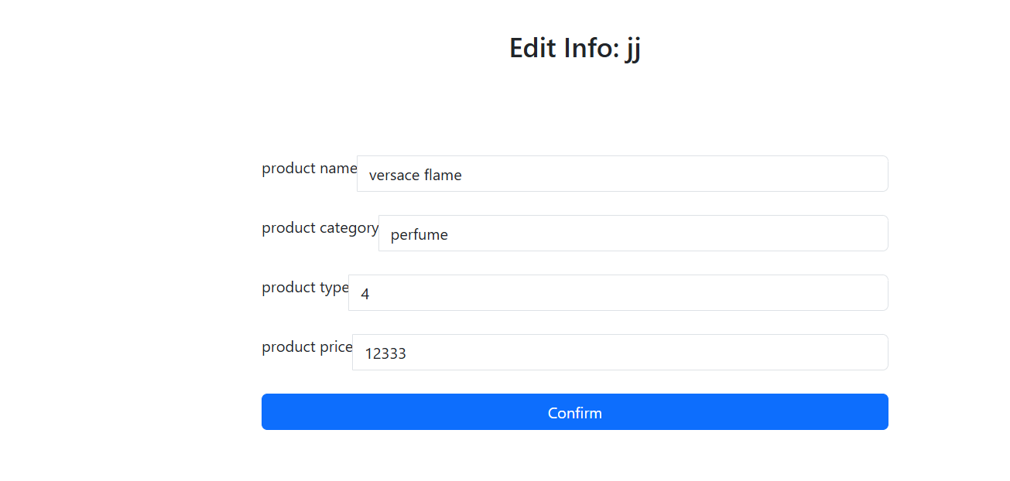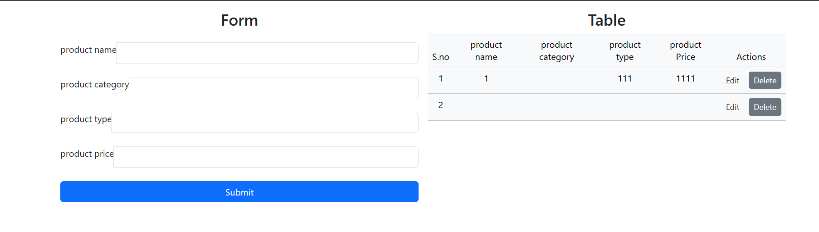

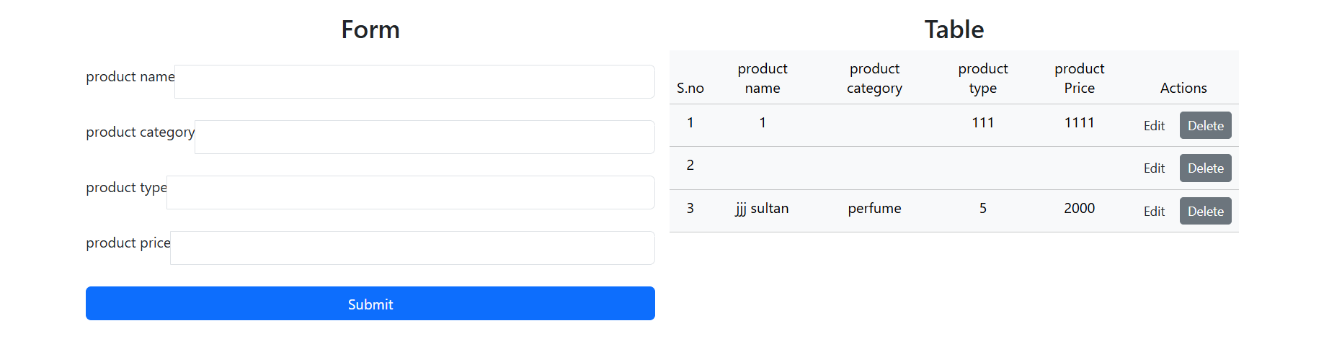

LAB # 11 PROJECT 25%  
  
  
  
<!DOCTYPE html>

<html lang="en">

<head>

<meta charset="UTF-8">

<meta name="viewport" content="width=device-width, initial-scale=1.0">

<title>Game Vault- Gaming Store</title>

<link rel="stylesheet" href="bootstrap/css/bootstrap.min.css">

<script src="bootstrap/js/bootstrap.bundle.min.js"></script>

<link rel="stylesheet" href="css/all.min.css">

<link rel="stylesheet" href="css/fontawesome.min.css">

</head>

<body style="font-family: 'Montreal', sans-serif;">

<div style="background-color: #020003; ">

<nav class="navbar">

<button class="btn btn-link text-white form-text" type="button" data-bs-toggle="offcanvas" data-bs-target="#sidebar">

<i class="fa-solid fa-bars fw-bold fs-4"></i>

</button>

<a class="navbar-brand ms-2 text-white fw-bold fst-italic form-text ms-3 fs-4" href="#">GAMEVAULT </a>

<form class="d-flex mx-auto " style="width: 500px;">

<div class="input-group">

<input type="search" class="form-control" placeholder="Search entire store here..." id="search" name="search">

<button class="btn btn-danger" type="submit">

<i class="fa-solid fa-magnifying-glass"></i>

</button>

</div>

</form>

<ul class="navbar-nav d-flex flex-row gap-5 me-5">

<li class="nav-item form-text">

<a class="nav-link text-white fs-5 fw-semibold" href="#">Home</a>

</li>

<li class="nav-item form-text">

<a class="nav-link text-white fs-5 fw-semibold" href="#">Product</a>

</li>

<li class="nav-item form-text ">

<a class="nav-link text-white fs-5 fw-semibold" href="#">Contact</a>

</li>

<li class="nav-item form-text">

<a class="nav-link text-white fs-5 fw-semibold" href="sign in.html"><i class="fa-solid fa-user"></i></a>

</li>

<li class="nav-item form-text">

<a class="nav-link text-white fs-5 fw-semibold" href="#" data-bs-toggle="offcanvas"

data-bs-target="#shoppingcart"><i class="fa-solid fa-cart-shopping"></i>(0) </a>

</li>

</ul>

</nav>

</div>

<div class="offcanvas offcanvas-start" tabindex="-1" id="sidebar"

style="width: 300px; background-color: #ffffff;">

<div class="offcanvas-header text-white" style="background-color: #08010e;">

<h5 class="offcanvas-title">Categories</h5>

<button type="button" class="btn-close btn-close-white" data-bs-dismiss="offcanvas"></button>

</div>

<div class="offcanvas-body p-0">

<div class="accordion accordion-flush" id="sidebarAccordion">

<div class="list-group list-group-flush">

<a href="#" class="list-group-item list-group-item-action ps-4">

<i class="fa-brands fa-playstation me-2" style="color: black;"></i> PlayStation 5

</a>

<a href="#" class="list-group-item list-group-item-action ps-4">

<i class="fa-brands fa-playstation me-2" style="color: #1521a4;"></i> PlayStation 4

</a>

<a href="#" class="list-group-item list-group-item-action ps-4">

<i class="fa-brands fa-xbox me-2" style="color: green;"></i> Xbox

</a>

<a href="#" class="list-group-item list-group-item-action ps-4">

<i class="fas fa-gamepad me-2" style="color: red;"></i> Nintendo Switch

</a>

<a href="signin.php" target="_blank" class="list-group-item list-group-item-action ps-4">

<i class="fa-solid fa-right-to-bracket me-2"></i> Sign In

</a>

<a href="singup.php" target="_blank" class="list-group-item list-group-item-action ps-4">

<i class="fa-solid fa-user-plus me-2"></i> Create Account

</a>

</div>

</div>

</div>

</div>

<div class="offcanvas offcanvas-end" tabindex="-1" id="shoppingcart" style="width: 400px;

background-color: rgb(255, 255, 255);">

<div class="offcanvas-header text-white" style="background-color: #0d0117;">

<h5 class="offcanvas-title">Cart</h5>

<button type="button" class="btn-close btn-close-white" data-bs-dismiss="offcanvas"></button>

</div>

<div class="offcanvas-body p-0">

</div>

</div>

<div id="promobanner" class="carousel slide">

<div class="carousel-inner w-100">

<div class="carousel-item active">

<img src="images/60bd647d-0f8f-49f6-b53c-90370462d209.jpg" class="w-100" alt="sale"

style="height: 620px; ">

</div>

<div class="carousel-item">

<img src="images/1.jpg" class="w-100" alt="xbox" style="height: 620px; ">

</div>

<div class="carousel-item">

<img src="images/cb44e938bef3d877aa115fdba8968b18.jpg" class="w-100" alt="ps5" style="height: 620px;">

</div>

</div>

<button class="carousel-control-prev" type="button" data-bs-target="#promobanner" data-bs-slide="prev">

<span class="carousel-control-prev-icon"></span>

</button>

<button class="carousel-control-next" type="button" data-bs-target="#promobanner" data-bs-slide="next">

<span class="carousel-control-next-icon"></span>

</button>

</div>

<div class="container my-5">

<div class="d-flex justify-content-between align-items-center mb-4">

<h2 class="fw-bold mb-0 border-bottom border-danger border-3 pb-2">NEW ARRIVAL</h2>

<a href="#" class="btn border-black">View All</a>

</div>

<div id="newarrival" class="carousel slide" data-bs-ride="false">

<div class="carousel-inner">

<div class="carousel-item active">

<div class="row g-4">

<div class="col-lg-3 col-md-4">

<div class="card border shadow-sm h-100">

<a class="text-decoration-none text-dark" href="">

<img src="images/images (2).jpg" class="card-img-top" alt="Product" style="height: 300px; ">

<div class="card-body d-flex flex-column ">

<div class="card-title" style="min-height: 48px;">Red Dead Redemption 2 PS4</div>

</a>

<p class="text-danger fw-bold mb-3">$56.00</p>

<button class="btn btn-danger w-100 mt-auto" type="submit" >

<i class="fa-solid fa-cart-arrow-down"></i> Add to Cart

</button>

</div>

</div>

</div>

<div class="col-lg-3 col-md-4 ">

<div class="card border shadow-sm h-100">

<a class="text-decoration-none text-dark" href="">

<img src="images/images (3).jpg" class="card-img-top" alt="Product" style="height: 300px; ">

<div class="card-body d-flex flex-column">

<div class="card-title" style="min-height: 48px;">Forza Horizon 5</div> </a>

<p class="text-danger fw-bold mb-3">$49.00</p>

<button class="btn btn-danger w-100 mt-auto">

<i class="fa-solid fa-cart-arrow-down"></i> Add to Cart

</button>

</div>

</div>

</div>

<div class="col-lg-3 col-md-4">

<div class="card border shadow-sm h-100">

<a class="text-decoration-none text-dark" href="">

<img src="images/mario kart.jpg" class="card-img-top" alt="Product" style="height: 300px; ">

<div class="card-body d-flex flex-column">

<div class="card-title" style="min-height: 48px;">Mario Kart World SWITCH 2</div> </a>

<p class="text-danger fw-bold mb-3">$61.00</p>

<button class="btn btn-danger w-100 mt-auto">

<i class="fa-solid fa-cart-arrow-down"></i> Add to Cart

</button>

</div>

</div>

</div>

<div class="col-lg-3 col-md-4">

<div class="card border shadow-sm h-100">

<a class="text-decoration-none text-dark" href="">

<img src="images/pokemon legends z-a .jpg" class="card-img-top" alt="Product" style="height: 300px; ">

<div class="card-body d-flex flex-column">

<div class="card-title" style="min-height: 48px;">POKEMON LEGENDS Z-A Switch 2</div> </a>

<p class="text-danger fw-bold mb-3">$25.00</p>

<button class="btn btn-danger w-100 mt-auto">

<i class="fa-solid fa-cart-arrow-down"></i> Add to Cart

</button>

</div>

</div>

</div>

</div>

</div>

<div class="carousel-item">

<div class="row g-4">

<div class="col-lg-3 col-md-4 ">

<div class="card border shadow-sm h-100">

<a class="text-decoration-none text-dark" href="">

<img src="images/elden ring shadow of erd tree.jpg" class="card-img-top" alt="Product" style="height: 300px; ">

<div class="card-body d-flex flex-column">

<div class="card-title" style="min-height: 48px;">Elden Ring Shadow of the Erdtree PS5</div> </a>

<p class="text-danger fw-bold mb-3">$45.00</p>

<button class="btn btn-danger w-100 mt-auto">

<i class="fa-solid fa-cart-arrow-down"></i> Add to Cart

</button>

</div>

</div>

</div>

<div class="col-lg-3 col-md-4 ">

<div class="card border shadow-sm h-100">

<a class="text-decoration-none text-dark" href="">

<img src="images/resident evil 4.jpg" class="card-img-top" alt="Product" style="height: 300px; ">

<div class="card-body d-flex flex-column">

<div class="card-title" style="min-height: 48px;">Resident Evil 4 Remake PS5</div> </a>

<p class="text-danger fw-bold mb-3">$43.00</p>

<button class="btn btn-danger w-100 mt-auto">

<i class="fa-solid fa-cart-arrow-down"></i>Add to Cart

</button>

</div>

</div>

</div>

<div class="col-lg-3 col-md-4">

<div class="card border shadow-sm h-100">

<a class="text-decoration-none text-dark" href="">

<img src="images/Animal_Crossing_New_Horizons.jpg"

class="card-img-top" alt="Product" style="height: 300px; ">

<div class="card-body d-flex flex-column">

<div class="card-title" style="min-height: 48px;">Animal Crossing: New Horizons Switch</div> </a>

<p class="text-danger fw-bold mb-3">$36.00</p>

<button class="btn btn-danger w-100 mt-auto">

<i class="fa-solid fa-cart-arrow-down"></i> Add to Cart

</button>

</div>

</div>

</div>

<div class="col-lg-3 col-md-4 ">

<div class="card border shadow-sm h-100">

<a class="text-decoration-none text-dark" href="">

<img src="images/spiderman 2.jpg" class="card-img-top" alt="Product" style="height: 300px; ">

<div class="card-body d-flex flex-column">

<div class="card-title" style="min-height: 48px;">Marvel's Spider-Man 2 PS5</div> </a>

<p class="text-danger fw-bold mb-3">$70.00</p>

<button class="btn btn-danger w-100 mt-auto">

<i class="fa-solid fa-cart-arrow-down"></i> Add to Cart

</button>

</div>

</div>

</div>

</div>

</div>

</div>

<button class="carousel-control-prev" type="button" data-bs-target="#newarrival" data-bs-slide="prev"

style="width: 0px;">

<span class="carousel-control-prev-icon bg-dark rounded-circle p-3" ></span>

</button>

<button class="carousel-control-next " type="button" data-bs-target="#newarrival" data-bs-slide="next"

style="width: 0px ;">

<span class="carousel-control-next-icon bg-dark rounded-circle p-3" ></span>

</button>

</div>

</div>

<div class="container my-5">

<div class="d-flex justify-content-between align-items-center mb-4">

<h2 class="fw-bold mb-0 border-bottom border-danger border-3 pb-2">PS5 GAMES</h2>

<a href="#" class="btn border-black">View All</a>

</div>

<div id="ps5games" class="carousel slide" data-bs-ride="false">

<div class="carousel-inner">

<div class="carousel-item active">

<div class="row g-4">

<div class="col-lg-3 col-md-4">

<div class="card border shadow-sm h-100">

<a class="text-decoration-none text-dark" href="">

<img src="images/god of war ragnarok.jpg" class="card-img-top" alt="Product" style="height: 300px; ">

<div class="card-body d-flex flex-column ">

<div class="card-title" style="min-height: 48px;">God of War Ragnarok PS5</div>

</a>

<p class="text-danger fw-bold mb-3">$69.00</p>

<button class="btn btn-danger w-100 mt-auto" type="submit" >

<i class="fa-solid fa-cart-arrow-down"></i> Add to Cart

</button>

</div>

</div>

</div>

<div class="col-lg-3 col-md-4 ">

<div class="card border shadow-sm h-100">

<a class="text-decoration-none text-dark" href="">

<img src="images/horizon forbidden west.jpg" class="card-img-top" alt="Product" style="height: 300px; ">

<div class="card-body d-flex flex-column">

<div class="card-title" style="min-height: 48px;">Horizon Forbidden West PS5</div> </a>

<p class="text-danger fw-bold mb-3">$59.00</p>

<button class="btn btn-danger w-100 mt-auto">

<i class="fa-solid fa-cart-arrow-down"></i> Add to Cart

</button>

</div>

</div>

</div>

<div class="col-lg-3 col-md-4">

<div class="card border shadow-sm h-100">

<a class="text-decoration-none text-dark" href="">

<img src="images/ratchet and clank rift apart.jpg" class="card-img-top" alt="Product" style="height: 300px; ">

<div class="card-body d-flex flex-column">

<div class="card-title" style="min-height: 48px;">Ratchet & Clank: Rift Apart PS5</div> </a>

<p class="text-danger fw-bold mb-3">$54.00</p>

<button class="btn btn-danger w-100 mt-auto">

<i class="fa-solid fa-cart-arrow-down"></i> Add to Cart

</button>

</div>

</div>

</div>

<div class="col-lg-3 col-md-4">

<div class="card border shadow-sm h-100">

<a class="text-decoration-none text-dark" href="">

<img src="images/demon souls.jpg" class="card-img-top" alt="Product" style="height: 300px; ">

<div class="card-body d-flex flex-column">

<div class="card-title" style="min-height: 48px;">Demon's Souls Remake PS5</div> </a>

<p class="text-danger fw-bold mb-3">$64.00</p>

<button class="btn btn-danger w-100 mt-auto">

<i class="fa-solid fa-cart-arrow-down"></i> Add to Cart

</button>

</div>

</div>

</div>

</div>

</div>

<div class="carousel-item">

<div class="row g-4">

<div class="col-lg-3 col-md-4 ">

<div class="card border shadow-sm h-100">

<a class="text-decoration-none text-dark" href="">

<img src="images/returnal ps5.jpg" class="card-img-top" alt="Product" style="height: 300px; ">

<div class="card-body d-flex flex-column">

<div class="card-title" style="min-height: 48px;">Returnal PS5</div> </a>

<p class="text-danger fw-bold mb-3">$49.00</p>

<button class="btn btn-danger w-100 mt-auto">

<i class="fa-solid fa-cart-arrow-down"></i> Add to Cart

</button>

</div>

</div>

</div>

<div class="col-lg-3 col-md-4 ">

<div class="card border shadow-sm h-100">

<a class="text-decoration-none text-dark" href="">

<img src="images/ghost of tshushma.jpg" class="card-img-top" alt="Product" style="height: 300px; ">

<div class="card-body d-flex flex-column">

<div class="card-title" style="min-height: 48px;">Ghost of Tsushima Director's Cut PS5</div> </a>

<p class="text-danger fw-bold mb-3">$59.00</p>

<button class="btn btn-danger w-100 mt-auto">

<i class="fa-solid fa-cart-arrow-down"></i>Add to Cart

</button>

</div>

</div>

</div>

<div class="col-lg-3 col-md-4">

<div class="card border shadow-sm h-100">

<a class="text-decoration-none text-dark" href="">

<img src="images/final fantasy xvi .jpg"

class="card-img-top" alt="Product" style="height: 300px; ">

<div class="card-body d-flex flex-column">

<div class="card-title" style="min-height: 48px;">Final Fantasy XVI PS5</div> </a>

<p class="text-danger fw-bold mb-3">$69.00</p>

<button class="btn btn-danger w-100 mt-auto">

<i class="fa-solid fa-cart-arrow-down"></i> Add to Cart

</button>

</div>

</div>

</div>

<div class="col-lg-3 col-md-4 ">

<div class="card border shadow-sm h-100">

<a class="text-decoration-none text-dark" href="">

<img src="images/grand tursimo 7.jpg" class="card-img-top" alt="Product" style="height: 300px; ">

<div class="card-body d-flex flex-column">

<div class="card-title" style="min-height: 48px;">Gran Turismo 7 PS5</div> </a>

<p class="text-danger fw-bold mb-3">$59.00</p>

<button class="btn btn-danger w-100 mt-auto">

<i class="fa-solid fa-cart-arrow-down"></i> Add to Cart

</button>

</div>

</div>

</div>

</div>

</div>

</div>

<button class="carousel-control-prev" type="button" data-bs-target="#ps5games" data-bs-slide="prev"

style="width: 0px;">

<span class="carousel-control-prev-icon bg-dark rounded-circle p-3" ></span>

</button>

<button class="carousel-control-next " type="button" data-bs-target="#ps5games" data-bs-slide="next"

style="width: 0px ;">

<span class="carousel-control-next-icon bg-dark rounded-circle p-3" ></span>

</button>

</div>

</div>

<div class="container my-5">

<div class="d-flex justify-content-between align-items-center mb-4">

<h2 class="fw-bold mb-0 border-bottom border-danger border-3 pb-2">PS4 GAMES</h2>

<a href="#" class="btn border-black">View All</a>

</div>

<div id="ps4games" class="carousel slide" data-bs-ride="false">

<div class="carousel-inner">

<div class="carousel-item active">

<div class="row g-4">

<div class="col-lg-3 col-md-4">

<div class="card border shadow-sm h-100">

<a href="" class="text-decoration-none text-dark">

<img src="images/god of war 2018_.jpg" class="card-img-top" style="height: 300px;" alt="Product">

<div class="card-body d-flex flex-column">

<div class="card-title" style="min-height: 48px;">God of War PS4</div>

</a>

<p class="text-danger fw-bold mb-3">$29.00</p>

<button class="btn btn-danger w-100 mt-auto">

<i class="fa-solid fa-cart-arrow-down"></i> Add to Cart

</button>

</div>

</div>

</div>

<div class="col-lg-3 col-md-4">

<div class="card border shadow-sm h-100">

<a href="" class="text-decoration-none text-dark">

<img src="images/spiderman_.jpg" class="card-img-top" style="height: 300px;" alt="Product">

<div class="card-body d-flex flex-column">

<div class="card-title" style="min-height: 48px;">Marvel’s Spider-Man PS4</div>

</a>

<p class="text-danger fw-bold mb-3">$39.00</p>

<button class="btn btn-danger w-100 mt-auto">

<i class="fa-solid fa-cart-arrow-down"></i> Add to Cart

</button>

</div>

</div>

</div>

<div class="col-lg-3 col-md-4">

<div class="card border shadow-sm h-100">

<a href="" class="text-decoration-none text-dark">

<img src="images/last of us part 2.jpg" class="card-img-top" style="height: 300px;" alt="Product">

<div class="card-body d-flex flex-column">

<div class="card-title" style="min-height: 48px;">The Last of Us Part II PS4</div>

</a>

<p class="text-danger fw-bold mb-3">$34.00</p>

<button class="btn btn-danger w-100 mt-auto">

<i class="fa-solid fa-cart-arrow-down"></i> Add to Cart

</button>

</div>

</div>

</div>

<div class="col-lg-3 col-md-4">

<div class="card border shadow-sm h-100">

<a href="" class="text-decoration-none text-dark">

<img src="images/uncharted 4.jpg" class="card-img-top" style="height: 300px;" alt="Product">

<div class="card-body d-flex flex-column">

<div class="card-title" style="min-height: 48px;">Uncharted 4: A Thief’s End PS4</div>

</a>

<p class="text-danger fw-bold mb-3">$19.00</p>

<button class="btn btn-danger w-100 mt-auto">

<i class="fa-solid fa-cart-arrow-down"></i> Add to Cart

</button>

</div>

</div>

</div>

</div>

</div>

<div class="carousel-item">

<div class="row g-4">

<div class="col-lg-3 col-md-4">

<div class="card border shadow-sm h-100">

<a href="" class="text-decoration-none text-dark">

<img src="images/ghost of tshushma.jpg" class="card-img-top" style="height: 300px;" alt="Product">

<div class="card-body d-flex flex-column">

<div class="card-title" style="min-height: 48px;">Ghost of Tsushima PS4</div>

</a>

<p class="text-danger fw-bold mb-3">$39.00</p>

<button class="btn btn-danger w-100 mt-auto">

<i class="fa-solid fa-cart-arrow-down"></i> Add to Cart

</button>

</div>

</div>

</div>

<div class="col-lg-3 col-md-4">

<div class="card border shadow-sm h-100">

<a href="" class="text-decoration-none text-dark">

<img src="images/images (2).jpg" class="card-img-top" style="height: 300px;" alt="Product">

<div class="card-body d-flex flex-column">

<div class="card-title" style="min-height: 48px;">Red Dead Redemption 2 PS4</div>

</a>

<p class="text-danger fw-bold mb-3">$29.00</p>

<button class="btn btn-danger w-100 mt-auto">

<i class="fa-solid fa-cart-arrow-down"></i> Add to Cart

</button>

</div>

</div>

</div>

<div class="col-lg-3 col-md-4">

<div class="card border shadow-sm h-100">

<a href="" class="text-decoration-none text-dark">

<img src="images/fifa 23.jpg" class="card-img-top" style="height: 300px;" alt="Product">

<div class="card-body d-flex flex-column">

<div class="card-title" style="min-height: 48px;">FIFA 23 PS4</div>

</a>

<p class="text-danger fw-bold mb-3">$39.00</p>

<button class="btn btn-danger w-100 mt-auto">

<i class="fa-solid fa-cart-arrow-down"></i> Add to Cart

</button>

</div>

</div>

</div>

<div class="col-lg-3 col-md-4">

<div class="card border shadow-sm h-100">

<a href="" class="text-decoration-none text-dark">

<img src="images/wwe 2k22.jpg" class="card-img-top" style="height: 300px;" alt="Product">

<div class="card-body d-flex flex-column">

<div class="card-title" style="min-height: 48px;">WWE 2K22 PS4</div>

</a>

<p class="text-danger fw-bold mb-3">$34.00</p>

<button class="btn btn-danger w-100 mt-auto">

<i class="fa-solid fa-cart-arrow-down"></i> Add to Cart

</button>

</div>

</div>

</div>

</div>

</div>

</div>

<button class="carousel-control-prev" type="button" data-bs-target="#ps4games" data-bs-slide="prev" style="width: 0px;">

<span class="carousel-control-prev-icon bg-dark rounded-circle p-3"></span>

</button>

<button class="carousel-control-next" type="button" data-bs-target="#ps4games" data-bs-slide="next" style="width: 0px;">

<span class="carousel-control-next-icon bg-dark rounded-circle p-3"></span>

</button>

</div>

</div>

<div class="container my-5">

<div class="d-flex justify-content-between align-items-center mb-4">

<h2 class="fw-bold mb-0 border-bottom border-danger border-3 pb-2">XBOX SERIES X</h2>

<a href="#" class="btn border-black">View All</a>

</div>

<div id="xboxseriesx" class="carousel slide" data-bs-ride="false">

<div class="carousel-inner">

<div class="carousel-item active">

<div class="row g-4">

<div class="col-lg-3 col-md-4">

<div class="card border shadow-sm h-100">

<a class="text-decoration-none text-dark" href="">

<img src="images/Halo infinite.jpg" class="card-img-top" alt="Product" style="height: 300px; ">

<div class="card-body d-flex flex-column ">

<div class="card-title" style="min-height: 48px;">Halo Infinite Xbox Series X</div>

</a>

<p class="text-danger fw-bold mb-3">$59.00</p>

<button class="btn btn-danger w-100 mt-auto" type="submit" >

<i class="fa-solid fa-cart-arrow-down"></i> Add to Cart

</button>

</div>

</div>

</div>

<div class="col-lg-3 col-md-4 ">

<div class="card border shadow-sm h-100">

<a class="text-decoration-none text-dark" href="">

<img src="images/FORZA MOTORSPORT.jpg" class="card-img-top" alt="Product" style="height: 300px; ">

<div class="card-body d-flex flex-column">

<div class="card-title" style="min-height: 48px;">Forza Motorsport Xbox Series X</div> </a>

<p class="text-danger fw-bold mb-3">$69.00</p>

<button class="btn btn-danger w-100 mt-auto">

<i class="fa-solid fa-cart-arrow-down"></i> Add to Cart

</button>

</div>

</div>

</div>

<div class="col-lg-3 col-md-4">

<div class="card border shadow-sm h-100">

<a class="text-decoration-none text-dark" href="">

<img src="images/starfield.jpg" class="card-img-top" alt="Product" style="height: 300px; ">

<div class="card-body d-flex flex-column">

<div class="card-title" style="min-height: 48px;">Starfield Xbox Series X</div> </a>

<p class="text-danger fw-bold mb-3">$69.00</p>

<button class="btn btn-danger w-100 mt-auto">

<i class="fa-solid fa-cart-arrow-down"></i> Add to Cart

</button>

</div>

</div>

</div>

<div class="col-lg-3 col-md-4">

<div class="card border shadow-sm h-100">

<a class="text-decoration-none text-dark" href="">

<img src="images/GEARS5.jpg" class="card-img-top" alt="Product" style="height: 300px; ">

<div class="card-body d-flex flex-column">

<div class="card-title" style="min-height: 48px;">Gears 5 Xbox Series X</div> </a>

<p class="text-danger fw-bold mb-3">$39.00</p>

<button class="btn btn-danger w-100 mt-auto">

<i class="fa-solid fa-cart-arrow-down"></i> Add to Cart

</button>

</div>

</div>

</div>

</div>

</div>

<div class="carousel-item">

<div class="row g-4">

<div class="col-lg-3 col-md-4 ">

<div class="card border shadow-sm h-100">

<a class="text-decoration-none text-dark" href="">

<img src="images/MICROFOST FLIGHT SIMULATOR.jpg" class="card-img-top" alt="Product" style="height: 300px; ">

<div class="card-body d-flex flex-column">

<div class="card-title" style="min-height: 48px;">Microsoft Flight Simulator Xbox Series X</div> </a>

<p class="text-danger fw-bold mb-3">$59.00</p>

<button class="btn btn-danger w-100 mt-auto">

<i class="fa-solid fa-cart-arrow-down"></i> Add to Cart

</button>

</div>

</div>

</div>

<div class="col-lg-3 col-md-4 ">

<div class="card border shadow-sm h-100">

<a class="text-decoration-none text-dark" href="">

<img src="images/FABLE.jpg" class="card-img-top" alt="Product" style="height: 300px; ">

<div class="card-body d-flex flex-column">

<div class="card-title" style="min-height: 48px;">Fable Xbox Series X</div> </a>

<p class="text-danger fw-bold mb-3">$69.00</p>

<button class="btn btn-danger w-100 mt-auto">

<i class="fa-solid fa-cart-arrow-down"></i>Add to Cart

</button>

</div>

</div>

</div>

<div class="col-lg-3 col-md-4">

<div class="card border shadow-sm h-100">

<a class="text-decoration-none text-dark" href="">

<img src="images/SEA OF THEIVES.jpg"class="card-img-top" alt="Product" style="height: 300px; ">

<div class="card-body d-flex flex-column">

<div class="card-title" style="min-height: 48px;">Sea of Thieves Xbox Series X</div> </a>

<p class="text-danger fw-bold mb-3">$39.00</p>

<button class="btn btn-danger w-100 mt-auto">

<i class="fa-solid fa-cart-arrow-down"></i> Add to Cart

</button>

</div>

</div>

</div>

<div class="col-lg-3 col-md-4 ">

<div class="card border shadow-sm h-100">

<a class="text-decoration-none text-dark" href="">

<img src="images/PERFECT DARK.jpg" class="card-img-top" alt="Product" style="height: 300px; ">

<div class="card-body d-flex flex-column">

<div class="card-title" style="min-height: 48px;">Perfect Dark Xbox Series X</div> </a>

<p class="text-danger fw-bold mb-3">$69.00</p>

<button class="btn btn-danger w-100 mt-auto">

<i class="fa-solid fa-cart-arrow-down"></i> Add to Cart

</button>

</div>

</div>

</div>

</div>

</div>

</div>

<button class="carousel-control-prev" type="button" data-bs-target="#xboxseriesx" data-bs-slide="prev"

style="width: 0px;">

<span class="carousel-control-prev-icon bg-dark rounded-circle p-3" ></span>

</button>

<button class="carousel-control-next " type="button" data-bs-target="#xboxseriesx" data-bs-slide="next"

style="width: 0px ;">

<span class="carousel-control-next-icon bg-dark rounded-circle p-3" ></span>

</button>

</div>

</div>

<div class="container my-5">

<div class="d-flex justify-content-between align-items-center mb-4">

<h2 class="fw-bold mb-0 border-bottom border-danger border-3 pb-2">NINTENDO SWITCH</h2>

<a href="#" class="btn border-black">View All</a>

</div>

<div id="nintendoswitch" class="carousel slide" data-bs-ride="false">

<div class="carousel-inner">

<div class="carousel-item active">

<div class="row g-4">

<div class="col-lg-3 col-md-4">

<div class="card border shadow-sm h-100">

<a class="text-decoration-none text-dark" href="">

<img src="images/LEGEND OF ZELDA.jpg" class="card-img-top" alt="Product" style="height: 300px; ">

<div class="card-body d-flex flex-column ">

<div class="card-title" style="min-height: 48px;">The Legend of Zelda: Tears of the Kingdom</div>

</a>

<p class="text-danger fw-bold mb-3">$69.00</p>

<button class="btn btn-danger w-100 mt-auto" type="submit" >

<i class="fa-solid fa-cart-arrow-down"></i> Add to Cart

</button>

</div>

</div>

</div>

<div class="col-lg-3 col-md-4 ">

<div class="card border shadow-sm h-100">

<a class="text-decoration-none text-dark" href="">

<img src="images/SUPERMARIO ODYSSEY_.jpg" class="card-img-top" alt="Product" style="height: 300px; ">

<div class="card-body d-flex flex-column">

<div class="card-title" style="min-height: 48px;">Super Mario Odyssey Switch</div> </a>

<p class="text-danger fw-bold mb-3">$59.00</p>

<button class="btn btn-danger w-100 mt-auto">

<i class="fa-solid fa-cart-arrow-down"></i> Add to Cart

</button>

</div>

</div>

</div>

<div class="col-lg-3 col-md-4">

<div class="card border shadow-sm h-100">

<a class="text-decoration-none text-dark" href="">

<img src="images/SPLATOON 3.jpg" class="card-img-top" alt="Product" style="height: 300px; ">

<div class="card-body d-flex flex-column">

<div class="card-title" style="min-height: 48px;">Splatoon 3 Switch</div> </a>

<p class="text-danger fw-bold mb-3">$59.00</p>

<button class="btn btn-danger w-100 mt-auto">

<i class="fa-solid fa-cart-arrow-down"></i> Add to Cart

</button>

</div>

</div>

</div>

<div class="col-lg-3 col-md-4">

<div class="card border shadow-sm h-100">

<a class="text-decoration-none text-dark" href="">

<img src="images/METROID DREAD.jpg" class="card-img-top" alt="Product" style="height: 300px; ">

<div class="card-body d-flex flex-column">

<div class="card-title" style="min-height: 48px;">Metroid Dread Switch</div> </a>

<p class="text-danger fw-bold mb-3">$59.00</p>

<button class="btn btn-danger w-100 mt-auto">

<i class="fa-solid fa-cart-arrow-down"></i> Add to Cart

</button>

</div>

</div>

</div>

</div>

</div>

<div class="carousel-item">

<div class="row g-4">

<div class="col-lg-3 col-md-4 ">

<div class="card border shadow-sm h-100">

<a class="text-decoration-none text-dark" href="">

<img src="images/KIRBY THE FORGOTTEN LAND.jpg" class="card-img-top" alt="Product" style="height: 300px; ">

<div class="card-body d-flex flex-column">

<div class="card-title" style="min-height: 48px;">Kirby and the Forgotten Land Switch</div> </a>

<p class="text-danger fw-bold mb-3">$59.00</p>

<button class="btn btn-danger w-100 mt-auto">

<i class="fa-solid fa-cart-arrow-down"></i> Add to Cart

</button>

</div>

</div>

</div>

<div class="col-lg-3 col-md-4 ">

<div class="card border shadow-sm h-100">

<a class="text-decoration-none text-dark" href="">

<img src="images/SUPER SMASH BRO ULTIMATE SWITCH.jpg" class="card-img-top" alt="Product" style="height: 300px; ">

<div class="card-body d-flex flex-column">

<div class="card-title" style="min-height: 48px;">Super Smash Bros. Ultimate Switch</div> </a>

<p class="text-danger fw-bold mb-3">$59.00</p>

<button class="btn btn-danger w-100 mt-auto">

<i class="fa-solid fa-cart-arrow-down"></i>Add to Cart

</button>

</div>

</div>

</div>

<div class="col-lg-3 col-md-4">

<div class="card border shadow-sm h-100">

<a class="text-decoration-none text-dark" href="">

<img src="images/POKEMON SCARLETjpg.jpg"

class="card-img-top" alt="Product" style="height: 300px; ">

<div class="card-body d-flex flex-column">

<div class="card-title" style="min-height: 48px;">Pokémon Scarlet Switch</div> </a>

<p class="text-danger fw-bold mb-3">$59.00</p>

<button class="btn btn-danger w-100 mt-auto">

<i class="fa-solid fa-cart-arrow-down"></i> Add to Cart

</button>

</div>

</div>

</div>

<div class="col-lg-3 col-md-4 ">

<div class="card border shadow-sm h-100">

<a class="text-decoration-none text-dark" href="">

<img src="images/LUIGI MANSION 3.jpg" class="card-img-top" alt="Product" style="height: 300px; ">

<div class="card-body d-flex flex-column">

<div class="card-title" style="min-height: 48px;">Luigi's Mansion 3 Switch</div> </a>

<p class="text-danger fw-bold mb-3">$59.00</p>

<button class="btn btn-danger w-100 mt-auto">

<i class="fa-solid fa-cart-arrow-down"></i> Add to Cart

</button>

</div>

</div>

</div>

</div>

</div>

</div>

<button class="carousel-control-prev" type="button" data-bs-target="#nintendoswitch" data-bs-slide="prev"

style="width: 0px;">

<span class="carousel-control-prev-icon bg-dark rounded-circle p-3" ></span>

</button>

<button class="carousel-control-next " type="button" data-bs-target="#nintendoswitch" data-bs-slide="next"

style="width: 0px ;">

<span class="carousel-control-next-icon bg-dark rounded-circle p-3" ></span>

</button>

</div>

</div>

<div class="container my-5">

<h2 class="fw-bold mb-4 border-bottom border-danger border-3 pb-2 JSU">Shop by Category</h2>

<div class="row g-4 text-center justify-content-center g-lg-5">

<div class="col-lg-2 col-md-4 col-6">

<a href="#" class="text-decoration-none text-dark">

<div class="card border shadow-sm h-100">

<div class="card-body">

<i class="fa-brands fa-xbox fs-1 text-success mb-3 mt-3" style="color: #199421;"></i>

<h6 class="card-title">Xbox</h6>

</div>

</div>

</a>

</div>

<div class="col-lg-2 col-md-4 col-6">

<a href="#" class="text-decoration-none text-dark">

<div class="card border shadow-sm h-100">

<div class="card-body">

<i class="fa-brands fa-playstation fs-1 text-primary mb-3 mt-3"></i>

<h6 class="card-title">PS4</h6>

</div>

</div>

</a>

</div>

<div class="col-lg-2 col-md-4 col-6">

<a href="#" class="text-decoration-none text-dark">

<div class="card border shadow-sm h-100">

<div class="card-body">

<i class="fa-brands fa-steam fs-1 text-danger mb-3 mt-3 " style="color: #ce0909"; ></i>

<h6 class="card-title">Nintendo Switch</h6>

</div>

</div>

</a>

</div>

<div class="col-lg-2 col-md-4 col-6">

<a href="#" class="text-decoration-none text-dark">

<div class="card border shadow-sm h-100">

<div class="card-body">

<i class="fa-brands fa-playstation fs-1 text-info mb-3 mt-3"></i>

<h6 class="card-title">PS5</h6>

</div>

</div>

</a>

</div>

</div>

</div>

<footer class="bg-dark text-white mt-5 pt-5 pb-3">

<div class="container">

<div class="row">

<div class="col-lg-3 col-md-6 mb-4">

<h5 class="text-danger">About Us</h5>

<p>Deals in all kind of games Discs,Xbox Playstation 5 , nintendo.</p>

<p class="mb-2"><i class="fa-solid fa-phone me-2" style="color: #bec6d5;"></i> +923303098292</p>

<p class="mb-2"><i class="fa-solid fa-phone me-2" style="color: #bec6d5;"></i> +923090078601</p>

<p><i class="fa-solid fa-envelope me-2" style="color: #bec6d5;"> </i> sahsanzafar@gmail.com</p>

<p><i class="fa-solid fa-envelope me-2" style="color: #bec6d5;"> </i> Rayyanjaved@gmail.com</p>

</div>

<div class="col-lg-3 col-md-6 mb-4">

<h5 class="text-danger">PlayStation 5</h5>

<ul class="list-unstyled">

<li class="mb-2"><a href="#" class="text-white-50 text-decoration-none">Action</a></li>

<li class="mb-2"><a href="#" class="text-white-50 text-decoration-none">Simulation</a></li>

<li class="mb-2"><a href="#" class="text-white-50 text-decoration-none">Sports</a></li>

</ul>

</div>

<div class="col-lg-3 col-md-6 mb-4">

<h5 class="text-danger">Xbox</h5>

<ul class="list-unstyled">

<li class="mb-2"><a href="#" class="text-white-50 text-decoration-none">Action</a></li>

<li class="mb-2"><a href="#" class="text-white-50 text-decoration-none">Simulation</a></li>

<li class="mb-2"><a href="#" class="text-white-50 text-decoration-none">Sports</a></li>

</ul>

</div>

<div class="col-lg-3 col-md-6 mb-4">

<h5 class="text-danger">Follow Us</h5>

<div class="d-flex gap-3 fs-3 mb-4">

<a href="https://www.facebook.com/r.php?entry_point=login" target="_blank" class="text-white"><i class="fa-brands fa-facebook-f"></i></a>

<a href="https://www.instagram.com/" class="text-white" target="_blank"><i class="fa-brands fa-square-instagram"></i></a>

<a href="https://x.com/" class="text-white" target="_blank"><i class="fa-brands fa-x-twitter"></i></a>

</div>

<div class="mt-4">

<h5 class="text-danger">For GameVault Updates</h5>

<div class="input-group">

<input type="email" class="form-control" placeholder="Your email">

<button class="btn btn-danger" type="button">

<i class="fa-solid fa-paper-plane"></i>

</button>

</div>

</div>

</div>

</div>

<hr class="border-secondary my-4">

<div class="text-center">

<p class="mb-0"> 2025 Game Vault. All Rights Reserved.</p>

</div>

</div>

</footer>

</body>

</html>

<?php

$conn = mysqli_connect('localhost', 'root', '', 'gaming_store');

if(isset($_POST['signupButton'])){

$fname = $_POST['first_name'];

$lname = $_POST['last_name'];

$name = $fname . " " . $lname;

$day = $_POST['day'];

$month = $_POST['month'];

$year = $_POST['year'];

$dob = $day . "-" . $month . "-" . $year;

$gender = $_POST['gender'];

$email = $_POST['email'];

$password = $_POST['password'];

$phone = $_POST['contact'];

$query = "INSERT INTO customers(name,dob,gender,email,password,phone) values('$name','$dob','$gender','$email','$password','$phone')";

mysqli_query($conn, $query);

header("Location: signin.php");

exit();

}

?>

<?php

$conn = mysqli_connect('localhost', 'root', '', 'gaming_store');

session_start();

if(!isset($_SESSION['customer'])){

header("Location: signin.php");

exit();

}

$user = $_SESSION['customer'];

?>

<!DOCTYPE html>

<html lang="en">

<head>

<meta charset="UTF-8">

<meta name="viewport" content="width=device-width, initial-scale=1.0">

<title>Game Vault- Gaming Store</title>

<link rel="stylesheet" href="bootstrap/css/bootstrap.min.css">

<script src="bootstrap/js/bootstrap.bundle.min.js"></script>

<link rel="stylesheet" href="css/all.min.css">

<link rel="stylesheet" href="https://cdn.jsdelivr.net/npm/bootstrap-icons@1.11.3/font/bootstrap-icons.min.css">

<link rel="stylesheet" href="css/fontawesome.min.css">

</head>

<body style="font-family: 'Montreal', sans-serif;">

<div style="background-color: #020003; ">

<nav class="navbar">

<button class="btn btn-link text-white form-text" type="button" data-bs-toggle="offcanvas" data-bs-target="#sidebar">

<i class="fa-solid fa-bars fw-bold fs-4"></i>

</button>

<a class="navbar-brand ms-2 text-white fw-bold fst-italic form-text ms-3 fs-4" href="#">GAMEVAULT </a>

<form class="d-flex mx-auto " style="width: 500px;">

<div class="input-group">

<input type="search" class="form-control" placeholder="Search entire store here..." id="search" name="search">

<button class="btn btn-danger" type="submit">

<i class="fa-solid fa-magnifying-glass"></i>

</button>

</div>

</form>

<ul class="navbar-nav d-flex flex-row gap-5 me-5">

<li class="nav-item form-text">

<a class="nav-link text-white fs-5 fw-semibold" href="#">Home</a>

</li>

<li class="nav-item form-text">

<a class="nav-link text-white fs-5 fw-semibold" href="#">Product</a>

</li>

<li class="nav-item form-text ">

<a class="nav-link text-white fs-5 fw-semibold" href="#">Contact</a>

</li>

<li class="nav-item form-text">

<a class="nav-link text-white fs-5 fw-semibold" href="sign in.html"><i class="fa-solid fa-user"></i></a>

</li>

<li class="nav-item form-text">

<a class="nav-link text-white fs-5 fw-semibold" href="#" data-bs-toggle="offcanvas"

data-bs-target="#shoppingcart"><i class="fa-solid fa-cart-shopping"></i>(0) </a>

</li>

</ul>

</nav>

</div>

<div class="offcanvas offcanvas-start" tabindex="-1" id="sidebar"

style="width: 300px; background-color: #ffffff;">

<div class="offcanvas-header text-white" style="background-color: #08010e;">

<h5 class="offcanvas-title">Categories</h5>

<button type="button" class="btn-close btn-close-white" data-bs-dismiss="offcanvas"></button>

</div>

<div class="offcanvas-body p-0">

<div class="accordion accordion-flush" id="sidebarAccordion">

<div class="list-group list-group-flush">

<a href="#" class="list-group-item list-group-item-action ps-4">

<i class="fa-brands fa-playstation me-2" style="color: black;"></i> PlayStation 5

</a>

<a href="#" class="list-group-item list-group-item-action ps-4">

<i class="fa-brands fa-playstation me-2" style="color: #1521a4;"></i> PlayStation 4

</a>

<a href="#" class="list-group-item list-group-item-action ps-4">

<i class="fa-brands fa-xbox me-2" style="color: green;"></i> Xbox

</a>

<a href="#" class="list-group-item list-group-item-action ps-4">

<i class="fas fa-gamepad me-2" style="color: red;"></i> Nintendo Switch

</a>

<a href="signin.php" target="_blank" class="list-group-item list-group-item-action ps-4">

<i class="fa-solid fa-user me-2" style="color: blue;"></i><span style="color: blue;"><b><?php echo $user['name'];?></b></span>

</a>

<a href="signout.php" target="" class="list-group-item list-group-item-action ps-4">

<i class="fa-solid fa-user-times me-2" style="color: red;"></i><span style="color: red;">Sign Out</span>

</a>

</div>

</div>

</div>

</div>

<div class="offcanvas offcanvas-end" tabindex="-1" id="shoppingcart" style="width: 400px;

background-color: rgb(255, 255, 255);">

<div class="offcanvas-header text-white" style="background-color: #0d0117;">

<h5 class="offcanvas-title">Cart</h5>

<button type="button" class="btn-close btn-close-white" data-bs-dismiss="offcanvas"></button>

</div>

<div class="offcanvas-body p-0">

</div>

</div>

<div id="promobanner" class="carousel slide">

<div class="carousel-inner w-100">

<div class="carousel-item active">

<img src="images/60bd647d-0f8f-49f6-b53c-90370462d209.jpg" class="w-100" alt="sale"

style="height: 620px; ">

</div>

<div class="carousel-item">

<img src="images/1.jpg" class="w-100" alt="xbox" style="height: 620px; ">

</div>

<div class="carousel-item">

<img src="images/cb44e938bef3d877aa115fdba8968b18.jpg" class="w-100" alt="ps5" style="height: 620px;">

</div>

</div>

<button class="carousel-control-prev" type="button" data-bs-target="#promobanner" data-bs-slide="prev">

<span class="carousel-control-prev-icon"></span>

</button>

<button class="carousel-control-next" type="button" data-bs-target="#promobanner" data-bs-slide="next">

<span class="carousel-control-next-icon"></span>

</button>

</div>

<div class="container my-5">

<div class="d-flex justify-content-between align-items-center mb-4">

<h2 class="fw-bold mb-0 border-bottom border-danger border-3 pb-2">NEW ARRIVAL</h2>

<a href="#" class="btn border-black">View All</a>

</div>

<div id="newarrival" class="carousel slide" data-bs-ride="false">

<div class="carousel-inner">

<div class="carousel-item active">

<div class="row g-4">

<div class="col-lg-3 col-md-4">

<div class="card border shadow-sm h-100">

<a class="text-decoration-none text-dark" href="">

<img src="images/images (2).jpg" class="card-img-top" alt="Product" style="height: 300px; ">

<div class="card-body d-flex flex-column ">

<div class="card-title" style="min-height: 48px;">Red Dead Redemption 2 PS4</div>

</a>

<p class="text-danger fw-bold mb-3">$56.00</p>

<button class="btn btn-danger w-100 mt-auto" type="submit" >

<i class="fa-solid fa-cart-arrow-down"></i> Add to Cart

</button>

</div>

</div>

</div>

<div class="col-lg-3 col-md-4 ">

<div class="card border shadow-sm h-100">

<a class="text-decoration-none text-dark" href="">

<img src="images/images (3).jpg" class="card-img-top" alt="Product" style="height: 300px; ">

<div class="card-body d-flex flex-column">

<div class="card-title" style="min-height: 48px;">Forza Horizon 5</div> </a>

<p class="text-danger fw-bold mb-3">$49.00</p>

<button class="btn btn-danger w-100 mt-auto">

<i class="fa-solid fa-cart-arrow-down"></i> Add to Cart

</button>

</div>

</div>

</div>

<div class="col-lg-3 col-md-4">

<div class="card border shadow-sm h-100">

<a class="text-decoration-none text-dark" href="">

<img src="images/mario kart.jpg" class="card-img-top" alt="Product" style="height: 300px; ">

<div class="card-body d-flex flex-column">

<div class="card-title" style="min-height: 48px;">Mario Kart World SWITCH 2</div> </a>

<p class="text-danger fw-bold mb-3">$61.00</p>

<button class="btn btn-danger w-100 mt-auto">

<i class="fa-solid fa-cart-arrow-down"></i> Add to Cart

</button>

</div>

</div>

</div>

<div class="col-lg-3 col-md-4">

<div class="card border shadow-sm h-100">

<a class="text-decoration-none text-dark" href="">

<img src="images/pokemon legends z-a .jpg" class="card-img-top" alt="Product" style="height: 300px; ">

<div class="card-body d-flex flex-column">

<div class="card-title" style="min-height: 48px;">POKEMON LEGENDS Z-A Switch 2</div> </a>

<p class="text-danger fw-bold mb-3">$25.00</p>

<button class="btn btn-danger w-100 mt-auto">

<i class="fa-solid fa-cart-arrow-down"></i> Add to Cart

</button>

</div>

</div>

</div>

</div>

</div>

<div class="carousel-item">

<div class="row g-4">

<div class="col-lg-3 col-md-4 ">

<div class="card border shadow-sm h-100">

<a class="text-decoration-none text-dark" href="">

<img src="images/elden ring shadow of erd tree.jpg" class="card-img-top" alt="Product" style="height: 300px; ">

<div class="card-body d-flex flex-column">

<div class="card-title" style="min-height: 48px;">Elden Ring Shadow of the Erdtree PS5</div> </a>

<p class="text-danger fw-bold mb-3">$45.00</p>

<button class="btn btn-danger w-100 mt-auto">

<i class="fa-solid fa-cart-arrow-down"></i> Add to Cart

</button>

</div>

</div>

</div>

<div class="col-lg-3 col-md-4 ">

<div class="card border shadow-sm h-100">

<a class="text-decoration-none text-dark" href="">

<img src="images/resident evil 4.jpg" class="card-img-top" alt="Product" style="height: 300px; ">

<div class="card-body d-flex flex-column">

<div class="card-title" style="min-height: 48px;">Resident Evil 4 Remake PS5</div> </a>

<p class="text-danger fw-bold mb-3">$43.00</p>

<button class="btn btn-danger w-100 mt-auto">

<i class="fa-solid fa-cart-arrow-down"></i>Add to Cart

</button>

</div>

</div>

</div>

<div class="col-lg-3 col-md-4">

<div class="card border shadow-sm h-100">

<a class="text-decoration-none text-dark" href="">

<img src="images/Animal_Crossing_New_Horizons.jpg"

class="card-img-top" alt="Product" style="height: 300px; ">

<div class="card-body d-flex flex-column">

<div class="card-title" style="min-height: 48px;">Animal Crossing: New Horizons Switch</div> </a>

<p class="text-danger fw-bold mb-3">$36.00</p>

<button class="btn btn-danger w-100 mt-auto">

<i class="fa-solid fa-cart-arrow-down"></i> Add to Cart

</button>

</div>

</div>

</div>

<div class="col-lg-3 col-md-4 ">

<div class="card border shadow-sm h-100">

<a class="text-decoration-none text-dark" href="">

<img src="images/spiderman 2.jpg" class="card-img-top" alt="Product" style="height: 300px; ">

<div class="card-body d-flex flex-column">

<div class="card-title" style="min-height: 48px;">Marvel's Spider-Man 2 PS5</div> </a>

<p class="text-danger fw-bold mb-3">$70.00</p>

<button class="btn btn-danger w-100 mt-auto">

<i class="fa-solid fa-cart-arrow-down"></i> Add to Cart

</button>

</div>

</div>

</div>

</div>

</div>

</div>

<button class="carousel-control-prev" type="button" data-bs-target="#newarrival" data-bs-slide="prev"

style="width: 0px;">

<span class="carousel-control-prev-icon bg-dark rounded-circle p-3" ></span>

</button>

<button class="carousel-control-next " type="button" data-bs-target="#newarrival" data-bs-slide="next"

style="width: 0px ;">

<span class="carousel-control-next-icon bg-dark rounded-circle p-3" ></span>

</button>

</div>

</div>

<div class="container my-5">

<div class="d-flex justify-content-between align-items-center mb-4">

<h2 class="fw-bold mb-0 border-bottom border-danger border-3 pb-2">PS5 GAMES</h2>

<a href="#" class="btn border-black">View All</a>

</div>

<div id="ps5games" class="carousel slide" data-bs-ride="false">

<div class="carousel-inner">

<div class="carousel-item active">

<div class="row g-4">

<div class="col-lg-3 col-md-4">

<div class="card border shadow-sm h-100">

<a class="text-decoration-none text-dark" href="">

<img src="images/god of war ragnarok.jpg" class="card-img-top" alt="Product" style="height: 300px; ">

<div class="card-body d-flex flex-column ">

<div class="card-title" style="min-height: 48px;">God of War Ragnarok PS5</div>

</a>

<p class="text-danger fw-bold mb-3">$69.00</p>

<button class="btn btn-danger w-100 mt-auto" type="submit" >

<i class="fa-solid fa-cart-arrow-down"></i> Add to Cart

</button>

</div>

</div>

</div>

<div class="col-lg-3 col-md-4 ">

<div class="card border shadow-sm h-100">

<a class="text-decoration-none text-dark" href="">

<img src="images/horizon forbidden west.jpg" class="card-img-top" alt="Product" style="height: 300px; ">

<div class="card-body d-flex flex-column">

<div class="card-title" style="min-height: 48px;">Horizon Forbidden West PS5</div> </a>

<p class="text-danger fw-bold mb-3">$59.00</p>

<button class="btn btn-danger w-100 mt-auto">

<i class="fa-solid fa-cart-arrow-down"></i> Add to Cart

</button>

</div>

</div>

</div>

<div class="col-lg-3 col-md-4">

<div class="card border shadow-sm h-100">

<a class="text-decoration-none text-dark" href="">

<img src="images/ratchet and clank rift apart.jpg" class="card-img-top" alt="Product" style="height: 300px; ">

<div class="card-body d-flex flex-column">

<div class="card-title" style="min-height: 48px;">Ratchet & Clank: Rift Apart PS5</div> </a>

<p class="text-danger fw-bold mb-3">$54.00</p>

<button class="btn btn-danger w-100 mt-auto">

<i class="fa-solid fa-cart-arrow-down"></i> Add to Cart

</button>

</div>

</div>

</div>

<div class="col-lg-3 col-md-4">

<div class="card border shadow-sm h-100">

<a class="text-decoration-none text-dark" href="">

<img src="images/demon souls.jpg" class="card-img-top" alt="Product" style="height: 300px; ">

<div class="card-body d-flex flex-column">

<div class="card-title" style="min-height: 48px;">Demon's Souls Remake PS5</div> </a>

<p class="text-danger fw-bold mb-3">$64.00</p>

<button class="btn btn-danger w-100 mt-auto">

<i class="fa-solid fa-cart-arrow-down"></i> Add to Cart

</button>

</div>

</div>

</div>

</div>

</div>

<div class="carousel-item">

<div class="row g-4">

<div class="col-lg-3 col-md-4 ">

<div class="card border shadow-sm h-100">

<a class="text-decoration-none text-dark" href="">

<img src="images/returnal ps5.jpg" class="card-img-top" alt="Product" style="height: 300px; ">

<div class="card-body d-flex flex-column">

<div class="card-title" style="min-height: 48px;">Returnal PS5</div> </a>

<p class="text-danger fw-bold mb-3">$49.00</p>

<button class="btn btn-danger w-100 mt-auto">

<i class="fa-solid fa-cart-arrow-down"></i> Add to Cart

</button>

</div>

</div>

</div>

<div class="col-lg-3 col-md-4 ">

<div class="card border shadow-sm h-100">

<a class="text-decoration-none text-dark" href="">

<img src="images/ghost of tshushma.jpg" class="card-img-top" alt="Product" style="height: 300px; ">

<div class="card-body d-flex flex-column">

<div class="card-title" style="min-height: 48px;">Ghost of Tsushima Director's Cut PS5</div> </a>

<p class="text-danger fw-bold mb-3">$59.00</p>

<button class="btn btn-danger w-100 mt-auto">

<i class="fa-solid fa-cart-arrow-down"></i>Add to Cart

</button>

</div>

</div>

</div>

<div class="col-lg-3 col-md-4">

<div class="card border shadow-sm h-100">

<a class="text-decoration-none text-dark" href="">

<img src="images/final fantasy xvi .jpg"

class="card-img-top" alt="Product" style="height: 300px; ">

<div class="card-body d-flex flex-column">

<div class="card-title" style="min-height: 48px;">Final Fantasy XVI PS5</div> </a>

<p class="text-danger fw-bold mb-3">$69.00</p>

<button class="btn btn-danger w-100 mt-auto">

<i class="fa-solid fa-cart-arrow-down"></i> Add to Cart

</button>

</div>

</div>

</div>

<div class="col-lg-3 col-md-4 ">

<div class="card border shadow-sm h-100">

<a class="text-decoration-none text-dark" href="">

<img src="images/grand tursimo 7.jpg" class="card-img-top" alt="Product" style="height: 300px; ">

<div class="card-body d-flex flex-column">

<div class="card-title" style="min-height: 48px;">Gran Turismo 7 PS5</div> </a>

<p class="text-danger fw-bold mb-3">$59.00</p>

<button class="btn btn-danger w-100 mt-auto">

<i class="fa-solid fa-cart-arrow-down"></i> Add to Cart

</button>

</div>

</div>

</div>

</div>

</div>

</div>

<button class="carousel-control-prev" type="button" data-bs-target="#ps5games" data-bs-slide="prev"

style="width: 0px;">

<span class="carousel-control-prev-icon bg-dark rounded-circle p-3" ></span>

</button>

<button class="carousel-control-next " type="button" data-bs-target="#ps5games" data-bs-slide="next"

style="width: 0px ;">

<span class="carousel-control-next-icon bg-dark rounded-circle p-3" ></span>

</button>

</div>

</div>

<div class="container my-5">

<div class="d-flex justify-content-between align-items-center mb-4">

<h2 class="fw-bold mb-0 border-bottom border-danger border-3 pb-2">PS4 GAMES</h2>

<a href="#" class="btn border-black">View All</a>

</div>

<div id="ps4games" class="carousel slide" data-bs-ride="false">

<div class="carousel-inner">

<div class="carousel-item active">

<div class="row g-4">

<div class="col-lg-3 col-md-4">

<div class="card border shadow-sm h-100">

<a href="" class="text-decoration-none text-dark">

<img src="images/god of war 2018_.jpg" class="card-img-top" style="height: 300px;" alt="Product">

<div class="card-body d-flex flex-column">

<div class="card-title" style="min-height: 48px;">God of War PS4</div>

</a>

<p class="text-danger fw-bold mb-3">$29.00</p>

<button class="btn btn-danger w-100 mt-auto">

<i class="fa-solid fa-cart-arrow-down"></i> Add to Cart

</button>

</div>

</div>

</div>

<div class="col-lg-3 col-md-4">

<div class="card border shadow-sm h-100">

<a href="" class="text-decoration-none text-dark">

<img src="images/spiderman_.jpg" class="card-img-top" style="height: 300px;" alt="Product">

<div class="card-body d-flex flex-column">

<div class="card-title" style="min-height: 48px;">Marvel’s Spider-Man PS4</div>

</a>

<p class="text-danger fw-bold mb-3">$39.00</p>

<button class="btn btn-danger w-100 mt-auto">

<i class="fa-solid fa-cart-arrow-down"></i> Add to Cart

</button>

</div>

</div>

</div>

<div class="col-lg-3 col-md-4">

<div class="card border shadow-sm h-100">

<a href="" class="text-decoration-none text-dark">

<img src="images/last of us part 2.jpg" class="card-img-top" style="height: 300px;" alt="Product">

<div class="card-body d-flex flex-column">

<div class="card-title" style="min-height: 48px;">The Last of Us Part II PS4</div>

</a>

<p class="text-danger fw-bold mb-3">$34.00</p>

<button class="btn btn-danger w-100 mt-auto">

<i class="fa-solid fa-cart-arrow-down"></i> Add to Cart

</button>

</div>

</div>

</div>

<div class="col-lg-3 col-md-4">

<div class="card border shadow-sm h-100">

<a href="" class="text-decoration-none text-dark">

<img src="images/uncharted 4.jpg" class="card-img-top" style="height: 300px;" alt="Product">

<div class="card-body d-flex flex-column">

<div class="card-title" style="min-height: 48px;">Uncharted 4: A Thief’s End PS4</div>

</a>

<p class="text-danger fw-bold mb-3">$19.00</p>

<button class="btn btn-danger w-100 mt-auto">

<i class="fa-solid fa-cart-arrow-down"></i> Add to Cart

</button>

</div>

</div>

</div>

</div>

</div>

<div class="carousel-item">

<div class="row g-4">

<div class="col-lg-3 col-md-4">

<div class="card border shadow-sm h-100">

<a href="" class="text-decoration-none text-dark">

<img src="images/ghost of tshushma.jpg" class="card-img-top" style="height: 300px;" alt="Product">

<div class="card-body d-flex flex-column">

<div class="card-title" style="min-height: 48px;">Ghost of Tsushima PS4</div>

</a>

<p class="text-danger fw-bold mb-3">$39.00</p>

<button class="btn btn-danger w-100 mt-auto">

<i class="fa-solid fa-cart-arrow-down"></i> Add to Cart

</button>

</div>

</div>

</div>

<div class="col-lg-3 col-md-4">

<div class="card border shadow-sm h-100">

<a href="" class="text-decoration-none text-dark">

<img src="images/images (2).jpg" class="card-img-top" style="height: 300px;" alt="Product">

<div class="card-body d-flex flex-column">

<div class="card-title" style="min-height: 48px;">Red Dead Redemption 2 PS4</div>

</a>

<p class="text-danger fw-bold mb-3">$29.00</p>

<button class="btn btn-danger w-100 mt-auto">

<i class="fa-solid fa-cart-arrow-down"></i> Add to Cart

</button>

</div>

</div>

</div>

<div class="col-lg-3 col-md-4">

<div class="card border shadow-sm h-100">

<a href="" class="text-decoration-none text-dark">

<img src="images/fifa 23.jpg" class="card-img-top" style="height: 300px;" alt="Product">

<div class="card-body d-flex flex-column">

<div class="card-title" style="min-height: 48px;">FIFA 23 PS4</div>

</a>

<p class="text-danger fw-bold mb-3">$39.00</p>

<button class="btn btn-danger w-100 mt-auto">

<i class="fa-solid fa-cart-arrow-down"></i> Add to Cart

</button>

</div>

</div>

</div>

<div class="col-lg-3 col-md-4">

<div class="card border shadow-sm h-100">

<a href="" class="text-decoration-none text-dark">

<img src="images/wwe 2k22.jpg" class="card-img-top" style="height: 300px;" alt="Product">

<div class="card-body d-flex flex-column">

<div class="card-title" style="min-height: 48px;">WWE 2K22 PS4</div>

</a>

<p class="text-danger fw-bold mb-3">$34.00</p>

<button class="btn btn-danger w-100 mt-auto">

<i class="fa-solid fa-cart-arrow-down"></i> Add to Cart

</button>

</div>

</div>

</div>

</div>

</div>

</div>

<button class="carousel-control-prev" type="button" data-bs-target="#ps4games" data-bs-slide="prev" style="width: 0px;">

<span class="carousel-control-prev-icon bg-dark rounded-circle p-3"></span>

</button>

<button class="carousel-control-next" type="button" data-bs-target="#ps4games" data-bs-slide="next" style="width: 0px;">

<span class="carousel-control-next-icon bg-dark rounded-circle p-3"></span>

</button>

</div>

</div>

<div class="container my-5">

<div class="d-flex justify-content-between align-items-center mb-4">

<h2 class="fw-bold mb-0 border-bottom border-danger border-3 pb-2">XBOX SERIES X</h2>

<a href="#" class="btn border-black">View All</a>

</div>

<div id="xboxseriesx" class="carousel slide" data-bs-ride="false">

<div class="carousel-inner">

<div class="carousel-item active">

<div class="row g-4">

<div class="col-lg-3 col-md-4">

<div class="card border shadow-sm h-100">

<a class="text-decoration-none text-dark" href="">

<img src="images/Halo infinite.jpg" class="card-img-top" alt="Product" style="height: 300px; ">

<div class="card-body d-flex flex-column ">

<div class="card-title" style="min-height: 48px;">Halo Infinite Xbox Series X</div>

</a>

<p class="text-danger fw-bold mb-3">$59.00</p>

<button class="btn btn-danger w-100 mt-auto" type="submit" >

<i class="fa-solid fa-cart-arrow-down"></i> Add to Cart

</button>

</div>

</div>

</div>

<div class="col-lg-3 col-md-4 ">

<div class="card border shadow-sm h-100">

<a class="text-decoration-none text-dark" href="">

<img src="images/FORZA MOTORSPORT.jpg" class="card-img-top" alt="Product" style="height: 300px; ">

<div class="card-body d-flex flex-column">

<div class="card-title" style="min-height: 48px;">Forza Motorsport Xbox Series X</div> </a>

<p class="text-danger fw-bold mb-3">$69.00</p>

<button class="btn btn-danger w-100 mt-auto">

<i class="fa-solid fa-cart-arrow-down"></i> Add to Cart

</button>

</div>

</div>

</div>

<div class="col-lg-3 col-md-4">

<div class="card border shadow-sm h-100">

<a class="text-decoration-none text-dark" href="">

<img src="images/starfield.jpg" class="card-img-top" alt="Product" style="height: 300px; ">

<div class="card-body d-flex flex-column">

<div class="card-title" style="min-height: 48px;">Starfield Xbox Series X</div> </a>

<p class="text-danger fw-bold mb-3">$69.00</p>

<button class="btn btn-danger w-100 mt-auto">

<i class="fa-solid fa-cart-arrow-down"></i> Add to Cart

</button>

</div>

</div>

</div>

<div class="col-lg-3 col-md-4">

<div class="card border shadow-sm h-100">

<a class="text-decoration-none text-dark" href="">

<img src="images/GEARS5.jpg" class="card-img-top" alt="Product" style="height: 300px; ">

<div class="card-body d-flex flex-column">

<div class="card-title" style="min-height: 48px;">Gears 5 Xbox Series X</div> </a>

<p class="text-danger fw-bold mb-3">$39.00</p>

<button class="btn btn-danger w-100 mt-auto">

<i class="fa-solid fa-cart-arrow-down"></i> Add to Cart

</button>

</div>

</div>

</div>

</div>

</div>

<div class="carousel-item">

<div class="row g-4">

<div class="col-lg-3 col-md-4 ">

<div class="card border shadow-sm h-100">

<a class="text-decoration-none text-dark" href="">

<img src="images/MICROFOST FLIGHT SIMULATOR.jpg" class="card-img-top" alt="Product" style="height: 300px; ">

<div class="card-body d-flex flex-column">

<div class="card-title" style="min-height: 48px;">Microsoft Flight Simulator Xbox Series X</div> </a>

<p class="text-danger fw-bold mb-3">$59.00</p>

<button class="btn btn-danger w-100 mt-auto">

<i class="fa-solid fa-cart-arrow-down"></i> Add to Cart

</button>

</div>

</div>

</div>

<div class="col-lg-3 col-md-4 ">

<div class="card border shadow-sm h-100">

<a class="text-decoration-none text-dark" href="">

<img src="images/FABLE.jpg" class="card-img-top" alt="Product" style="height: 300px; ">

<div class="card-body d-flex flex-column">

<div class="card-title" style="min-height: 48px;">Fable Xbox Series X</div> </a>

<p class="text-danger fw-bold mb-3">$69.00</p>

<button class="btn btn-danger w-100 mt-auto">

<i class="fa-solid fa-cart-arrow-down"></i>Add to Cart

</button>

</div>

</div>

</div>

<div class="col-lg-3 col-md-4">

<div class="card border shadow-sm h-100">

<a class="text-decoration-none text-dark" href="">

<img src="images/SEA OF THEIVES.jpg"class="card-img-top" alt="Product" style="height: 300px; ">

<div class="card-body d-flex flex-column">

<div class="card-title" style="min-height: 48px;">Sea of Thieves Xbox Series X</div> </a>

<p class="text-danger fw-bold mb-3">$39.00</p>

<button class="btn btn-danger w-100 mt-auto">

<i class="fa-solid fa-cart-arrow-down"></i> Add to Cart

</button>

</div>

</div>

</div>

<div class="col-lg-3 col-md-4 ">

<div class="card border shadow-sm h-100">

<a class="text-decoration-none text-dark" href="">

<img src="images/PERFECT DARK.jpg" class="card-img-top" alt="Product" style="height: 300px; ">

<div class="card-body d-flex flex-column">

<div class="card-title" style="min-height: 48px;">Perfect Dark Xbox Series X</div> </a>

<p class="text-danger fw-bold mb-3">$69.00</p>

<button class="btn btn-danger w-100 mt-auto">

<i class="fa-solid fa-cart-arrow-down"></i> Add to Cart

</button>

</div>

</div>

</div>

</div>

</div>

</div>

<button class="carousel-control-prev" type="button" data-bs-target="#xboxseriesx" data-bs-slide="prev"

style="width: 0px;">

<span class="carousel-control-prev-icon bg-dark rounded-circle p-3" ></span>

</button>

<button class="carousel-control-next " type="button" data-bs-target="#xboxseriesx" data-bs-slide="next"

style="width: 0px ;">

<span class="carousel-control-next-icon bg-dark rounded-circle p-3" ></span>

</button>

</div>

</div>

<div class="container my-5">

<div class="d-flex justify-content-between align-items-center mb-4">

<h2 class="fw-bold mb-0 border-bottom border-danger border-3 pb-2">NINTENDO SWITCH</h2>

<a href="#" class="btn border-black">View All</a>

</div>

<div id="nintendoswitch" class="carousel slide" data-bs-ride="false">

<div class="carousel-inner">

<div class="carousel-item active">

<div class="row g-4">

<div class="col-lg-3 col-md-4">

<div class="card border shadow-sm h-100">

<a class="text-decoration-none text-dark" href="">

<img src="images/LEGEND OF ZELDA.jpg" class="card-img-top" alt="Product" style="height: 300px; ">

<div class="card-body d-flex flex-column ">

<div class="card-title" style="min-height: 48px;">The Legend of Zelda: Tears of the Kingdom</div>

</a>

<p class="text-danger fw-bold mb-3">$69.00</p>

<button class="btn btn-danger w-100 mt-auto" type="submit" >

<i class="fa-solid fa-cart-arrow-down"></i> Add to Cart

</button>

</div>

</div>

</div>

<div class="col-lg-3 col-md-4 ">

<div class="card border shadow-sm h-100">

<a class="text-decoration-none text-dark" href="">

<img src="images/SUPERMARIO ODYSSEY_.jpg" class="card-img-top" alt="Product" style="height: 300px; ">

<div class="card-body d-flex flex-column">

<div class="card-title" style="min-height: 48px;">Super Mario Odyssey Switch</div> </a>

<p class="text-danger fw-bold mb-3">$59.00</p>

<button class="btn btn-danger w-100 mt-auto">

<i class="fa-solid fa-cart-arrow-down"></i> Add to Cart

</button>

</div>

</div>

</div>

<div class="col-lg-3 col-md-4">

<div class="card border shadow-sm h-100">

<a class="text-decoration-none text-dark" href="">

<img src="images/SPLATOON 3.jpg" class="card-img-top" alt="Product" style="height: 300px; ">

<div class="card-body d-flex flex-column">

<div class="card-title" style="min-height: 48px;">Splatoon 3 Switch</div> </a>

<p class="text-danger fw-bold mb-3">$59.00</p>

<button class="btn btn-danger w-100 mt-auto">

<i class="fa-solid fa-cart-arrow-down"></i> Add to Cart

</button>

</div>

</div>

</div>

<div class="col-lg-3 col-md-4">

<div class="card border shadow-sm h-100">

<a class="text-decoration-none text-dark" href="">

<img src="images/METROID DREAD.jpg" class="card-img-top" alt="Product" style="height: 300px; ">

<div class="card-body d-flex flex-column">

<div class="card-title" style="min-height: 48px;">Metroid Dread Switch</div> </a>

<p class="text-danger fw-bold mb-3">$59.00</p>

<button class="btn btn-danger w-100 mt-auto">

<i class="fa-solid fa-cart-arrow-down"></i> Add to Cart

</button>

</div>

</div>

</div>

</div>

</div>

<div class="carousel-item">

<div class="row g-4">

<div class="col-lg-3 col-md-4 ">

<div class="card border shadow-sm h-100">

<a class="text-decoration-none text-dark" href="">

<img src="images/KIRBY THE FORGOTTEN LAND.jpg" class="card-img-top" alt="Product" style="height: 300px; ">

<div class="card-body d-flex flex-column">

<div class="card-title" style="min-height: 48px;">Kirby and the Forgotten Land Switch</div> </a>

<p class="text-danger fw-bold mb-3">$59.00</p>

<button class="btn btn-danger w-100 mt-auto">

<i class="fa-solid fa-cart-arrow-down"></i> Add to Cart

</button>

</div>

</div>

</div>

<div class="col-lg-3 col-md-4 ">

<div class="card border shadow-sm h-100">

<a class="text-decoration-none text-dark" href="">

<img src="images/SUPER SMASH BRO ULTIMATE SWITCH.jpg" class="card-img-top" alt="Product" style="height: 300px; ">

<div class="card-body d-flex flex-column">

<div class="card-title" style="min-height: 48px;">Super Smash Bros. Ultimate Switch</div> </a>

<p class="text-danger fw-bold mb-3">$59.00</p>

<button class="btn btn-danger w-100 mt-auto">

<i class="fa-solid fa-cart-arrow-down"></i>Add to Cart

</button>

</div>

</div>

</div>

<div class="col-lg-3 col-md-4">

<div class="card border shadow-sm h-100">

<a class="text-decoration-none text-dark" href="">

<img src="images/POKEMON SCARLETjpg.jpg"

class="card-img-top" alt="Product" style="height: 300px; ">

<div class="card-body d-flex flex-column">

<div class="card-title" style="min-height: 48px;">Pokémon Scarlet Switch</div> </a>

<p class="text-danger fw-bold mb-3">$59.00</p>

<button class="btn btn-danger w-100 mt-auto">

<i class="fa-solid fa-cart-arrow-down"></i> Add to Cart

</button>

</div>

</div>

</div>

<div class="col-lg-3 col-md-4 ">

<div class="card border shadow-sm h-100">

<a class="text-decoration-none text-dark" href="">

<img src="images/LUIGI MANSION 3.jpg" class="card-img-top" alt="Product" style="height: 300px; ">

<div class="card-body d-flex flex-column">

<div class="card-title" style="min-height: 48px;">Luigi's Mansion 3 Switch</div> </a>

<p class="text-danger fw-bold mb-3">$59.00</p>

<button class="btn btn-danger w-100 mt-auto">

<i class="fa-solid fa-cart-arrow-down"></i> Add to Cart

</button>

</div>

</div>

</div>

</div>

</div>

</div>

<button class="carousel-control-prev" type="button" data-bs-target="#nintendoswitch" data-bs-slide="prev"

style="width: 0px;">

<span class="carousel-control-prev-icon bg-dark rounded-circle p-3" ></span>

</button>

<button class="carousel-control-next " type="button" data-bs-target="#nintendoswitch" data-bs-slide="next"

style="width: 0px ;">

<span class="carousel-control-next-icon bg-dark rounded-circle p-3" ></span>

</button>

</div>

</div>

<div class="container my-5">

<h2 class="fw-bold mb-4 border-bottom border-danger border-3 pb-2 JSU">Shop by Category</h2>

<div class="row g-4 text-center justify-content-center g-lg-5">

<div class="col-lg-2 col-md-4 col-6">

<a href="#" class="text-decoration-none text-dark">

<div class="card border shadow-sm h-100">

<div class="card-body">

<i class="fa-brands fa-xbox fs-1 text-success mb-3 mt-3" style="color: #199421;"></i>

<h6 class="card-title">Xbox</h6>

</div>

</div>

</a>

</div>

<div class="col-lg-2 col-md-4 col-6">

<a href="#" class="text-decoration-none text-dark">

<div class="card border shadow-sm h-100">

<div class="card-body">

<i class="fa-brands fa-playstation fs-1 text-primary mb-3 mt-3"></i>

<h6 class="card-title">PS4</h6>

</div>

</div>

</a>

</div>

<div class="col-lg-2 col-md-4 col-6">

<a href="#" class="text-decoration-none text-dark">

<div class="card border shadow-sm h-100">

<div class="card-body">

<i class="fa-brands fa-steam fs-1 text-danger mb-3 mt-3 " style="color: #ce0909"; ></i>

<h6 class="card-title">Nintendo Switch</h6>

</div>

</div>

</a>

</div>

<div class="col-lg-2 col-md-4 col-6">

<a href="#" class="text-decoration-none text-dark">

<div class="card border shadow-sm h-100">

<div class="card-body">

<i class="fa-brands fa-playstation fs-1 text-info mb-3 mt-3"></i>

<h6 class="card-title">PS5</h6>

</div>

</div>

</a>

</div>

</div>

</div>

<footer class="bg-dark text-white mt-5 pt-5 pb-3">

<div class="container">

<div class="row">

<div class="col-lg-3 col-md-6 mb-4">

<h5 class="text-danger">About Us</h5>

<p>Deals in all kind of games Discs,Xbox Playstation 5 , nintendo.</p>

<p class="mb-2"><i class="fa-solid fa-phone me-2" style="color: #bec6d5;"></i> +923303098292</p>

<p class="mb-2"><i class="fa-solid fa-phone me-2" style="color: #bec6d5;"></i> +923090078601</p>

<p><i class="fa-solid fa-envelope me-2" style="color: #bec6d5;"> </i> sahsanzafar@gmail.com</p>

<p><i class="fa-solid fa-envelope me-2" style="color: #bec6d5;"> </i> Rayyanjaved@gmail.com</p>

</div>

<div class="col-lg-3 col-md-6 mb-4">

<h5 class="text-danger">PlayStation 5</h5>

<ul class="list-unstyled">

<li class="mb-2"><a href="#" class="text-white-50 text-decoration-none">Action</a></li>

<li class="mb-2"><a href="#" class="text-white-50 text-decoration-none">Simulation</a></li>

<li class="mb-2"><a href="#" class="text-white-50 text-decoration-none">Sports</a></li>

</ul>

</div>

<div class="col-lg-3 col-md-6 mb-4">

<h5 class="text-danger">Xbox</h5>

<ul class="list-unstyled">

<li class="mb-2"><a href="#" class="text-white-50 text-decoration-none">Action</a></li>

<li class="mb-2"><a href="#" class="text-white-50 text-decoration-none">Simulation</a></li>

<li class="mb-2"><a href="#" class="text-white-50 text-decoration-none">Sports</a></li>

</ul>

</div>

<div class="col-lg-3 col-md-6 mb-4">

<h5 class="text-danger">Follow Us</h5>

<div class="d-flex gap-3 fs-3 mb-4">

<a href="https://www.facebook.com/r.php?entry_point=login" target="_blank" class="text-white"><i class="fa-brands fa-facebook-f"></i></a>

<a href="https://www.instagram.com/" class="text-white" target="_blank"><i class="fa-brands fa-square-instagram"></i></a>

<a href="https://x.com/" class="text-white" target="_blank"><i class="fa-brands fa-x-twitter"></i></a>

</div>

<div class="mt-4">

<h5 class="text-danger">For GameVault Updates</h5>

<div class="input-group">

<input type="email" class="form-control" placeholder="Your email">

<button class="btn btn-danger" type="button">

<i class="fa-solid fa-paper-plane"></i>

</button>

</div>

</div>

</div>

</div>

<hr class="border-secondary my-4">

<div class="text-center">

<p class="mb-0"> 2025 Game Vault. All Rights Reserved.</p>

</div>

</div>

</footer>

</body>

</html>  
  
<!DOCTYPE html>

<html lang="en">

<head>

<meta charset="UTF-8">

<meta name="viewport" content="width=device-width, initial-scale=1.0">

<title>GAMEVAULT</title>

<link rel="stylesheet" href="bootstrap/css/bootstrap.min.css">

<script src="bootstrap/js/bootstrap.bundle.min.js"></script>

</head>

<body style="background-image: url(images/rockstar-games-officially-announces-red-dead-redemption-2-maad1e2f619t85vx.jpg)">

<div class="container pt-3 pt-md-5 pb-3 pb-md-5">

<div class="row justify-content-end">

<div class=" col-md-8 col-lg-6 ">

<h1 class="text-dark fw-bold text-center mb-3 mb-md-4" style="font-size: 48px; font-style: italic;">

GAMEVAULT</h1>

<div class="card p-3 p-md-4">

<h2 class="fw-bold fs-4 text-center">Create a new account</h2>

<hr class="mb-3 mt-3">

<form action="http://localhost:85/wplproject/create_customer.php" method="POST">

<div class="row g-2 mb-3">

<div class="col-12 col-sm-6">

<label class="form-label">First name</label>

<input type="text" class="form-control" id="first_name" name="first_name" placeholder="First name">

<span id="first_name_error" class="text-danger small"></span>

</div>

<div class="col-12 col-sm-6">

<label class="form-label">Last name</label>

<input type="text" class="form-control" placeholder="Last name" id="last_name" name="last_name">

<span id="last_name_error" class="text-danger small"></span>

</div>

</div>

<div class="mb-3">

<label class="form-label">Date of birth</label>

<div class="row g-2">

<div class="col-4">

<select class="form-select" name="day" id="day">

<option>day</option>

<option>1</option>

<option>2</option>

<option>3</option>

<option>4</option>

<option>5</option>

<option>6</option>

<option>7</option>

<option>8</option>

<option>9</option>

<option>10</option>

<option>11</option>

<option>12</option>

<option>13</option>

<option>14</option>

<option>15</option>

<option>16</option>

<option>17</option>

<option>18</option>

<option>19</option>

<option>20</option>

<option>21</option>

<option>22</option>

<option>23</option>

<option>24</option>

</select>

<span id="days_error" class="text-danger small d-block"></span>

</div>

<div class="col-4">

<select class="form-select" name="month" id="month">

<option>month</option>

<option>Jan</option>

<option>Feb</option>

<option>Mar</option>

<option>Apr</option>

<option>May</option>

<option>Jun</option>

<option>Jul</option>

<option>Aug</option>

<option>Sep</option>

<option>Oct</option>

<option>Nov</option>

<option>Dec</option>

</select>

<span id="months_error" class="text-danger small d-block"></span>

</div>

<div class="col-4">

<select class="form-select" name="year" id="year">

<option>year</option>

<option>2013</option>

<option>2012</option>

<option>2011</option>

<option>2010</option>

<option>2009</option>

<option>2008</option>

<option>2007</option>

<option>2006</option>

<option>2005</option>

<option>2004</option>

<option>2003</option>

<option>2002</option>

<option>2001</option>

<option>2000</option>

<option>1999</option>

<option>1998</option>

<option>1997</option>

<option>1996</option>

<option>1995</option>

<option>1994</option>

<option>1993</option>

<option>1992</option>

<option>1991</option>

<option>1990</option>

</select>

<span id="years_error" class="text-danger small d-block"></span>

</div>

</div>

</div>

<div class="mb-3">

<label class="form-label d-block">Gender</label>

<div class="d-flex flex-wrap gap-2 gap-sm-3">

<div class="form-check">

<input class="form-check-input" type="radio" name="gender" id="male" value="male">

<label class="form-check-label">Male</label>

</div>

<div class="form-check">

<input class="form-check-input" type="radio" name="gender" id="female" value="female">

<label class="form-check-label">Female</label>

</div>

<div class="form-check">

<input class="form-check-input" type="radio" name="gender" id="custom" value="custom">

<label class="form-check-label">Custom</label>

</div>

</div>

<span id="gender_error" class="text-danger small d-block"></span>

</div>

<div class="mb-3">

<label class="form-label">Email</label>

<input type="email" class="form-control" id="email" placeholder="email address" name="email">

<span id="email_error" class="text-danger small d-block"></span>

</div>

<div class="mb-3">

<label class="form-label">Contact</label>

<input type="text" class="form-control" id="contact" name="contact" placeholder="03323098292">

<span id="contact_error" class="text-danger small d-block"></span>

</div>

<div class="mb-3">

<label class="form-label">Password</label>

<input type="password" class="form-control" id="password" name="password" placeholder="password">

<span id="password_error" class="text-danger small d-block"></span>

</div>

<div class="text-center mb-3 ">

<button name="signupButton" type="submit" onclick="formsub(event)" class="btn btn-dark px-4 px-md-5 mt-3">Sign Up</button>

</div>

<div class="text-center">

<a href="signin.php" target="_blank"

class="text-decoration-none fw-semibold text-black">Already have an account?</a>

</div>

</form>

</div>

</div>

</div>

</div>

<script>

function formsub(event) {

document.getElementById('first_name_error').innerHTML = "";

document.getElementById('last_name_error').innerHTML = "";

document.getElementById('email_error').innerHTML = "";

document.getElementById('password_error').innerHTML = "";

document.getElementById('contact_error').innerHTML = "";

document.getElementById('days_error').innerHTML = "";

document.getElementById('months_error').innerHTML = "";

document.getElementById('years_error').innerHTML = "";

document.getElementById('gender_error').innerHTML = "";

var firstName = document.getElementById('first_name').value

if (firstName != '') {

var firstNameRegex = /^[a-zA-Z]{1,1000}$/

var testFirstName = firstNameRegex.test(firstName)

if (testFirstName == false) {

document.getElementById('first_name_error').innerHTML = "enter valid value please"

event.preventDefault();

}

} else {

document.getElementById('first_name_error').innerHTML = "enter first name value please"

event.preventDefault();

}

var lastName = document.getElementById('last_name').value

if (lastName != '') {

var lastNameRegex = /^[a-zA-Z]{1,1000}$/

var testLastName = lastNameRegex.test(lastName)

if (testLastName == false) {

document.getElementById('last_name_error').innerHTML = "enter valid value please"

event.preventDefault();

}

} else {

document.getElementById('last_name_error').innerHTML = "enter last name value please"

event.preventDefault();

}

var Email = document.getElementById('email').value

if (Email != '') {

var EmailRegex = /^[a-zA-Z0-9_.+-]+@[a-zA-Z0-9-]+\.[a-zA-Z0-9-.]{1,100}$/

var TestEmail = EmailRegex.test(Email)

if (TestEmail == false) {

document.getElementById('email_error').innerHTML = "enter valid value please"

event.preventDefault();

}

} else {

document.getElementById('email_error').innerHTML = "enter email value please"

event.preventDefault();

}

var Pass = document.getElementById('password').value

if (Pass != '') {

var PassRegex = /^(?=.*[a-z])(?=.*[A-Z])(?=.*\d)(?=.*[#$@!%&*?])[A-Za-z\d#$@!%&*?]{8,16}$/;

var TestPass = PassRegex.test(Pass)

if (TestPass == false) {

document.getElementById('password_error').innerHTML = "Minimum eight characters, at least one uppercase letter, one lowercase letter, one number and one special character:"

event.preventDefault();

}

} else {

document.getElementById('password_error').innerHTML = "enter password please"

event.preventDefault();

}

var Contact = document.getElementById('contact').value

if (Contact != '') {

var ContactRegex = /^\s*(?:\+?(\d{1,3}))?[-. (]*(\d{3})[-. )]*(\d{3})[-. ]*(\d{5})(?: *x(\d+))?\s*$/

var TestContact = ContactRegex.test(Contact)

if (TestContact == false) {

document.getElementById('contact_error').innerHTML = "range is 11 to 12 digit use + - and numeric values"

event.preventDefault();

}

} else {

document.getElementById('contact_error').innerHTML = "enter Contact number please"

event.preventDefault();

}

var day = document.getElementById('day').value

if (day == 'day') {

document.getElementById('days_error').innerHTML = "please select day";

event.preventDefault();

}

var month = document.getElementById('month').value

if (month == 'month') {

document.getElementById('months_error').innerHTML = "please select month";

event.preventDefault();

}

var year = document.getElementById('year').value

if (year == 'year') {

document.getElementById('years_error').innerHTML = "please select year";

event.preventDefault();

}

var gender1 = document.getElementById('male');

var gender2 = document.getElementById('female');

var gender3 = document.getElementById('custom');

if (gender1.checked == true) {} else if (gender2.checked == true) {} else if (gender3.checked == true) {} else {

document.getElementById('gender_error').innerHTML = "please select a gender";

event.preventDefault();

}

}

</script>

</body>

</html>

<?php

session_start();

session_unset();

session_destroy();

header("Location: new.php");

exit();

?>

<?php

$conn = mysqli_connect('localhost', 'root', '', 'gaming_store');

if(isset($_POST['signinButton'])){

session_start();

$email = $_POST['email'];

$password = $_POST['password'];

$adminQuery = "SELECT * FROM users WHERE email = '$email' AND password = '$password'";

$customerQuery = "SELECT * FROM customers WHERE email = '$email' AND password = '$password'";

$adminResult = mysqli_query($conn, $adminQuery);

$customerResult = mysqli_query($conn, $customerQuery);

$adminRow = mysqli_num_rows($adminResult);

$customerRow = mysqli_num_rows($customerResult);

if($adminRow == 1){

$admin = mysqli_fetch_assoc($adminResult);

$_SESSION['admin'] = $admin;

header("Location: admin_dashboard.php");

exit();

}

elseif($customerRow == 1){

$customer = mysqli_fetch_assoc($customerResult);

$_SESSION['customer'] = $customer;

header("Location: home_customer.php");

exit();

}

else{

header("Location: signin.php?error=1");

exit();

}

}

if(isset($_GET['error'])){

echo "<script>

alert('User Not Found')

window.history.replaceState({}, document.title, 'signin.php')

</script>";

}

?>

<!DOCTYPE html>

<html lang="en">

<head>

<meta charset="UTF-8">

<meta name="viewport" content="width=device-width, initial-scale=1.0">

<title>GAMEVAULT - Sign In</title>

<link rel="stylesheet" href="bootstrap/css/bootstrap.min.css">

<script src="bootstrap/js/bootstrap.bundle.min.js"></script>

</head>

<body style="background-image: url(images/ChatGPT\ Image\ Dec\ 9\,\ 2025\,\ 02_36_10\ PM.png)">

<div class="container pt-3 pt-md-5 pb-3 pb-md-5">

<div class="row justify-content-center">

<div class="col-md-6 col-lg-5">

<h1 class="text-dark fw-bold text-center mb-3 mb-md-4" style="font-size: 48px; font-style: italic;">

GAMEVAULT</h1>

<div class="card p-3 p-md-4">

<h2 class="fw-bold fs-4 text-center">Sign In to your account</h2>

<hr class="mb-3 mt-3">

<form action="" method="POST">

<div class="mb-3">

<label class="form-label">Email</label>

<input type="email" class="form-control" id="email" placeholder="email address" name="email">

<span id="email_error" class="text-danger small d-block"></span>

</div>

<div class="mb-3">

<label class="form-label">Password</label>

<input type="password" class="form-control" id="password" name="password" placeholder="password">

<span id="password_error" class="text-danger small d-block"></span>

</div>

<div class="text-center mb-3">

<button name="signinButton" type="submit" onclick="formsub(event)" class="btn btn-dark px-4 px-md-5 mt-3">Sign In</button>

</div>

<div class="text-center">

<a href="singup.php" target="_blank" class="text-decoration-none fw-semibold text-black">Don't have an account? Sign Up</a>

</div>

</form>

</div>

</div>

</div>

</div>

<script>

function formsub(event) {

document.getElementById('email_error').innerHTML = "";

document.getElementById('password_error').innerHTML = "";

var Email = document.getElementById('email').value

if (Email != ''){

var EmailRegex = /^[a-zA-Z0-9_.+-]+@[a-zA-Z0-9-]+\.[a-zA-Z0-9-.]{1,100}$/

var TestEmail = EmailRegex.test(Email)

if(TestEmail == false){

document.getElementById('email_error').innerHTML = "enter valid value please"

event.preventDefault();

}

}

else

{

document.getElementById('email_error').innerHTML = "enter email value please"

event.preventDefault();

}

var Pass = document.getElementById('password').value

if (Pass != ''){

var PassRegex = /^(?=.*[a-z])(?=.*[A-Z])(?=.*\d)(?=.*[#$@!%&*?])[A-Za-z\d#$@!%&*?]{8,16}$/;

var TestPass = PassRegex.test(Pass)

if(TestPass == false){

document.getElementById('password_error').innerHTML = "Minimum eight characters, at least one uppercase letter, one lowercase letter, one number and one special character:"

event.preventDefault();

}

}

else

{

document.getElementById('password_error').innerHTML = "enter password please"

event.preventDefault();

}

}

</script>

</body>

</html>

